**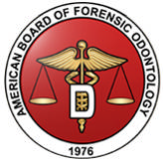**

**AMERICAN BOARD OF FORENSIC ODONTOLOGY**

**DIPLOMATE INFORMATION**

***(All listed are “Board Certified” unless otherwise noted)***

***Updated 8/2017***

[LIST OF ABFO DIPLOMATES BY CERTIFICATE NUMBER](#DIPLOMATEBIOGRAPHIESANDPHOTOGRAPHS)

[ALPHABETICAL LIST OF ABFO DIPLOMATES](#ALPHABETICALLISTOFABFODIPLOMATES)

[ABFO OFFICERS 2018-201](#ABFOOFFICERS)9

[ABFO BOARD OF DIRECTORS 2018-201](#BOD)9

[ABFO COMMITTEES 2018-201](#committees)9

[GEOGRAPHIC DISTRIBUTION OF ABFO DIPLOMATES](#Geographicdistribution)

[CONTACT INFORMATION FOR ABFO DIPLOMATES](#CONTACTINFORMATIONOFABFODIPLOMATES)

[ACTIVE ABFO DIPLOMATES EMAIL ADDRESSES](#ACTIVEABFODIPLOMATESEMAILADDRESSES)

[ABFO DIPLOMATE’S BIOGRAPHIES AND PHOTOGRAPHS](#Bios)

**ABFO DIPLOMATES**

[EDWARD D. WOOLRIDGE, DDS](#Woolridge)

[RICHARD R. SOUVIRON, D.D.S.](#_RICHARD_R._SOUVIRON,_D.D.S.)

[CURTIS A. MERTZ, DDS](#_CURTIS_A._MERTZ,_DDS)

[ARTHUR D. GOLDMAN, D.M.D.](#_ARTHUR_D._GOLDMAN,_D.M.D.)

[GERALD L. VALE, DDS, JD](#Vale)

[STANLEY M. SCHWARTZ, D.M.D.](#_STANLEY_M._SCHWARTZ,_D.M.D.)

[LOWELL J. LEVINE, D.D.S.](#_LOWELL_J._LEVINE,_D.D.S.)

[ROBERT DORION, D.D.S.](#_ROBERT_DORION,_D.D.S.)

[PAUL G. STIMSON, DDS, MS](#Stimson)

[DAVID B. SCOTT, D.D.S.](#_DAVID_B._SCOTT,_D.D.S.)

[MANUEL M. MASLANSKY, DDS](#Maslansky)

[GEORGE T. WARD, DDS](#_GEORGE_T._WARD,_D.D.S.)

[LESTER L. LUNTZ, D.D.S.](#_LESTER_L._LUNTZ,_D.D.S.)

[EDWIN E. ANDREWS, DMD, MED](#Andrews)

[HOMER R. CAMPBELL, JR, DDS](#Campbell)

[EDWARD V. COMULADA, D.D.S.](#_EDWARD_V._COMULADA,_D.D.S.)

[B. KALMAN FRIEDMAN, D.D.S.](#_B._KALMAN_FRIEDMAN,_D.D.S.)

[WILLIAM S. GILES, DDS, MSD](#Giles)

[THOMAS C. KRAUSS, D.D.S.](#_THOMAS_C._KRAUSS,_D.D.S.)

[GERALD F. PROHASKA, D.D.S., MS](#Prohaska)

[NEAL R. RIESNER, D.D.S.](#_NEAL_R._RIESNER,_D.D.S.)

[ROBERT SIEGEL, D.D.S.](#_ROBERT_SIEGEL,_D.D.S.)

[NORMAN D. SPERBER, D.D.S.](#_NORMAN_D._SPERBER,_D.D.S.)

[S. MILES STANDISH, D.D.S.](#_S._MILES_STANDISH,_D.D.S.)

[JAMES D. WOODWARD, DMD, MED](#Woodward)

[REIDAR F. SOGNNAES, DDS, MS, PHD](#Sognnaes)

[LAURENCE S. CHEEVERS, D.D.S.](#_LAURENCE_S._CHEEVERS,_D.D.S.)

[EDWARD R. BULPITT, JR, DDS](#Bulpitt)

[L. THOMAS JOHNSON, D.D.S.](#_L._Thomas_Johnson,_D.D.S.)

[WILLIAM E. ALEXANDER, D.M.D.](#_WILLIAM_E._ALEXANDER,_D.M.D.)

[WILLIAM P. WEBSTER, DDS, MS](#Webster)

[WILLIAM L. FARRELL, D.D.S.](#_WILLIAM_L._FARRELL,_D.D.S.)

[JIM B. HALES, D.D.S.](#_JIM_B._HALES,_D.D.S.)

[EDWARD E. HERSCHAFT, DDS, MA](#Herschaft)

[HARRY H. MINCER, DDS, PHD](#Mincer)

[RAYMOND D. RAWSON, DDS, MA](#Rawson)

[DAVID R. SIPES, DDS, MFS](#Sipes)

[HASKELL ASKIN, D.D.S.](#_HASKELL_ASKIN,_D.D.S.)

[GEORGE FURST, DDS.](#_GEORGE_FURST,_DDS)

[EDWARD J. PAVLIK, DDS, MS](#Pavlik)

[JOHN W. BLAIR, D.D.S.](#_JOHN_W._BLAIR,_D.D.S.)

[ALVIN W. KAGEY, D.D.S.](#_ALVIN_W._KAGEY,_D.D.S.)

[RODNEY MICHAEL CROW, D.D.S.](#_RODNEY_MICHAEL_CROW,_D.D.S.)

[MARK L. BERNSTEIN, D.D.S.](#_MARK_L._BERNSTEIN,_D.D.S.)

[RODNEY F. BROWN, D.D.S.](#_RODNEY_F._BROWN,_D.D.S.)

[PHILIP R. GERON, D.M.D.](#_PHILIP_R._GERON,_D.M.D.)

[GREGORY S. GOLDEN, DDS](#_Gregory_S._Golden,_DDS)

[GEORGE M. ISAAC, D.D.S.](#_GEORGE_M._ISAAC,_D.D.S.)

[THOMAS L. JOHNSON, D.D.S.](#_THOMAS_L._JOHNSON,_D.D.S.)

[ELIZABETH M. ROBINSON, DDS](#Robinson)

[JAMES A. COTTONE, DMD, MS](#Cottone)

[PETER F. HAMPL, DDS.](#_Peter_F._Hampl,_DDS)

[ROBERT PARKER KELLY, D.D.S.](#_ROBERT_PARKER_KELLY,_D.D.S.)

[JOHN D. MCDOWELL, DDS, MS](#McDowell)

[JAMES B. MCGIVNEY, D.M.D.](#_JAMES_B._MCGIVNEY,_D.M.D.)

[EDWARD R. MOFSON, D.D.S.](#_EDWARD_R._MOFSON,_D.D.S.)

[FRANK A. MORGAN, DDS.](#_Frank_A._Morgan,_DDS)

[WILLIAM M. MORLANG, D.D.S.](#_WILLIAM_M._MORLANG,_D.D.S.)

[GERALD M. REYNOLDS, DDS.](#_GERALD_M._REYNOLDS,_DDS)

[WILBUR B. RICHIE, D.D.S.](#_WILBUR_B._RICHIE,_D.D.S.)

[MICHAEL H. WEST, D.D.S.](#_MICHAEL_H._WEST,_D.D.S.)

[JOSEPH A. ANSELMO, D.D.S.](#_JOSEPH_A._ANSELMO,_D.D.S.)

[ROBERT E. BARSLEY, DDS, JD](#Barsley)

[ALAN S. BENOV, D.D.S.](#_ALAN_S._BENOV,_D.D.S.)

[JOHN K. BERK, D.D.S.](#_JOHN_K._BERK,_D.D.S.)

[DONALD D. JEFFRIES, D.D.S.](#_DONALD_D._JEFFRIES,_D.D.S.)

[JOHN P. KENNEY, D.D.S.](#_JOHN_P._KENNEY,_D.D.S.)

[PHILLIP E. O’SHAUGHNESSY, DDS, MSD](#OShaughnessy)

[DUANE E. SPENCER, D.D.S.](#_DUANE_E._SPENCER,_D.D.S.)

[RONALD J. WICKUM, D.D.S.](#_RONALD_J._WICKUM,_D.D.S.)

[GARY L. BELL, D.D.S.](#_GARY_L._BELL,_D.D.S.)

[JOHN L. BRIGGLE, DDS](#JOHNLBRIGGLEDDS)

[JOSEPH W. BRIGGLE, DDS](#JOSEPHWBRIGGLEDDS)

[JON CURTIS DAILEY, D.D.S.](#_JON_CURTIS_DAILEY,_D.D.S.)

[THOMAS J. DAVID, D.D.S.](#_THOMAS_J._DAVID,_D.D.S.)

[DONNELL C. MARLIN, D.D.S.](#_DONNELL_C._MARLIN,_D.D.S.)

[IRA R. TITUNIK, DDS.](#_IRA_R._TITUNIK,_DDS)

[JOSEPH R. GENTILE, D.D.S.](#_JOSEPH_R._GENTILE,_D.D.S.)

[GEORGE A. GOULD, DDS.](#_GEORGE_A._GOULD,_DDS)

[MITCHELL M. KIRSCHBAUM, D.D.S.](#_MITCHELL_M._KIRSCHBAUM,_D.D.S.)

[STUART A. REDER, D.D.S.](#_STUART_A._REDER,_D.D.S.)

[ALLAN J. WARNICK, D.D.S.](#_ALLAN_J._WARNICK,_D.D.S.)

[DAVID C. AVERILL, D.D.S.](#_DAVID_C._AVERILL,_D.D.S.)

[C. MICHAEL BOWERS, DDS, JD](#Bowers)

[REED L. HOLT, DDS.](#_REED_L._HOLT,_DDS)

[ANN L. NORRLANDER, DDS.](#_ANN_L._NORRLANDER,_DDS)

[HARVEY A. SILVERSTEIN, DDS.](#_HARVEY_A._SILVERSTEIN,_DDS)

[BRION C. SMITH, DDS.](#_Brion_C._Smith,_DDS)

[MICHAEL N. SOBEL, DMD.](#_MICHAEL_N._SOBEL,_DMD)

[FRANKLIN D. WRIGHT, DMD.](#_FRANKLIN_D._WRIGHT,_DMD)

[BERNARD L. HARMELING, DMD.](#_BERNARD_L._HARMELING,_DMD)

[RICHARD H. FIXOTT, DDS.](#_RICHARD_H._FIXOTT,_DDS)

[GERALD F. JONES, D.D.S.](#_GERALD_F._JONES,_D.D.S.)

[PHILIP J. LEVINE, DDS.](#_PHILIP_J._LEVINE,_DDS)

[JOHN A. LEWIS, JR., DDS](#Lewis)

[DAVID SWEET,O.C., DMD, PhD.](#_David_Sweet,_DMD,_PhD)

[MICHAEL P. TABOR, DDS.](#_MICHAEL_P._TABOR,_DDS)

[DONALD O. SIMLEY II, DDS](#Simley)

[BRYAN CHRZ DDS.](#_BRYAN_CHRZ_DDS._1)

[MICHEL EVENOT, DDS, MS.](#Evenot)

[ROBERT G. WILLIAMS, DDS.](#_ROBERT_G._WILLIAMS,_DDS)

[DANIEL M. WINTER, DDS.](#_DANIEL_M._WINTER,_DDS)

[RICHARD D. DIAL, DDS.](#_RICHARD_D._DIAL,_DDS)

[PAMELA W. HAMMEL, DDS.](#_PAMELA_W._HAMMEL,_DDS)

[ERNEST JACKSON, DMD.](#_ERNEST_JACKSON,_DMD)

[DAVID W. JOHNSON, DDS.](#_DAVID_W._JOHNSON,_DDS)

[ARACELI ORTIZ, DMD, MSD.](#_ARACELI_ORTIZ,_DMD,_MSD)

[MARDEN E. ALDER, DDS, MS](#ALDER)

[DOUGLAS M. ARENDT, DDS, MS](#Arendt)

[JOHN A. PIAKIS, DDS.](#_John_A._Piakis,_DDS)

[GARY M. BERMAN, DDS.](#_GARY_M._BERMAN,_DDS)

[KIM M. LOOK, DDS.](#_Kim_M._Look,_DDS)

[DAVID R. SENN, DDS.](#Senn)

[BARRY E. LIPTON, DDS.](#_Barry_E._Lipton,_DDS)

[PETER W. LOOMIS, DDS](#_Peter_E._Loomis,_DDS)

[JAN J. WESTBERRY, DMD.](#_Jan_J._Westberry,_DMD)

[JAMES D. WOOD, DDS.](#_James_D._Wood,_DDS)

[ROBERT E. WOOD, DDS, MS, PHD](#WoodR)

[KATHLEEN M. CROWLEY, DMD.](#Crowley)

[VERONIQUE F. DELATTRE, DDS.](#Delattre)

[CATHY A. LAW, DDS.](#Law)

[RICHARD A. WEEMS, DMD, MS.](#Weems)

[CYNTHIA C. BRZOZOWSKI, DMD](#Brzozowski)

[JOHN E. FILIPPI, DDS](#Filippi)

[LILLIAN A. NAWROCKI, MA, DDS](#nawrocki)

[ANTHONY K. Y. SUR, DDS](#Sur)

[WARREN D. TEWES, DDS](#Tewes)

[STEPHANIE KAVANAUGH, DMD, MS](#KAVANAUGH)

[WILLIAM E.SILVER, DDS](#WilliamSilverDDS)

[JOHN M. WILLIAMS, DDS](#JohnMWilliamsDDS)

[PAULA C. BRUMIT, DDS](#paulacbrumitdds)

[KENNETH COHRN, DDS](#kennethcohrndds)

[JAMES M. LEWIS, DMD](#jamesmlewisdmd)

[ADAM J. FREEMAN, DDS](#adamjfreemandds)

[LAURA A. KAISER, DMD](#lauraakaiserdmd)

[STEPHEN M. LOJESKI, DDS](#stephenmlojeskidds)

[ROGER D. METCALF, DDS](#rogerdmetcalfdds)

[BRUCE A. SCHRADER, DDS](#bruceaschraderdds)

[ANTHONY R. CARDOZA, DDS](#Cardoza)

[SHEILA M. DASHKOW, DDS](#Dashkow)

[LAWRENCE A. DOBRIN, DMD](#Dobrin)

[KATHLEEN A. KASPER, DDS](#Kasper)

[JANICE W. KLIM-LEMANN, DDS](#KlimLemann)

[GREGORY L. MAR, DDS](#Mar)

[PETER J. MARSH, DDS](#Marsh)

[BARBARA L. NEEDELL, DMD](#Needell)

[CHARLES M. BERNER, DDS](#Berner)

[RAYMOND J. JOHANSEN DMD](#Johansen)

[DENISE C. MURMANN, DDS](#Murmann)

[EDGAR W. TURNER III, DDS](#Turner)

[SCOTT HAHN, DMD](#Hahn)

[JACQUELINE S. REID, DDS](#Reid)

[DELORA L. FLETCHER, DDS](#Fletcher)

[HOLLAND MANESS, DMD](#Maness)

[ERIC S. WILSON, DDS](#Wilson)

[ROBIN AINSWORTH, DDS, MS](#Scheper)

PHILLIS HO, DDS

JOE ADSERIAS GARRIGA, DDS, PhD

KENNETH ASCHHEIM, DDS

CORINNE D’ANJOU, DMD

DEREK DRAFT, DDS

JAMES P. FANCHER DDS, MA, PhD

LENA KARKALAS, DDS

ELIZABETH RUTH SMITH, DDS

[ALPHABETICAL LIST OF ABFO DIPLOMATES](\\\\SBS01WDA\\Users\\afreeman\\My Documents\\My Dropbox\\ABFO Business\\Jean Hample\\Desktop\\ABFO\\ABFO Manual June 2005\\March 15,  2005  ABFO Manual June 2005.doc" \l "_Toc93067755#_Toc93067755)

**A**

Adserias

Ainsworth

[Alder](#_Marden_E._Alder,_DDS, MS)

[Alexander](#_WILLIAM_E._ALEXANDER,_D.M.D.)

[Andrews](#_EDWIN_E._ANDREWS,_D.M.D., M.E.D.)

[Anselmo](#_JOSEPH_A._ANSELMO,_D.D.S.)

[Arendt](#Arendt)

[Askin](#_HASKELL_ASKIN,_D.D.S.)

Aschheim

[Averill](#_DAVID_C._AVERILL,_D.D.S.)

**B**

[Barsley](#_ROBERT_E._BARSLEY,_D.D.S., J.D.)

[Bell](#_GARY_L._BELL,_D.D.S.)

[Benov](#_ALAN_S._BENOV,_D.D.S.)

[Berk](#_JOHN_K._BERK,_D.D.S.)

[Berman](#_GARY_M._BERMAN,_DDS)

[Berner](#Berner)

[Bernstein](#_MARK_L._BERNSTEIN,_D.D.S.)

[Blair](#_JOHN_W._BLAIR,_D.D.S.)

[Bowers](#_C._MICHAEL_BOWERS,_D.D.S., J.D.)

[Brown](#_RODNEY_F._BROWN,_D.D.S.)

[Brumit](#paulacbrumitdds)

[Brzozowski](#Brzozowski)

[Bulpitt](#_EDWARD_R._BULPITT,_D.D.S.)

**C**

[Campbell](#_HOMER_R._CAMPBELL,_JR., D.D.S.)

[Cardoza](#Cardoza)

[Cheevers](#_LAURENCE_S._CHEEVERS,_D.D.S.)

[Chrz](#_BRYAN_CHRZ_DDS.)

[Cohrn](#kennethcohrndds)

[Comulada](#_EDWARD_V._COMULADA,_D.D.S.)

[Cottone](#_JAMES_A._COTTONE,_D.M.D., M.S.)

[Crow](#_RODNEY_MICHAEL_CROW,_D.D.S.)

[Crowley](#Crowley)

**D**

[Dailey](#_JON_CURTIS_DAILEY,_D.D.S.)

D’Anjou

[Dashkow](#Dashkow)

[David](#David)

[Delattre](#Delattre)

[Dial](#_RICHARD_D._DIAL,_DDS)

[Dobrin](#Dobrin)

[Dorion](#_ROBERT_DORION,_D.D.S.)

Draft

**E**

[Evenot](#Evenot)

**F**

Fancher

[Farrell](#_WILLIAM_L._FARRELL,_D.D.S.)

[Filippi](#Filippi)

[Fixott](#_RICHARD_H._FIXOTT,_DDS)

Fletcher

[Freeman](#adamjfreemandds)

[Friedman](#_B._KALMAN_FRIEDMAN,_D.D.S.)

[Furst](#_GEORGE_FURST,_DDS)

**G**

[Gentile](#_JOSEPH_R._GENTILE,_D.D.S.)

[Geron](#_PHILIP_R._GERON,_D.M.D.)

[Giles](#_WILLIAM_S._GILES,_D.D.S., MSD)

[Golden](#_Gregory_S._Golden,_DDS)

[Goldman](#_ARTHUR_D._GOLDMAN,_D.M.D.)

[Gould](#_GEORGE_A._GOULD,_DDS)

**H**

[Hahn](#Hahn)

[Hales](#_JIM_B._HALES,_D.D.S.)

[Hammel](#_PAMELA_W._HAMMEL,_DDS)

[Hampl](#_Peter_F._Hampl,_DDS)

[Harmeling](#_BERNARD_L._HARMELING,_DMD)

[Herschaft](#Herschaft)

[Holt](#_REED_L._HOLT,_DDS)

**I**

[Isaac](#_GEORGE_M._ISAAC,_D.D.S.)

**J**

[Jackson](#_ERNEST_JACKSON,_DMD)

[Jeffries](#_DONALD_D._JEFFRIES,_D.D.S.)

[Johansen](#Johansen)

[Johnson, David](#_DAVID_W._JOHNSON,_DDS)

[Johnson, L., Thomas](#_L._Thomas_Johnson,_D.D.S.)

[Johnson, Thomas L](#_THOMAS_L._JOHNSON,_D.D.S.).

[Jones](#_GERALD_F._JONES,_D.D.S.)

**K**

[Kagey](#_ALVIN_W._KAGEY,_D.D.S.)

[Kaiser](#lauraakaiserdmd)

Karkalas

[Kasper](#Kasper)

[Kavanaugh](#KAVANAUGH)

[Kelly](#_ROBERT_PARKER_KELLY,_D.D.S.)

[Kenney](#_JOHN_P._KENNEY,_D.D.S.)

[Kirschbaum](#_MITCHELL_M._KIRSCHBAUM,_D.D.S.)

[Klim-Lemann](#KlimLemann)

[Krauss](#_THOMAS_C._KRAUSS,_D.D.S.)

**L**

[Law](#Law)

[Levine, Lowell](#_LOWELL_J._LEVINE,_D.D.S.)

[Levine, Philip](#_PHILIP_J._LEVINE,_DDS)

[Lewis, James](#jamesmlewisdmd)

[Lewis, John](#_JOHN_A._LEWIS,_JR., D.D.S.)

[Lipton](#_Barry_E._Lipton,_DDS)

[Lojeski](#stephenmlojeskidds)

[Look](#_Kim_M._Look,_DDS)

[Loomis](#_Peter_E._Loomis,_DDS)

[Luntz](#_LESTER_L._LUNTZ,_D.D.S.)

**M**

[Maness](#Maness)

[Mar](#Mar)

[Marlin](#Marlin)

[Marsh](#Marsh)

[Maslansky](#_MANUEL_M._MASLANSKY,_D.D.S.)

[McDowell](#_JOHN_D._McDowell,_D.D.S., MS)

[McGivney](#_JAMES_B._MCGIVNEY,_D.M.D.)

[Mertz](#_CURTIS_A._MERTZ,_DDS)

[Metcalf](#rogerdmetcalfdds)

[Mincer](#Mincer)

[Mofson](#_EDWARD_R._MOFSON,_D.D.S.)

[Morgan](#_Frank_A._Morgan,_DDS)

[Morlang](#_WILLIAM_M._MORLANG,_D.D.S.)

[Murmann](#Murmann)

**N**

[Nawrocki](#Nawrocki)

[Needell](#Needell)

[Norrlander](#_ANN_L._NORRLANDER,_DDS)

**O**

[Ortiz](#_ARACELI_ORTIZ,_DMD,_MSD)

[O’Shaughnessy](#_PHILLIP_E._O'SHAUGHNESSY,_DDS, MSD)

**P**

[Pavlik](#_EDWARD_J._PAVLIK,_D.D.S., M.S.)

[Piakis](#_John_A._Piakis,_DDS)

[Prohaska](#_GERALD_F._PROHASKA,_D.D.S., MS)

**Q**

**R**

[Rawson](#_RAYMOND_D._RAWSON,_D.D.S., M.A.)

[Reder](#_STUART_A._REDER,_D.D.S.)

[Reid](#Reid)

[Reynolds](#_GERALD_M._REYNOLDS,_DDS)

[Richie](#_WILBUR_B._RICHIE,_D.D.S.)

[Riesner](#_NEAL_R._RIESNER,_D.D.S.)

**S**

[Schrader](#bruceaschraderdds)

[Schwartz](#_STANLEY_M._SCHWARTZ,_D.M.D.)

[Scott](#_DAVID_B._SCOTT,_D.D.S.)

[Senn](#Senn)

[Siegel](#Siegel)

[Silver](#Silver)

[Silverstein](#_HARVEY_A._SILVERSTEIN,_DDS)

[Simley](#_DONALD_O._SIMLEY_II, DDS)

[Sipes](#_DAVID_R._SIPES,_D.D.S., M.F.S.)

[Smith](#_Brion_C._Smith,_DDS)

Smith

[Sobel](#_MICHAEL_N._SOBEL,_DMD)

[Sognnaes](#_REIDAR_F._SOGNNAES,_D.D.S., M.S., P)

[Souviron](#_RICHARD_R._SOUVIRON,_D.D.S.)

[Spencer](#_DUANE_E._SPENCER,_D.D.S.)

[Sperber](#_NORMAN_D._SPERBER,_D.D.S.)

[Standish](#_S._MILES_STANDISH,_D.D.S.)

[Stimson](#_PAUL_G._STIMSON,_D.D.S., M.S.)

[Sur](#Sur)

[Sweet](#_David_Sweet,_DMD,_PhD), O.C.

**T**

[Tabor](#_MICHAEL_P._TABOR,_DDS)

[Tewes](#Tewes)

[Titunik](#_IRA_R._TITUNIK,_DDS)

[Turner](#Turner)

**U**

**V**

[Vale](#_GERALD_L._VALE,_D.D.S., JD)

**W**

[Ward](#_GEORGE_T._WARD,_D.D.S.)

[Warnick](#_ALLAN_J._WARNICK,_D.D.S.)

[Webster](#_WILLIAM_P._WEBSTER,_D.D.S., MS)

[Weems](#Weems)

[West](#_MICHAEL_H._WEST,_D.D.S.)

[Westberry](#_Jan_J._Westberry,_DMD)

[Wickum](#_RONALD_J._WICKUM,_D.D.S.)

[Williams, John](#WilliamsJohn)

[Williams, Robert](#Williams)

Wilson

[Winter](#_DANIEL_M._WINTER,_DDS)

[Wood, James](#_James_D._Wood,_DDS)

[Wood, Robert](#_Robert_E._Wood,_DDS, MS, PhD)

[Woodward](#_EDWARD_D._WOOLRIDGE,_JR., D.D.S.)

[Woolridge](#_EDWARD_D._WOOLRIDGE,_JR., D.D.S.)

[Wright](#_FRANKLIN_D._WRIGHT,_DMD)

**X**

**Y**

**Z**

**ABFO Executive Committee**

**2018-2019**

**1) President**

**Dr. Richard Weems**

592 Oakline Dr.

Birmingham, AL

205-902-2478

[rweems@uab.edu](mailto:rweems@uab.edu)

**2) President Elect**

**Dr. Edward Herschaft**

W 702-774-2654

C 702-300-2255

Las Vegas, NV

eherschaft@unlv.edu

**3) Vice President**

**Dr. Jim Lewis**

165 Intracoastal Dr.

Madison, AL 35758

256-509-0567

[jmlewisdmd@knology.net](mailto:jmlewisdmd@knology.net)

**4) Secretary**

**Dr. Richard Fixott**

3576 SW Valleyview Dr.

Redmond, OR 97756

541-788-9094

[radar@hevanet.com](mailto:radar@hevanet.com)

**5) Treasurer**

**Dr. Roger Metcalf**

PO Box 137442

Ft Worth, TX

817-371-3312

[RMetcalf@abfo.org](mailto:kfc@cohrn.com)

**6) Immediate Past President**

**Dr. Paula Brumit**

PO Box 608

Nocona, TX

214-244-7008

[Pbrumit@abfo.org](mailto:Pbrumit@abfo.org)

**ABFO Board of Directors**

**2018-2019**

**1) Dr. David Senn** (19)

18 Villa Jardin

San Antonio, TX 78230

210-501-3302

senn@uthscsa.edu

**2) Dr. Robert Williams** (19)

11661 Preston Rd. #104

Dallas, TX 75230

214-629-4761

painless1886@aol.com

**3) Dr. Stephen Lojeski** (20)

600 North Santa Anita Avenue

Arcadia, CA 91006

626-574-7020

[steve1512@roadrunner.com](mailto:steve1512@roadrunner.com)

**4) Dr. Warren Tewes** (20)

108 Bakers Lane

Queenstown, MD 21658

410-903-2111

tewesdds@ocmemd.org

**5) Dr. Jacqueline Reid** 2nd Term(20)

390 Main St.

Chatham, NJ 07928

973-635-9456

[j.reid@att.net](mailto:j.reid@att.net)

**6) Dr. Cynthia Brzozowski** 2nd Term(20)

179 Dayton Street

Sea Cliff, NY 11579

516-775-7344

[theclyde@aol.com](mailto:theclyde@aol.com)

**7) Dr. Cathy Law** 2nd Term(20)

2356 Sunset Curve

Upland, CA 91784

909-908-5365

clawdds@aol.com

**8) Dr. Brian Chrz** (20)

505 N. 14th Street

Perry, OK 73077

580-336-2255

bchrzdds@sbcglobal.net

**9) Dr. Tom David** (20)

1221 Rosette Way

Marietta, GA 30062

770-367-6153

[tjd214@comcast.net](mailto:tjd214@comcast.net)

**10) Dr. Robin Ainsworth** 2nd term(21)

10900 East Taylor Rd, Unit 254

Gulfport, MS 39503

240-418-3607 (c)

[robin.a.ainsworth@gmail.com](mailto:robin.scheper@comcast.net)

**11) Dr. Kathleen Kasper** (21)

1514 E. Beltline Rd. #100

Corrollton, TX. 75006

214-673-3745 (c)

[exfiles11@aol.com](mailto:exfiles11@aol.com)

**12) Dr. Ann Norrlander** (21)

5711 Colfax Av. S

Minneapolis, MN. 55419

612-240-9929 (c)

[anorrlander@iphouse.com](mailto:anorrlander@iphouse.com)

**13) Dr. Eric Wilson** (21)

PO Box 50

Cole Camp, MO. 65325

573-480-0723 (c)

[fijidr96@gmail.com](mailto:fijidr96@gmail.com)

**Legal advisor to the Board of Directors:** (non voting member of the board of directors)

**Haskell M. Pitluck**, JD

573 Lake Ave.

Crystal Lake, IL 60014

815-459-7192

pitluck@mc.net

**ABFO Committees 2018-2019**

**Standing Committees**

Executive Committee

Dick Weems (P) (20)

Ed Herschaft (PE) (21)

Jim Lewis (VP) (22)

Roger Metcalf (Treas) (23)

Richard Fixott (Sec) (24)

Paula Brumit (PP) (19)

Certification & Examination

1. Bob Wood - Chair (20)

2. Ned Turner – Past Chair (19)

2. Chuck Berner (21)

3. Kim Look (22)

4. Peter Loomis (23)

EC Liaison- Paula Brumit

Ethics

1. John Fillipi (19)

2. Ira Titunik (20)

3. Duane Spencer (21)

4. Haskell Pitluck-non-voting

EC Liaison- Jim Lewis

Nominating Committee

Adam Freeman - Chair (19)

1. Paula Brumit

2. Cathy Law

3. Eric Wilson

4. Ken Cohrn

Articles & Bylaws

Ann Norrlander- Chair (19)

1. Dave Johnson (19)

2. Denise Murmann (19)

3. Jan Westberry (20)

6. Cathy Law (20)

7. Gary Bell (21)

8. Bryan Chrz (21)

7. Haskell Pitluck (non-voting)

EC Liaison- Dick Weems

Research

Barry Lipton – Chair (19)

1. Bob Wood (19)

2. Veronique DeLattre (19)

3. Bob Dorion (20)

4. Tom David (20)

EC Liaison- Roger Metcalf

Strategic Planning

Jacqueline Reid - Chair (19)

1. Jim Lewis

2. Cathy Law

3. Jan Westberry

4. Dick Weems (EC)

EC Liaison- Jim Lewis

Bitemark Evidence & Patterned Injury

Robert Dorion - Chair (19)

1. Bob Barsley
2. Greg Golden
3. Jim Lewis
4. Roger Metcalf
5. David Senn

EC Liaison- Paula Brumit

Dental Identification

Bryan Chrz- Chair (20)

1. MUP Subcommittee Chair- Dick Weems (19)

1. MFI Subcommittee Chair- John Fillipi (19)
2. WinID Subcommittee Chair- Delora Fletcher (21)
3. Richard Fixott
4. Gary Berman
5. Phyllis Ho
6. Roger Metcalf
7. Joe Adserias
8. Lena Karkalas
9. Warren Tewes
10. Janice Klim-Lemann
11. Mitch Kirschbaum
12. Peter Hampl
13. Rick Cardoza

EC Liaison- Ed Herschaft

Civil Litigation

Tom David - Chair (19)

1. Chuck Berner
2. Roger Metcalf
3. Bruce Schrader
4. Paula Brumit
5. Bob Barsley
6. Ann Norrlander

EC Liaison- Dick Weems

Human Abuse & Neglect

Michael Sobel – Chair (19)

1. Joe Adserias
2. Phyllis Ho
3. Scott Hahn
4. Jack Kenney
5. Peter Marsh
6. John McDowell
7. Cynthia Brzozowski
8. Robin Ainsworth

EC Liaison-Ed Herschaft

Dental Age Assessment

Kathleen Kasper- Chair (19)

1. Paula Brumit
2. Denise Murmann
3. David Senn
4. Eric Wilson
5. Jim Lewis
6. Jackie Reid
7. Peter Marsh
8. JP Fancher
9. Derek Draft
10. Corinne D’Anjou

EC Liaison- Dick Weems

Metrology

Tom David- Chair

EC Liaison- Roger Metcalf

Public Relations/Social Media

1. Dick Weems- Chair (19)

2. Adam Freeman (19)

**Ad Hoc Committees**

Ad Hoc Overall Workshop Chair

Jim Lewis (19)

Ad Hoc Workshops 2019 Meeting

Civil Litigation (Saturday)

Tom David

Dental Age Estimation (Sunday)

Kathy Kasper

Ad Hoc Image Series IV

Jackie Reid- Chair (19)

Joe Adserias

Ad Hoc Archives

Warren Tewes- Chair (19)

Ad Hoc Local Arrangements

Warren Tewes (19)

Ad Hoc ADA Liaison

John Kenney (19)

Ad Hoc ADA Scientific Committee for Dental Informatics (SCDI)

Bob Barsley (19)

Ad Hoc FSAB Liaison

David Senn (19)

Ad Hoc FSAB recertification

Peter Loomis – Chair (19)

David Senn – consultant

Parliamentarian – Adam Freeman (19)

Webmaster – Dane Johnson

**GEOGRAPHIC DISTRIBUTION OF ABFO DIPLOMATES**

**ALABAMA** (2)

Richard A. Weems, DMD, MS

James M. Lewis, DMD

**ALASKA** (1)

Stuart A. Reder, DDS **(retired)**

**ARIZONA** (2)

Jon Curtis Dailey, DDS

John A. Piakis, DDS

**ARKANSAS** (1)

Edwin E. Andrews, DMD, MED **(retired)**

**CALIFORNIA** (21)

Joseph A. Anselmo, DDS **(retired)**

Alan S. Benov, DDS **(retired)**

John K. Berk, DDS **(resigned)**

Anthony R. Cardoza, DDS

William L. Farrell, DDS

Delora Fletcher, DDS

Gregory S. Golden, DDS

George A. Gould, DDS

Donald D. Jeffries, DDS **(retired)**

Raymond J. Johansen, DMD

Thomas L. Johnson, DDS **(retired)**

Janice W. Klim-Lemann, DDS

Cathy A. Law, DDS

Stephen M. Lojeski, DDS

Gregory L. Mar, DDS

Gerald M. Reynolds, DDS **(retired)**

Duane E. Spencer, DDS

Norman D. Sperber, DDS **(retired)**

Gerald L. Vale, DDS, JD **(Diplomate Emeritus/Deceased)**

James D. Wood, DDS

**COLORADO** (4)

Richard D. Dial, DDS **(resigned)**

Joseph R. Gentile, DDS

John D. McDowell, DDS

Kim M. Look, DDS

**CONNECTICUT** (1)

Adam J. Freeman, DDS

**DELAWARE** (0)

**FLORIDA** (10)

Kenneth Cohrn, DDS

Scott Hahn, DMD

Laura A. Kaiser, DMD

Philip J. Levine, DDS **(deceased)**

Barry E. Lipton, DDS

Barbara L, Needell, DMD

William Silver, DDS

Richard R. Souviron, DDS

William P. Webster, DDS, MS **(retired)**

Jan J. Westberry, DDS

**GEORGIA** (1)

Thomas J. David, DDS

**GUAM** (0)

**HAWAII** (1)

Anthony K. Y. Sur, DDS

**IDAHO** (0)

**ILLINOIS** (2)

Denise C. Murmann, DDS

Edward J. Pavlik, DDS, MS

**INDIANA** (2)

Rodney F. Brown, DDS **(retired)**

Donnell C. Marlin, DDS **(retired)**

**IOWA** (0)

**KANSAS**(1)

Daniel M. Winter, DDS **(retired)**

**KENTUCKY** (2)

Mark L. Bernstein, DDS

James D. Woodward, DMD, MED **(retired)**

**LOUISIANA** (1)

Robert E. Barsley, DDS, JD

**MAINE** (0)

**MARYLAND** (2)

Brion C. Smith, DDS **(retired)**

Warren D. Tewes, DDS

**MASSACHUSETTS** (1)

Kathleen M. Crowley, DMD

**MICHIGAN** (4)

Allan J. Warnick, DDS **(retired)**

Pamela W. Hammel, DDS

Gary M. Berman, DDS

Derek Draft, DDS

**MINNESOTA** (2)

Ann L. Norrlander, DDS

John Williams, DDS **(Deceased)**

**MISSISSIPPI** (1)

Robin Ainsworth, DDS, MS

John A. Lewis, Jr., DDS

**MISSOURI** (3)

Ernest Jackson, DMD

James McGivney, DDS

Eric Wilson, DDS

**MONTANA** (1)

David W. Johnson, DDS

**NEBRASKA** (1)

John E. Filippi, DDS

**NEVADA** (2)

Edward E. Herschaft, DDS, MA

Raymond D. Rawson, DDS, MA

**NEW HAMPSHIRE** (0)

**NEW JERSEY** (6)

Sheila M. Dashkow, DDS **(Deceased)**

Lawrence A. Dobrin, DMD

Philip R. Geron, DMD

Mitchell M. Kirschbaum, DDS

Jacqueline S. Reid, DDS

**NEW MEXICO** (3)

Homer Campbell, DDS **(deceased)**

Peter W. Loomis, DDS

Gerald F. Prohaska, DDS, MS **(retired)**

**NEW YORK** (8)

Kenneth Aschheim, DDS

Cynthia C. Brzozowski, DMD

B. K. Friedman, DDS **(deceased)**

Phillis Ho, DDS

Lowell J. Levine, DDS

Lillian A. Nawrocki, DDS

Neal Riesner, DDS **(retired)**

Ira R. Titunik, DDS

**NORTH CAROLINA** (2)

David R. Sipes, DDS, MFS **(retired)**

George T. Ward, DDS **(retired)**

**NORTH DAKOTA** (0)

**OHIO** (2)

Charles M. Berner, DDS

Franklin D. Wright, DMD

**OKLAHOMA** (1)

Bryan Chrz, DDS

**OREGON** (2)

Richard H. Fixott, DDS

Jim B. Hales, DDS **(retired)**

**PENNSYLVANIA** (1)

Michael N. Sobel, DMD

**RHODE ISLAND** (1)

Lena D Karkalas, DDS

**SOUTH CAROLINA** (1)

Holland Maness, DMD

**SOUTH DAKOTA** (0)

**TENNESSEE** (4)

John P. Kenney, DDS, MS

Harry H. Mincer, DDS, PhD **(Diplomate Emeritus/Retired)**

Michael P. Tabor, DDS

Edgar W. Turner, DDS

**TEXAS** (14)

Marden E. Alder, DDS, MS **(retired)**

Paula C. Brumit, DDS

James A. Cottone, DMD, MS **(retired)**

Veronique F. Delattre, DDS

James P Fancher, DDS. MA, PhD

George M. Isaac, DDS

Kathleen A. Kasper, DDS

Peter J. Marsh, DDS

Roger D. Metcalf, DDS

William M. Morlang, DDS **(Deceased)**

Bruce A. Schrader, DDS

Paul G. Stimson, DDS, MS **(retired)**

Robert G. Williams, DDS

David R. Senn, DDS

**UTAH** (2)

Reed L. Holt, DDS **(retired)**

Edward D. Woolridge, Jr., DDS, LLB, Med **(Emeritus/Deceased)**

**VERMONT** (0)

**VIRGIN ISLANDS** (0)

**VIRGINIA** (3)

Douglas M. Arendt, DDS **(retired)**

Alvin W. Kagey, DDS **(retired)**

David B. Scott, DDS, MS **(retired)**

Elizabeth Ruth Smith DDS

**WASHINGTON** (5)

Gary L. Bell, DDS

Peter F. Hampl, DDS

Gerald F. Jones, DDS **(retired)**

Stephanie Kavanaugh, DMD **(retired)**

Frank A. Morgan, DDS **(retired)**

**WEST VIRGINIA** (0)

**WISCONSIN** (2)

L. Thomas Johnson, DDS **(retired)**

Donald O. Simley II, DDS

**WYOMING** (0)

**PUERTO RICO** (0)

**CANADA** (5)

**ALBERTA**

John W. Blair, DDS

**BRITISH COLUMBIA** (2)

Laurence Cheevers, DDS) **(retired)**

David Sweet, O.C., DMD, PhD

**ONTARIO**

Robert E Wood, DDS, MS, PhD

**QUEBEC**

Corinne D’Anjou, DMD

Robert B. J. Dorion, DDS

**SPAIN**

Joe Adserias Garriga, DDS, PhD

## CONTACT INFORMATION OF ABFO DIPLOMATES

**NAME & CERTIFICATE NUMBER CERTIFICATE**

**ADDRESS & PHONE DATE CERTIFIED EXPIRES**

Joe Adserias Garriga (#164) 02-25-2016 02-25-2021

C/Balmes 62 3o la, 08007

Barcelona, Spain

(+34) 649664437

Robin Ainsworth, DDS, MS (#162) 02/17/2014 02/17/2019

10900 East Taylor Rd., Unit 254

Gulfport, MS 39503

(240) 418-3607

Marden E. Alder, DDS, MS (#114) 02/15/1999 Retired

424 Silver Springs Road

Helotes, Texas 78023

830-510-2193

Edwin E. Andrews, DMD, MED (#016) 04/15/1976 Retired

16372 Ravens Roost Drive

Rogers, AR 72756

479-925-1083

Joseph A. Anselmo, DDS (#066) 12/06/1985 Retired

32325 Corte Palacio

Temecula, CA 92592-6309

323-226-5061

Douglas M. Arendt, DDS (#115) 02/21/2000 Retired

PO Box 1447

Fairfax, VA 22038

(703) 716-1917

Kenneth Aschheim DDS (#165) 02/19/2018 02/19/2023

44 E. 67th St.

New York, NY 10065

917-623-8440

David C. Averill, DDS (#086) 10/04/1989 Resigned

239 Pearl Street

Burlington, VT 05401

(802) 864-5315

**NAME & CERTIFICATE NUMBER CERTIFICATE**

**ADDRESS & PHONE DATE CERTIFIED EXPIRES**

Robert E. Barsley, DDS, JD (#067) 12/06/1985 02/28/2021

P.O. Box 745

Ponchatoula, LA 70454

(985) 386-643

Gary L. Bell, D.D.S. (#074B) 09/01/1986 02/28/2021

9730 Third Avenue N.E., Suite 204

Seattle, WA 98115

(206) 524-5700

Alan S. Benov, DDS (#068) 12/06/1985 Retired

5151 N. Palm, Suite 70

Fresno, CA 93704

(559) 224-1646

John K. Berk, DDS (#069) 12/06/1985 Resigned

20652 Redwood Road

Castro Valley, CA 94546

(510) 733-6282

Gary M. Berman, DDS (#117) 04/16/2002 02/28/2022

9840 Haggerty Road

Bellville, MI 48111

(734) 697-4400

Charles M. Berner, DDS (#153) 02/21/2011 02/28/2021

5940 Woodside Rd.

Highland Heights, OH 44143

(440) 449-8200

Mark L. Bernstein, DDS (#048) 01/01/1982 02/28/2021

Dept. of Diagnostic Sciences

School of Dentistry

University of Louisville

Louisville, KY 40292

(502) 852-5654

John W. Blair, DDS (#045) 02/28/1980 02/28/2020

12 Baycrest Place SW

Calgary, Alberta, T2V 0K6

Canada

(403) 264-1736

**NAME & CERTIFICATE NUMBER CERTIFICATE**

**ADDRESS & PHONE DATE CERTIFIED EXPIRES**

Rodney F. Brown, DDS (#049) 01/01/1982 Retired

636 Sunflower Cir.

Evansville, IN 47720

(812) 423-6723

Paula C. Brumit, DDS (#137) 2/17/2008 02/28/2018

P.O.Box 608

Nocona, TX 76255

(214) 244-7008

Cynthia C. Brzozowski, DMD (#129) 2/20/2006 02/28/2021

179 Dayton St,

Sea Cliff, NY 11579

(516) 775-7344

Anthony R. Cardoza, DDS (#145) 02/22/2010 02/28/2020

9530 Cuyamaca St. #101

Santee, CA 92071

(619) 444-6196

Bryan Chrz, DDS (#104) 02/19/1996 02/28/2021

Memorial Medical Center

505 14th Street

Perry, OK 73077

(W) (580) 336-2255

Kenneth Cohrn, DDS (#138) 2/17/2008 02/28/2018

422 Teague Trail

Lady Lake, FL 32159

(352) 750-4111

James A. Cottone, DMD, MS (#055) 06/10/1984 Retired

34 Donore Street

San Antonio, TX 78229

(210) 342-7979

Kathleen M. Crowley, DMD (#125) 02/21/2005 02/28/2019

15 Wildwood Circle

East Falmouth, MA 02536

(617) 267-6767 x234

Jon Curtis Dailey, DDS (#077) 09/01/1986 02/28/2021

152 East Broadway

Bangor, ME 04401

(706) 799-9617

**NAME & CERTIFICATE NUMBER CERTIFICATE**

**ADDRESS & PHONE DATE CERTIFIED EXPIRES**

Corinne D’Anjou, DMD (#166) 02/19/2018 02/19/2023

210 Boulevard Jean-Leman

Candiac, Quebec, J5R 6E6

Canada

514-774-8718

Sheila M. Dashkow, DDS (#146) 02/22/2010 Deceased

7675 Maple Ave.

Pennsauken, NJ 08109

(856)-665-1184

Thomas J. David, DDS (#078) 09/01/1986 02/28/2021

1000 Johnson Ferry Road, Bldg. H

Marietta, GA 30068

(770) 977-0364

Veronique F. Delattre, DDS (#126) 02/21/2005 02/28/2020

University of Texas Dental Branch

7500 Cambridge #5330,

Houston, TX 77030

(713) 500-4284

Richard D. Dial, DDS (#109) 10/01/1996 Resigned

12248 West Aqueduct Drive

Littleton, CO 80127

(303) 548-2223 (C)

Lawrence A. Dobrin, DMD (#147) 02/22/2010 02/28/2020

One Thresher Court

Tinton Falls, NJ 07753

(908) 298-1300

Robert Dorion, DDS (#008) 02/01/1976 02/28/2021

1440 Pierce Street, Suite 101

Montreal, QC

Canada H3H2K2

(514) 861-5085

Derek Draft, DDS (#167) 02/19/2018 02/19/2023

3100 Wilson Av SW, #3

Grandville, MI. 49418

616-403-1060

**NAME & CERTIFICATE NUMBER CERTIFICATE**

**ADDRESS & PHONE DATE CERTIFIED EXPIRES**

James P Fancher, DDS, MA, PhD (#168) 02/19/2018 02/19/2023

PO Box 682

Martindale, TX. 78655

210-896-8575

William L. Farrell, DDS (#036) 12/21/1978 02/28/2018

9461 Deschutes Road

Palo Cedro, CA 96073

(530) 547-5757

John E. Filippi, DDS (#130) 2/20/2006 02/28/2021

86 Ginger Cove Rd.

Valley, NE 68064

(402) 498-9094

Richard H. Fixott, DDS (#097) 02/18/1992 02/28/2022

3576 SW Valleyview Dr.

Redmond, OR 97756

(541) 788-9094

Delora L. Fletcher, DDS (#159) 02/18/2013 02/28/2018

6140 Calle Mariselda #303

San Diego, CA 92124

858-705-0529

Adam J. Freeman, DDS (#140) 02/28/2009 02/28/2020

22 Imperial Ave.

Westport, CT 06880

(203) 227-3709

B. Kalman Friedman, DDS (#020) 02/16/1977 Deceased

42 Greene Avenue

Amityville, NY 11701

(516) 264-1010

Joseph R. Gentile, DDS (#081) 11/01/1988 02/28/2018

1735 Spruce Lane

Colorado Springs, CO 80906

(719) 633-0056

Philip R. Geron, DMD (#050) 01/01/1982 02/28/2021

320 Lenox Avenue

Westfield, NJ 07090

(908) 233-8088

**NAME & CERTIFICATE NUMBER CERTIFICATE**

**ADDRESS & PHONE DATE CERTIFIED EXPIRES**

Gregory S. Golden, DDS (#051) 01/01/1982 02/28/2021

8577 Haven, #105

Rancho Cucamonga, CA 91730

909-987-5212

George A. Gould, DDS (#082) 11/01/1988 02/28/2018

6101 Puerto Drive

Rancho Murieta, CA 95683-9320

(916) 354-4141

Scott H. Hahn, DMD 02/20/2012 02/20/2022

571 Lincoln St.

Hollywood, FL 33019

(305) 944-9101

Jim B. Hales, DDS (#037) 12/21/1978 Retired

781 B NE 7th St

Grants Pass, OR 97526

(541) 441-1925

Pamela W. Hammel, DDS (#110) 10/01/1996 02/28/2022

571 Lincoln Road.

Grosse Pointe, MI 48230

(313) 886-9067

Peter F. Hampl, DDS (#056) 06/10/1984 02/28/2019

7898 Greyhawk Ave.

Gig Harbor, WA 98335-4926

(253) 853-1984

Edward E. Herschaft, DDS, MA (#038) 12/21/1978 02/28/2018

UNLV School of Dental Medicine

1001 Shadow Lane – MS 7410

Las Vegas, NV 89106-4124

(702) 774-2654

Reed L. Holt, DDS (#088) 10/04/1989 Retired

6579 Canyon Cove Place

Salt Lake City, UT 84121-6355

(801) 272-7832

George M. Isaac, DDS (#052) 01/01/1982 02/28/2021

615 E. Schuster Bldg. 9B

El Paso, TX 79902

(915) 532-3611

**NAME & CERTIFICATE NUMBER CERTIFICATE**

**ADDRESS & PHONE DATE CERTIFIED EXPIRES**

Ernest W. Jackson, DMD (#111) 10/01/1996 02/28/2022

3702 W. Truman Blvd.

Jefferson City, MO 65101

(573) 635-5315

Donald D. Jeffries, DDS (#070) 12/06/1985 Retired

1721 Crestmont Drive

Bakersfield, CA 93306

(661) 871-5234

Raymond J. Johansen (#154) 02/21/2011 02/28/2021

601 E. Arrellaga St, Suite 202

Santa Barbara, CA 93103

(805) 962-6058

David W. Johnson, DDS (#112) 10/01/1996 02/28/2022

2800 11th Avenue South, Suite 24

Great Falls, MT 59405-5263

406-761-1091

L. Thomas Johnson, DDS (#033) 05/20/1977 Retired

6040 N. Kent Avenue

Whitefish Bay, WI 53217-4644

(414) 332-8008

Thomas L. Johnson, DDS (#053) 01/01/1982 Retired

7690 Valle Vista

Rancho Cucamonga, CA 91730

(909) 982-2769

Gerald F. Jones, DDS (#098) 02/18/1992 Retired

14928 N. Fairview Feb 2002

Mead, WA 99021-9001

(509) 464-2372

Alvin W. Kagey, DDS (#046) 02/28/1980 Retired

5720 Williamson Road, Suite 105

Roanoke, VA 24012

(540) 362-2629

Laura A. Kaiser, DMD (#141) 02/28/2009 02/28/2019

9401 Fountain Medical Court #100

Bonita Springs, FL 34135

(239) 949-8220

**NAME & CERTIFICATE NUMBER CERTIFICATE**

**ADDRESS & PHONE DATE CERTIFIED EXPIRES**

Lena D. Karkalas, DDS (#169) 02/19/2018 02/19/2023

151 Waterman St

Providence, RI. 02906

401-868-8012

Kathleen A. Kasper, DDS (#148) 02/22/2010 02/28/2020

1514 East Beltline Rd, Suite 100

Carrollton, TX 75006

(972) 446-0101

Stephanie Kavanaugh, DMD (#134) 02/18/2007 Retired

2731 Fairview Ave. E#4

Seattle, WA 98102

(206) 323-6002

John P. Kenney, DDS (#071) 12/06/1985 02/28/2021

7529 Oakhaven Trace .

Nashville, TN 37209

(847) 698-2088

Mitchell M. Kirschbaum, DDS (#083) 11/01/1988 02/28/2018

421 West Main Street

Boonton, NJ 07005

(201) 334-8228

Janice W. Klim-Lemann, DDS (#149) 02/22/2010 02/28/2020

1802 Canyon Road

Redlands, CA 92373

(909) 307-3773

Cathy A. Law, DDS (#127) 02/21/2005 02/28/2020

2356 Sunset Cir.

Upland, CA 91784

(909) 946-6868

Lowell J. Levine, DDS (#007) 02/01/1976 02/28/2021

240 Brentwood Ct. West

Albany, NY 12203

(518) 464-7130

Philip J. Levine, DDS (#099) 02/18/1992 Deceased

6202 North 9th Ave., Suite 1-B

Pensacola, FL 32504

(904) 474-0001

**NAME & CERTIFICATE NUMBER CERTIFICATE**

**ADDRESS & PHONE DATE CERTIFIED EXPIRES**

James M. Lewis, DMD (#139) 2/17/2008 02/28/2018

165 Intracoastal Dr.

Madison, AL 35758

(256) 509-0567

John A. Lewis, Jr., DDS (#100) 02/18/1992 02/28/2022

407 Heritage Pl.

Flowood, MS 39232

(808) 497-0748

Barry E. Lipton, DDS (#120) 02/16/2004 02/28/2019

2549 Eagles Crossing Dr.

Clearwater, FL 33726

727-259-4418

Stephen M. Lojeski, DDS (#142) 02/28/2009 02/28/2019

600 North Santa Anita Avenue

Arcadia, CA 91006-2722

(626) 574-7020

Kim M. Look, DDS (#118) 04/16/2002 02/28/2022

1885 S. Academy Blvd

Colorado Springs, CO 80916-4511

(719) 392-3448

Peter W. Loomis, DDS (#121) 02/16/2004 02/28/2019

700 Ranchitos Rd NW

Los Ranchos, NM 87114

505-271-2381

Holland Maness, DMD (#160 ) 02/18/2013 02/28/2018

508 Fernwood Dr.

Spartenburg, SC

706-860-2200

Gregory L. Mar, DDS (#150) 02/22/2010 02/28/2020

850 Bryant Street – Room 442

San Francisco, CA 94103

(415) 553-1506

Donnell C. Marlin, DDS (#079) 09/01/1986 Retired

1201 Buchanan Street

Plainfield, IN 46168

(317) 839-0364

**NAME & CERTIFICATE NUMBER CERTIFICATE**

**ADDRESS & PHONE DATE CERTIFIED EXPIRES**

Peter J. Marsh, DDS (#151) 02/22/2010 02/28/2020

7318 Rogers Street

PO Box 888

Marvel, TX 77578

(281) 844-5519

John D. McDowell, DDS (#058) 06/10/1984 02/28/2019

U.C. School of Dentistry

MS F844

P.O. Box 6508

Aurora, CO 80262

(303) 724-6983

James McGivney, DMD (#059) 01/01/`1984 02/28/2019

346 Tulip Dr.

St. Louis, MO 63119

(314) 962-0389

Roger D. Metcalf, DDS (#143) 02/28/2009 02/28/2019

Director of Human ID Lab

Tarrant County Medical Examiner’s District

200 Feliks Gwozdz Place

Fort Worth, TX 76104-4919

(817) 920-5700 x160

Harry H. Mincer, DDS, PhD (#039) 12/21/1978 Diplomate Emeritus

University of Tennessee Retired

875 Union Avenue

Memphis, TN 38163

(901) 448-8659

Frank A. Morgan, DDS (#061) 06/10/1984 Retired

14015 E. 42nd Ct.

Veradale, WA 99037

(509) 928-6410

William M. Morlang, DDS (#062) 06/10/1984 Retired/deceased

9317 Gloxinia Drive

San Antonio, TX 78266-2532

(210) 651-5848

Denise C. Murmann, DDS (#155) 02/21/2011 02/28/2021

2531 W. 75th Street, Suite 202

Naperville, IL 60540

(630) 718-1234

**NAME & CERTIFICATE NUMBER CERTIFICATE**

**ADDRESS & PHONE DATE CERTIFIED EXPIRES**

Lillian A. Nawrocki, DDS (#131) 02/20/2006 02/28/2021

2 Laurel Court

Mount Sinai, NY 11766

(631) 331-8676

Barbara L. Needell, DMD (#152) 02/22/2010 02/28/2020

2583 Eagle Run Lane

Weston, FL 33327

(954) 389-1159

Ann L. Norrlander, DDS (#089) 10/04/1989 02/28/2019

825 Nicollet Mall, Suite 1553

Minneapolis, MN 55402

(612) 332-3649

Edward J. Pavlik, DDS, MS (#044) 02/28/1980 02/28/2020

2555 West Lincoln Highway

Olympia Fields, IL 60461

(312) 747-9300

John A. Piakis, DDS (#116) 02/21/2000 02/28/2020

701 W. Jefferson

Phoenix, Arizona 85007

(602) 372-0528

Gerald R. Prohaska, DDS, MS (#023) 02/16/1977 Retired

6800 Montgomery NE

Albuquerque, NM 87109

(505) 881-1100

Raymond D. Rawson, DDS, MA (#040) 02/21/1978 02/28/2018

7165 Cardinal Walk Way

North Las Vegas, NV 89084

(702) 290-2121

Stuart A. Reder, DDS (#084) 11/01/1988 Retired

7081 Chad Street

Anchorage, AK 99502

(907) 344-0928

Jacqueline S. Reid, DDS (#158) 02/20/2012 02/20/2022

390 Main Street

Chatham, NJ 07928

(973) 635-9456

**NAME & CERTIFICATE NUMBER CERTIFICATE**

**ADDRESS & PHONE DATE CERTIFIED EXPIRES**

Gerald M. Reynolds, DDS (#063) 06/10/1984 Retired/Deceased

PO Box 995

Penn Valley, CA 95946-0995

(916) 477-8034

Neal R. Riesner, DDS (#025) 02/16/77 Retired

111 Brook Street, Third Floor

Scarsdale, NY 10583-5149

(914) 472-1883

Bruce A. Schrader, DDS (#144) 02/28/09 02/28/2019

3305 81st St, Suite D

Lubbock, TX 79423

(806) 745-8413

David B. Scott, DDS (#010) 02/01/1976 Retired

5701 Williamsburg Landing Dr., #14A

Williamsburg, VA 23185

(703) 360-0230

David R. Senn, DDS (#119) 04/16/2002 02/28/2022

UTHSC at San Antonio

7703 Floyd Curl Drive, Mail Code 7919

San Antonio, TX 78229-3900

(210) 567-3379

William E. Silver, DDS (#135) 2/19/2007 02/28/2022

10 Edgewater Dr. #5 G

Coral Gables, FL 33133

(305) 665-5124

Harvey A. Silverstein, DDS (#091) 10/04/1989 Revoked

688 Sheldon Ave.

Staten Island, NY 10312

(718) 318-7300

Donald O. Simley II, DDS (#103) 10/22/1993 02/28/2018

2037 Winnebago Street

Madison, WI 53704

(608) 249-6616

David R. Sipes, DDS, MFS (#041) 12/21/1978 Retired

902 Fisher St.

Morehead City, N.C. 28557

(252) 726-0554

**NAME & CERTIFICATE NUMBER CERTIFICATE**

**ADDRESS & PHONE DATE CERTIFIED EXPIRES**

Brion C. Smith, DDS (#092) 10/04/1989 Retired

3393 Cotswold Lane

Keswick, VA 22947

(W) (434) 995-4100

Elizabeth Ruth Smith, DDS (#170) 02/19/2018 02/19/2023

POB 55297

Virginia Beach, VA. 23471

757-581-8272

Michael N. Sobel, DMD (#093) 10/04/1989 02/28/2019

300 Schenley Road

Pittsburgh, PA  15217-1173

(412) 681-1074

Richard R. Souviron, DDS (#002) 02/28/1976 02/28/2021

336 Alhambra Circle

Coral Gables, FL 33134

(305) 445-4956

Duane E. Spencer, DDS (#073) 12/06/1985 02/28/2021

1855 San Miguel Drive, Suite 9

Walnut Creek, CA 94596

(925) 937-4030

Norman D. Sperber, DDS (#027) 02/16/1977 Diplomate Emeritus

6237 Caminito Telmo Retired

San Diego, CA 92111

(858) 565-7547

Paul G. Stimson, DDS, MS (#009) 02/01/1976 Diplomate Emeritus

902 Lakespur Drive Deceased

Sugar Land, TX 77479-5909

(281) 565-4598

Anthony K. Y. Sur, DDS (#132) 02/20/2006 02/28/2021

280 Ponahawai St.

Hilo, HI 96720

(808) 969-6665

David Sweet, O.C., DMD, Ph.D. (#101) 02/18/1992 02/28/2022

BOLD Lab @ UBC Dentistry, Suite 220

6190 Agronomy Rd

Vancouver, B.C., V6T 1Z3 CANADA

(604) 822-8822

**NAME & CERTIFICATE NUMBER CERTIFICATE**

**ADDRESS & PHONE DATE CERTIFIED EXPIRES**

Michael P. Tabor, DDS (#102) 02/18/1992 02/28/2022

107 Maple Row Blvd.

Hendersonville, TN 37075

(615) 822-3200

Warren D. Tewes, DDS (#133) 02/20/2006 02/28/2021

108 Bakers Lane

Queenstown, MD 21658

(410) 706-3028

Ira R. Titunik, DDS (#080) 09/01/1986 02/28/2021

121 E. 69th St.

New York, NY 10021

(212) 650-0035

Edgar W. Turner, DDS (#156) 02/21/2011 02/28/2021

410 Farino Way

Somerville, TN 38068

(901) 268-4250

Gerald L. Vale, DDS, JD (#005) 02/01/1976 Diplomate Emeritus

14079 Arbolitos Drive Deceased

Poway, CA 92064

(858) 486-6122

George T. Ward, DDS (#012) 02/01/1976 Retired

PO Box 86

Tarboro, NC 27886

(252) 641-2700

Allan J. Warnick, DDS (#085) 11/01/1988 Retired

3033 Park Hill Place

West Bloomfield, MI 48323

(313) 833-2568

William P. Webster, DDS, MS (#035) 06/01/1978 Retired

3786 Whippoorwill Blvd.

Punta Gorda, FL 33950-7679

(941) 575-9235

Richard A.Weems, DMD, MS (#128) 02/21/2005 02/28/2020

592 Oakline Drive

Birmingham, AL 35226

(205) 902-2478

**NAME & CERTIFICATE NUMBER CERTIFICATE**

**ADDRESS & PHONE DATE CERTIFIED EXPIRES**

Jan J. Westberry, DMD (#122) 02/16/2004 02/28/2019

2234 State Road 44

New Smyrna Beach, FL 32168

(386) 423-1440

John M. Williams, DDS (#136) 02/18//2007 Deceased

1011 Broadway

Minneapolis, MN 55411

(612) 521-7611

Robert G. Williams, DDS (#107) 02/19/1996 02/28/2021

11661 Preston Rd., Suite 104

Dallas, TX 75230

(214) 361-7993

Eric S. Wilson (#161) 02/18/2013 02/28/2018

PO Box 50

Cole Camp, MO 65315

(660) 668-3322

Daniel M. Winter, DDS (#108) 02/19/1996 Retired

428 Houston Street

Manhattan, KS 66502

(785) 776-0097

James D. Wood, DDS (#123) 02/16/2004 02/28/2019

102 South Main Street

Cloverdale, CA 95425

(707) 894-2464

Robert E. Wood, DDS, MS, PhD (#124) 02/16/2004 02/28/2019

610 University Avenue

Toronto, ON M5G 2M9

Canada

(416) 946-2000 x5251

James D. Woodward, DMD, M.Ed. (#029) 02/16/1977 Retired/Deceased

4549 Southern Parkway

Louisville, KY 40214

(502) 588-5045

Edward D. Woolridge, DDS, LLB, MEd (#001) 02/01/1976 Diplomate Emeritus

3114 59th Street S Apt. 411 Deceased

Gulfport, FL 33707

(801) 942-1718

**NAME & CERTIFICATE NUMBER CERTIFICATE**

**ADDRESS & PHONE DATE CERTIFIED EXPIRES**

Franklin D. Wright, DMD (#094) 10/04/1989 Resigned

1055 Nimitzview Drive

Cincinnati, OH 45230

(513) 231-5353

ACTIVE ABFO DIPLOMATES EMAIL ADDRESSES

ADSERIAS GARRIGA, Joe…………………………………... [mjadserias@hotmail.com](mailto:mjadserias@hotmail.com)

AINSWORTH, Robin………………………………..…… [robin.a.ainsworth@gmail.com](mailto:robin.a.ainsworth@gmail.com)

ASCHHEIM. Kenneth………………………………………….[forensics@dental-nyc.com](mailto:forensics@dental-nyc.com)

BARSLEY, Robert ……………………………………..…………….. [rbarsl@lsuhsc.edu](mailto:rbarsl@lsuhsc.edu)

BELL, Gary …………………………………………..……………. [gbelldabfo@aol.com](mailto:gbelldabfo@aol.com)

BERMAN, Gary ...…………………………...………………………[gberman@mich.com](mailto:gberman@mich.com)

BERNER, Chuck……….. ……………………………………cebernerdds@sbcglobal.net

BERNSTEIN, Mark …………………………...………………..[mlbern01@louisville.edu](mailto:mlbern01@louisville.edu)

BLAIR, Bill ……………...…………………………………………… [jock.doc@shaw.ca](mailto:jock.doc@shaw.ca)

BRUMIT, Paula C………………………………………………………….[lovtx@aol.com](mailto:lovtx@aol.com)

BRZOZOWSKI, Cynthia……………………………………………….[theclyde@aol.com](mailto:theclyde@aol.com)

CARDOZA, Anthony ........................................................................ [acardoza@abfo.com](mailto:acardoza@abfo.com)

CHRZ, Bryan …………………………………….........................[bchrzdds@sbcglobal.net](mailto:bchrzdds@sbcglobal.net)

COHRN, Kenneth ………………………………………………………...[kfc@cohrn.com](mailto:kfc@cohrn.com)

CROWLEY, Kathleen ………………………………….. [kate.crowley@cme.state.ma.us](mailto:kate.crowley@cme.state.ma.us)

D’ANJOU, Corinne…………………………….. ……………….[corinned@videotron.ca](mailto:corinned@videotron.ca)

DAILEY, Curtis ……………………...................................... [iama4n6doc@hotmail.com](mailto:iama4n6doc@hotmail.com)

DAVID, Thomas ……………………………………...……………. [tjd214@comcast.net](mailto:tjd214@comcast.net)

DELATTRE, Veronique……….……………………….[veronique.f.delattre@uth.tmc.edu](mailto:veronique.f.delattre@uth.tmc.edu)

DOBRIN, Lawrence ……………………………………………... [the.dobie@comcast.net](mailto:the.dobie@comcast.net)

DORION, Robert …………………………………..……………… [dorionr@gmail.com](mailto:dorionr@gmail.com)

DRAFT, Derek………………………………………………….……[draftdds@gmail.com](mailto:draftdds@gmail.com)

FANCHER, James P…………………………………………..…[jpfancher@earthlink.nett](mailto:jpfancher@earthlink.nett)

FARRELL, William ………………………………..…………….. [farrelldds@gmail.com](mailto:farrelldds@gmail.com)

FILIPPI, John…………………………………………………………..[forendds@aol.com](mailto:forendds@aol.com)

FLETCHER, Delora……………………………………………….[deloralana@yahoo.com](mailto:deloralana@yahoo.com).

FIXOTT, Richard …………………………………...………………. [radar@hevanet.com](mailto:radar@hevanet.com)

FREEMAN, Adam……………………………………[DrAFreeman@WestportDental.com](mailto:DrAFreeman@WestportDental.com)

GENTILE, Joseph ………………………………...……………………. [jg4n6@msn.com](mailto:jg4n6@msn.com)

GOLDEN, Gregory …………………………………………………….. [medich@aol.com](mailto:medich@aol.com)

GOULD, George ……………………………………………………[.4drgag@calweb.com](mailto:4drgag@calweb.com)

HAHN, Scott………………………………………………………. [richmarc@comcast.net](mailto:richmarc@comcast.net)

HAMMEL, Pamela ............................................................................ [pwhammel@aol.com](mailto:pwhammel@aol.com)

HAMPL, Peter ...................................................................................... [peter@phampl.com](mailto:peter@phampl.com)

HERSCHAFT, Edward ……………………...……………. ..[edward.herschaft@unlv.edu](mailto:edward.herschaft@unlv.edu)

HO, Phyllis …………………………………….………………. [drphyllisho@yahoo.com](mailto:drphyllisho@yahoo.com)

ISAAC, George ………………………………………...……………….. [giabfo@aol.com](mailto:giabfo@aol.com)

JACKSON, Ernest ……………………………………..……………ejackson@cmsstl.com

JOHANSEN, Raymond………….............................................…… [johansen@silcom.com](mailto:johansen@silcom.com)

JOHNSON, David …………………………………..………………... [kc7yf@yahoo.com](mailto:kc7yf@yahoo.com)

KAISER, Laura …………………………………………… [thirdmolarstudy@yahoo.com](mailto:thirdmolarstudy@yahoo.com)

KARKALAS, Lena D.................................................................... [drkarkalas@gmail.com](mailto:drkarkalas@gmail.com)

KASPER, Kathleen .............................................................................. [exfiles11@aol.com](mailto:exfiles11@aol.com)

KENNEY, John ………………………………………..……………... [frnscdds@aol.com](mailto:frnscdds@aol.com)

KIRSCHBAUM, Mitchell ……………………………...……………. [docmitch@aol.com](mailto:docmitch@aol.com)

KLIM-LEMANN, Janice ……………………………………………… [jklim55@aol.com](mailto:jklim55@aol.com)

LAW, Cathy ……………………………………………..………...…. [clawdds@aol.com](mailto:clawdds@aol.com)

**Active Diplomate’s E-mail Addresses – continued**

LEVINE, Lowell …………………………………………..…….. [ljlevine@nycap.rr.com](mailto:ljlevine@nycap.rr.com)

LEWIS, James M. …………………………………………….[jmlewisdmd@knology.net](mailto:jmlewisdmd@knology.net)

LEWIS, John ……………………………………………..…......

[lewisJ020@comcast.net](mailto:lewisJ020@comcast.net)

LIPTON, Barry …………………………………………..………... [blipton214@aol.com](mailto:blipton214@aol.com)

LOJESKI, Stephen ………………………………………… [steve1512@roadrunner.com](mailto:steve1512@roadrunner.com)

LOOK, Kim ……………………………………………..……………... [koolmik@att.net](mailto:koolmik@att.net)

LOOMIS, Peter …………………………………………..…………. [peterdds@msn.com](mailto:peterdds@msn.com)

MANESS, Holland…………………………………..……….[manessholland@gmail.com](mailto:manessholland@gmail.com)

MAR, Gregory .......................................................................... [gregorymar@comcast.net](mailto:gregorymar@comcast.net)

MARSH, Peter …………………………………………………… [pjpmarsh@gmail.com](mailto:pjpmarsh@gmail.com)

McDOWELL, John ……………………………………… [john.mcdowell@ucdenver.edu](mailto:john.mcdowell@ucdenver.edu)

McGIVNEY, James ………………………………………..… [mcgivney.jim@gmail.com](mailto:mcgivney.jim@gmail.com)

METCALF, Roger ………………………………………….[rmetcalf@tarrantcounty.com](mailto:rmetcalf@tarrantcounty.com)

MURMANN, Denise……………………………………………. [dcmurmann@juno.com](mailto:dcmurmann@juno.com)

NAWROCKI, Lillian……………………………………………..

[anubislandds@aol.com](mailto:anubislandds@aol.com)

NEEDELL, Barbara ………………………………………………… [drbln@bellsouth.net](mailto:drbln@bellsouth.net)

NORRLANDER, Ann……………………………………..… [anorrlander@iphouse.com](mailto:anorrlander@iphouse.com)

PAVLIK, Edward ……………………………………………………. [epavs@comcast.net](mailto:epavs@comcast.net)

PIAKIS, John …………………….…………..……………... [piakisj@mail.maricop.gov](mailto:piakisj@mail.maricop.gov)

RAWSON, Raymond ……………………………………...….. [rrawson@lvcoxmail.com](mailto:rrawson@lvcoxmail.com)

REID, Jacqueline……………………………………………………..…..[j.reid@att.net](mailto:j.reid@att.net)

SCHRADER, Bruce …………………………………………………[forensic@ident.com](mailto:forensic@ident.com)

SENN, David ……………………………………………..……………[senn@uthscsa.edu](mailto:senn@uthscsa.edu)

SILVER, William………………………………………………….[billsilver@comcast.net](file:///\\\\SBS01WDA\\Users\\afreeman\\My%20Documents\\My%20Dropbox\\ABFO%20Business\\ABFO%20Diplomate%20Information%20Manual\\ABFO%20Diplomates%20Information%20Guide%202012\\billsilver@comcast.net)

SIMLEY, Donald ………………………………………….…. [donsimley@sbcglobal.net](mailto:donsimley@sbcglobal.net)

SMITH, Elizabeth Ruth……………………………………………...[eruthsmith@cox.net](mailto:eruthsmith@cox.net)

SOBEL, Michael …………………………………………..………… [mnsobel@mac.com](mailto:mnsobel@mac.com)

SOUVIRON, Richard …………………………………..……... [souviron4ensic@aol.com](mailto:souviron4ensic@aol.com)

SPENCER, Duane ………………………………………...………... [snoopydds@aol.com](mailto:snoopydds@aol.com)

SUR, Anthony…………………………………………………….tonysurbigisle@aol.com

SWEET,O.C., David ………………………………...……… [dsweet@interchange.ubc.ca](mailto:dsweet@interchange.ubc.ca)

TABOR, Michael ....................................................................... [ddsid@smilesareyou.com](mailto:ddsid@smilesareyou.com)

TEWES, Warren............................................................................. [tewesdds@ocmemd.org](mailto:tewesdds@ocmemd.org)

TITUNIK, Ira ........................................................................................ [iratitunik@aol.com](mailto:iratitunik@aol.com)

TURNER, Edgar …………………………………………………[nedturnerdds@gmail.com](mailto:nedturnerdds@gmail.com)

WARNICK, Allan ……………………………………….................. [wtoothdoc@aol.com](mailto:wtoothdoc@aol.com)

WEEMS, Richard ………………………………………..………….… .[rweems@uab.edu](mailto:rweems@uab.edu)

WESTBERRY, Jan ………………………………………………… [westberrys@aol.com](mailto:westberrys@aol.com)

WILLIAMS, Robert ....................................................................... [painless1886@aol.com](mailto:painless1886@aol.com)

WILSON, Eric ................................................................................[fijidr@embarqmail.com](mailto:fijidr@embarqmail.com)

WINTER, Daniel …………………………………………...………… [dmwdds@aol.com](mailto:dmwdds@aol.com)

WOOD, James …………………………………………...……… [jwooddds@comcast.net](mailto:jwooddds@comcast.net)

WOOD, Robert ………………………………………….......……. [Bob.wood@uhn.on.ca](mailto:Bob.wood@uhn.on.ca)

**List of ABFO diplomates by their certificate numbers**

001 Edward D. Woolridge, DDS, LLB, Med **(Diplomate Emeritus/Deceased)**

002 Richard R. Souviron, DDS

003 Curtis A. Mertz, DDS **(Deceased/Diplomate Emeritus)**

004 Arthur D. Goldman, DMD (**Deceased/Diplomate Emeritus)**

005 Gerald L. Vale, DDS, JD **(Deceased/Diplomate Emeritus)**

006 Stanley M. Schwartz, DMD **(Deceased/Diplomate Emeritus)**

007 Lowell J. Levine, DDS

008 Robert Dorion, DDS

009 Paul G. Stimson, DDS, MS **(Deceased/Diplomate Emeritus)**

010 David B. Scott, DDS **(retired)**

011 Manuel M. Maslansky, DDS **(Deceased)**

012 George T. Ward, DDS **(retired)**

013 John P. Williams, DDS, MS **(Revoked)**

014 Lester L. Luntz, DDS **(Deceased)**

015 Duane T. Devore, DDS **(Revoked)**

016 Edwin E. Andrews, DMD, MED **(Retired)**

017 John Beckstead, DDS **(Revoked)**

018 Homer R. Campbell, Jr., DDS **(Deceased)**

019 Edward V. Comulada, DDS **(Deceased)**

020 B. Kalman Friedman, DDS **(Deceased)**

021 William S. Giles, DDS, MSD **(Deceased)**

022 Thomas C. Krauss, DDS **(Deceased/Diplomate Emeritus)**

023 Gerald F. Prohaska, DDS, MS **(Retired)**

024 James D. Purves, DDS **(Resigned)**

025 Neal R. Riesner, DDS **(Retired)**

026 Robert Siegel, DDS **(Deceased)**

027 Norman D. Sperber, DDS **(Retired/Diplomate Emeritus)**

028 S. Miles Standish, DDS **(Deceased)**

029 James D. Woodward, DMD, MED **(Deceased/Diplomate Emeritus)**

030 Reidar F. Sognnaes, DDS, MS, PhD **(Deceased)**

031 Laurence S. Cheevers, DDS **(Retired)**

032 Edward R. Bulpitt, DDS **(Deceased)**

033 L. Thomas Johnson, DDS **(Retired)**

034 William E. Alexander, DMD **(Deceased)**

035 William P. Webster, DDS, MS **(Retired)**

036 William L. Farrell, DDS

037 Jim B. Hales, DDS **(Retired)**

038 Edward E. Herschaft, DDS, MA

039 Harry H. Mincer, DDS, PhD **(Retired/Diplomate Emeritus)**

040 Raymond D. Rawson, DDS, MA

041 David R. Sipes, DDS, MFS **(Retired)**

042 Haskell Askin, DDS **(Deceased)**

043 George Furst, DDS **(Deceased)**

044 Edward J. Pavlik, DDS, MS

045 John W. Blair, DDS

046 Alvin W. Kagey, DDS **(Retired)**

047 Rodney Michael Crow, DDS **(Deceased)**

048 Mark L. Bernstein, DDS

049 Rodney F. Brown, DDS **(Retired)**

050 Philip R. Geron, DMD

051 Gregory S. Golden, DDS

052 George M. Isaac, DDS

053 Thomas L. Johnson, DDS **(Retired)**

054 Elizabeth M. Robinson, DDS **(Revoked)**

055 James A. Cottone, DMD, MS **(Retired)**

056 Peter F. Hampl, DDS

057 Robert Parker Kelly, DDS **(Deceased)**

058 John D. McDowell, DDS

059 James B. McGivney, DMD

060 Edward R. Mofson, DDS **(Deceased)**

061 Frank A. Morgan, DDS **(Retired)**

062 William M. Morlang, DDS **(Retired/deceased)**

063 Gerald M. Reynolds, DDS **(Retired/Deceased)**

064 Wilbur B. Richie, DDS **(Deceased)**

065 Michael H. West, DDS (**Resigned 6/2006)**

066 Joseph A. Anselmo, DDS **(Retired)**

067 Robert E. Barsley, DDS, JD

068 Alan S. Benov, DDS **(Retired)**

069 John K. Berk, DDS **(Resigned)**

070 Donald D. Jeffries, DDS **(Retired)**

071 John P. Kenney, DDS

072 Phillip E. O'Shaughnessy, DDS **(Deceased)**

073 Duane E. Spencer, DDS

074A Ronald J. Wickum, DDS **(Deceased)**

074B Gary L. Bell, DDS

075 John L. Briggle, DDS **(Revoked)**

076 Joseph W. Briggle, DDS **(Revoked)**

077 Jon Curtis Dailey, DDS

078 Thomas J. David, DDS

079 Donnell C. Marlin, DDS **(Retired)**

080 Ira R. Titunik, DDS

081 Joseph R. Gentile, DDS

082 George A. Gould, DDS

083 Mitchell M. Kirschbaum, DDS

084 Stuart A. Reder, DDS **(Retired)**

085 Allan J. Warnick, DDS **(Retired)**

086 David C. Averill, DDS **(Resigned)**

087 C. Michael Bowers, DDS **(Resigned)**

088 Reed L. Holt, DDS **(Retired)**

089 Ann L. Norrlander, DDS

090 C. Jack Randel, DDS **(Revoked)**

091 Harvey A. Silverstein, DDS **(Revoked)**

092 Brion C. Smith, DDS **(Retired)**

093 Michael N. Sobel, DMD

094 Franklin D. Wright, DMD **(Resigned)**

095 Bernard L. Harmeling, DMD **(Deceased)**

096 Jeffrey R. Burkes, DDS **(Revoked)**

097 Richard H. Fixott, DDS

098 Gerald F. Jones, DDS **(Retired)**

099 Philip J. Levine, DDS **(Deceased)**

100 John A. Lewis Jr., DDS

101 David Sweet, O.C., DMD, Ph.D.

102 Michael P. Tabor, DDS

103 Donald O. Simley II, DDS

104 Bryan Chrz, DDS

105 Michel Evenot, DDS, MS **(Deceased)**

106 Curtis S. Hansford, DMD **(Revoked)**

107 Robert G. Williams, DDS

108 Daniel M. Winter, DDS **(Retired)**

109 Richard D. Dial, DDS **(Resigned)**

110 Pamela Wallace Hammel, DDS

111 Ernest Jackson, DMD

112 David W. Johnson, DDS

113 Araceli Ortiz, DMD, MSD **(Deceased)**

114 Marden E. Alder, DDS, MS **(Retired)**

115 Douglas M. Arendt, DDS **(Retired)**

116 John A. Piakis, DDS

117 Gary M. Berman, DDS

118 Kim M. Look, DDS

119 David R. Senn, DDS

120 Barry E. Lipton, DDS

121 Peter E. Loomis, DDS

122 Jan J. Westberry, DMD

123 James D. Wood, DDS

124 Robert E. Wood, DDS, MS, Ph.D

125 Kathleen M. Crowley, DMD

126 Veronique F Delattre, DDS

127 Kathy A. Law, DDS

128 Richard A. Weems. DMD, MS

129 Cynthia Brzozowski, DMD

130 John Filippi, DDS

131 Lillian Nawrocki, DDS

132 Anthony Sur, DDS

133 Warren Tewes, DDS

134 Stephanie Kavanaugh, DMD **(Retired)**

135 William Silver, DDS

136 John Williams, DDS **(Deceased)**

137 Paula C. Brumit, DDS

138 Kenneth Cohrn. DDS

139 James M. Lewis, DMD

140 Adam J. Freeman, DDS

141 Laura A. Kaiser, DMD

142 Stephen M. Lojeski, DDS

143 Roger D. Metcalf, DDS

144 Bruce A. Schrader, DDS

145 Anthony R. Cardoza, DDS

146 Sheila M. Dashkow, DDS **(Deceased)**

147 Lawrence A. Dobrin, DMD

148 Kathleen A. Kasper, DDS

149 Janice W. Klim-Lemann, DDS

150 Gregory L. Mar, DDS

151 Peter J. Marsh, DDS

152 Barbara L. Needell, DMD

153 Charles M. Berner, DDS

154 Raymond J. Johansen, DMD

155 Denise C. Murmann, DDS

156 Edgar W. Turner III, DDS

157 Scott H. Hahn, DMD

158 Jacqueline S. Reid, DDS

159 Delora L.Fletcher, DDS

160 Holland Maness, DMD

161 Eric S. Wilson, DDS

162 Robin Ainsworth, DDS, MS

163 Phillis Ho, DDS

164 Joe Adserias Garraga, DDS, PhD

165 Kenneth Aschheim, DDS

166 Corinne D’Anjou, DMD

167 Derek Draft DDS

168 James P Fancher, DDS, MS, PhD

169 Lena D Karkalas, DDS

170 Elizabeth Ruth Smith, DDS

**DIPLOMATE’S BIOGRAPHIES AND PHOTOGRAPHS**

The biographical and photographic information concerning each diplomate is listed in order of their certificate number.

*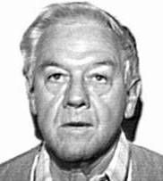* **DIPLOMATE EMERITUS** **ABFOFounding Member**

**DECEASED**

**Certificate 001**

## EDWARD D. WOOLRIDGE, JR., D.D.S.

Dr. Woolridge is a Charter Member of the ABFO and became a Diplomate of the ABFO in 1976. He was a member of the Board of Directors from 1976 to 1979 and from 1985 to 1988. Dr. Woolridge was the Chairman of the Organization Committee from 1974 to 1976. He was the Chairman of the Examining Committee from 1976 to 1979 and chairman of the Credentialing Committee from 1976 to 1977. He has also been the Chairman of the Nominating Committee in 1988. He was the Chairman of the AAFS Odontology Section from 1974 to 1975 and Secretary of the Section from 1972 to 1973. He is currently the Consultant to the Office of the Surgeon General. His commitment to the Board has been instrumental in its growth and development.

06/04

**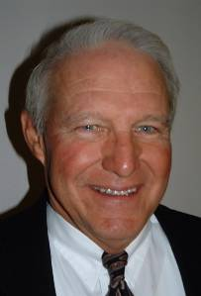 ABFO Founding Member**

**Certificate 002**

## RICHARD R. SOUVIRON, D.D.S.

Dr. Souviron became a Diplomate of the ABFO in 1976. He is currently a member of the Board of Directors. Dr. Souviron was a member of the Credentialing and Examination Committee from 1978 to 1985 and Chairman from 1980 to 1985. He was President of the ABFO from 1987 to 1988, Vice President from 1986 to 1987 and Secretary/Treasurer from 1984 to 1985. He has been a member of the Bite Mark Standards Committee and the Body Identification Guidelines Committee. Dr. Souviron was the AAFS Odontology Section Chairman in 1974 and was appointed to the Forensic Sciences Foundation from 1977 to 1979. He is the Chief Forensic Dentist for Dade County, Florida, and is a Forensic Consultant to numerous crime labs and police agencies throughout the State of Florida. He has served five years in the Ethics Committee of the East Coast Dental Society and the Florida Bar Grievance Committee, 11th Judicial Circuit.

*08/92*

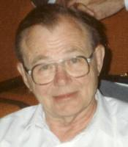 **DIPLOMATE EMERITUS** **ABFOFounding Member**

**First ABFO President**

**Certificate 003 DECEASED**

## CURTIS A. MERTZ, DDS

Dr. Mertz was born near Hallettsville, Texas. He was proud that his father was a “true cowboy” and, with his mother worked on many ranches in central Texas. Curtis attended The University of Texas in Austin and through a family friend was given the job of private secretary to the President of the University, while maintaining his student status. When he applied to attend dental school, the one school in Houston had a full class. He finally found a place in a class at the Ohio State University Dental School. After graduation from Ohio State, Dr. Mertz started an oral surgery residency at the Cleveland Clinic and Hospital. After the first year there were some changes in management and clinic directors and the clinic required that the residency staff be reduced. About that time Dr. Mertz had been offered a practice in Ashtabula, Ohio. He had completed about eighteen months of his surgical training and, unfortunately never got to finish the other six months to become board eligible as an oral surgeon. In Ashtabula, Dr. Mertz did general dentistry, exodontias and was asked to join a hospital staff. After this affiliation he did almost the entire maxillofacial trauma that occurred in the northern Ohio area. At this same time he began to add various dental specialists to his practice. At first these were part time, but eventually his practice included all the specialties of dentistry, except oral pathology. The clinic had fourteen dentists and multiple hygienists and dental assistants. The clinic operated for over twenty five years until he began to think about retirement. He then sold the practice. Along the way with the large practice he also started a medical and dental supply company which served northern Ohio and Eastern Pennsylvania. He closed this company a few years after selling the dental practice. The ABFO, AAFS and the Odontology Section all benefited and progressed in some measure due to his leadership. Dr. Mertz had a way to quickly get to the root of a problem or a financial situation based on his many years as chief executive officer of his large and successful group practice. Some individuals thought he was a little forceful and blunt, but the problems and situations were quickly and properly handled and you knew where you stood when the decision was made. You usually were also told the reasons why the decision was made. Dr. Curtis Mertz had the habit of eating small cigars. He said “smoking is bad for you but I need the roughage!” He suffered type I diabetes (insulin dependent) for over fifty years and was in excellent health and control.

01/06

**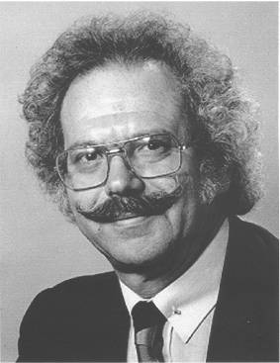 DIPLOMATE EMERITUS** **ABFOFounding Member**

**Certificate 004 DECEASED**

## ARTHUR D. GOLDMAN, D.M.D.

Dr. Goldman is a founding member of the A.B.FO. He received his BS at the University of Rhode Island and his DMD from Tufts University School of Dental Medicine. Following graduation he had a general practice residency at Montefiore Medical Center in New York City. Dr. Goldman served in the U. S. Army in Germany and South Korea from 1950 to 1953. Dr. Goldman practiced general dentistry from 1957 to 2002. Dr. Goldman has had post graduate studies at the Armed Forces Institute of Pathology, U.S. Army Institute of Dental Research, New York University, Columbia University and Tufts University. Dr. Goldman has held appointments at the New York City Medical Examiner, Rockland County Medical Examiner and Westchester County Medical Examiner officers. Dr. Goldman has held teaching positions as an attending at Montefiore Medical Center, scientist in residence at Herbret Lehman College, and assistant clinical professor Albert Einstein Medical Center, Columbia University Dental School and New York University. He is past president of the ABFO and the AAFS. Dr. Goldman has lectured on forensic odontology and child abuse nationally and internationally.

01/06

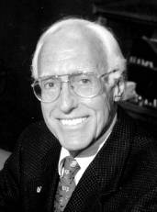**DIPLOMATE EMERITUS** **ABFOFounding Member**

**Certificate 005 DECEASED**

## GERALD L. VALE, D.D.S., JD

2005 marked the 57th year of an extraordinary career in dentistry for Dr. Vale.

After graduating from dental school at age 21, he entered U.S. Public Health Service, where he took a general practice residency and practiced general dentistry for four years. He then earned a master’s degree in orthodontics and practiced that specialty for 18 years in Hollywood, California. During that time he also earned degrees in public health and law. He subsequently served as Chief Public Health Dentist for Los Angeles County, Vice President of the Dental Board of California and Interim Dean at the USC School of Dentistry. A charter member of ABFO, he became a diplomate in 1976 and president of ABFO in 1984. He has served on the Board of Directors, the Credentialing, Ethics, and Bylaws Committees and was Chair of the Research Committee in 1984. Dr. Vale also chaired the committee that wrote the initial draft for the first bitemark guidelines. In addition, he was a member of the ad hoc committee for guidelines on body identification. Dr. Vale was named Distinguished Fellow of the American Academy of Forensic Sciences in 2004.

01/06

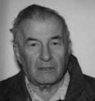 **ABFO Founding Member**

**DECEASED**

**Certificate 006**

## STANLEY M. SCHWARTZ, D.M.D.

Dr. Schwartz received his dental degree from Tufts Dental School in 1946. He spent three years in the Navy from 1946 to 1948.He then started a private practice in Boston. He later joined Tufts Dental School in 1970 and has been a member of the Faculty at Tufts until 1994 as a full Professor and is now a Professor Emeritus at Tufts in Oral Pathology. Dr. Schwartz has a number of teaching appointments including Harvard University Dental School, New England Hospital and Addison Gilbert Hospital. Dr. Schwartz has had 24 scientific articles published. He has lectured extensively throughout the United States on Oral Pathology, Oral Diagnosis, Radiology, Forensics, Child Abuse and Oral Medicine. Dr. Schwartz has been a Forensic Dental Examiner in Massachusetts since 1975. Dr. Schwartz has served the American Board of Forensic Odontology in many offices including President. He is a Board Diplomate of The American Board of Oral Medicine. He is currently serving in the U.S. Coast Guard Auxiliary as Flotilla Commander.

05/02

**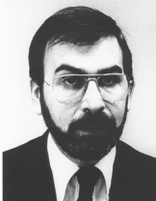 ABFO Founding Member**

**Certificate 007**

## LOWELL J. LEVINE, D.D.S.

Dr. Lowell J. Levine is a forensic scientist and Co-Director of Operations for the New York State Police Forensic Sciences Unit. After receiving a Doctor of Dental Surgery degree from New York University In 1963 he served two years of active duty as a dental officer in the US Navy and recently retired from US Naval Reserve as a Captain. He has served as President of the American Academy of Forensic Sciences, the Forensic Sciences Foundation and the American Board of Forensic Odontology. He has testified as an expert witness in celebrated cases nationwide. Including that of serial murderer Theodore Bundy as well as in federal courts, court marshals and committeesof the Congress of the United States. He has established on international reputation for his participation in the identification of Nazi war criminal Joseph Mengele. Assisted in the investigation by the Commission on the Disappeared of Argentina and most recently has served asa member of a team that went to Ekaterinburg, Russia, to examine remains of Tsar Nicholas II and his family. He has also served as a consultant to the Philadelphia Special Investigation Commission investigating the MOVE conflagration and US Army's Central Identification Laboratory identifying MIAs of Vietnam. He participated in the medicolegal investigation of the sailors killed on the USS Stark (EFG-31) as well as the Select Committee on Assassinations of the US House of Representatives which investigated the assassination of President John F. Kennedy. In addition to training scientists in Indonesia, Panama, Costa Rico, Ecuador and other countries forvarious governments and agencies he has published numerous scientific papers and lectures throughout the United States and internationally. He was instrumental in developing the annual NYSP Col. Henry F. Williams Homicide Seminar. The Homicide Seminar will hold its ninth meeting this year and attendees are from throughout the USA, Canada, Belarus, Russia, Scotland and England. Our fourth annual NYSP Sex Offense Seminar was recently host to 170 attendees from throughout New York State. Dr. Levine brings his expertise to dead and living victims of abuse. He recently received Hobart College’s Medal of Excellence as a distinguished alumnus.

06/04

**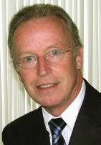 ABFO Founding Member**

**Certificate 008**

## ROBERT DORION, D.D.S.

Dr. Dorion received a B.Sc. from St. Francis Xavier University in 1968 and a D.D.S. from McGill University in 1972. This founding member of the ABFO has served as President in 1985-86 and held various positions on the Ethics, Certification and Examination, Bitemark Evidence and Patterned Injuries, and Research Committees and contributed to Bitemark Workshop #3, #4, #5, #6 and #8; he has held appointments/lectured at the University of Montreal, Laval, and McGill, the Canadian Police College (RCMP), Federal Bureau of Investigation (FBI), National Crime Information Center (NCIC) Dental Task Force, (CPIC) Advisory Committee and the Child Abduction and Serial Killer Unit. In 2002 he received an «exceptional service in the public interest » award from the FBI director. In 2004 as assistant professor inaugurated the first forensic dentistry internet course for McGill University’s Faculty of Dentistry and the Laboratoire des science judiciaries et de médecine légale, Ministry of Public Security for Quebec. He has served as Director of forensic dentistry for the latter since 1973. He become a member of the American Academy of Forensic Sciences in 1975, Fellow in 1977, received the Distinguished Fellow award in 2002, the Lester Luntz Award in 2005 and the Reidar Sognnaes Award of Excellence in 2006, a member of the Board of Directors (2007-2010) and Executive Committee (2008-2009). He has held various posts with the Canadian Society of Forensic Science since 1972 including President in 1978-79 and Fellow in 1997. He is Fellow of L’Académie Dentaire du Québec, and the American College of Dentists. As Research Assistant Professor, Dept of Oral Diagnostic Sciences, School of Dental Medicine, SUNY at Buffalo has contributed to bitemark research and literature. He has served on the Editorial Board of the Journal of the Canadian Society of Forensic Science, the Journal of the Canadian Dental Association, and Consultant to the Law Reform Commission of Canada. Dr. Dorion has researched, lectured and published extensively in forensic dentistry and edited the first stand-alone book on *Bitemark Evidence*.

09/06

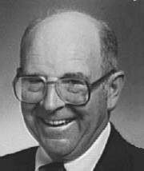 **DIPLOMATE EMERITUS**

**ABFO Founding Member**

**Certificate 009 DECEASED**

## PAUL G. STIMSON, D.D.S., M.S.

Dr. Stimson is Professor and Vice Chairman of the Department of Oral Diagnostic Sciences at the University of Texas Health Sciences Center at Houston, Dental Branch. He holds board certification in Forensic Odontology and Oral Pathology. He is the consultant in forensic odontology to the Harris County Medical Examiner. He has been this consultant for over twenty years. He has lectured at the Armed Forces Institute of Pathology in the Forensic Dentistry Course since 1968. He is on the faculty and serves as course consultant for the Southwest Symposium on Forensic Dentistry during their last nine symposiums. He was co-editor of the Dental Clinics of North America issue directed to Forensic Dentistry. He has served in the offices of the American Society of Forensic Odontology from secretary treasurer to president. His services to the American Board of Forensic Odontology include board member, secretary, treasurer and president of the Board. He was recently appointed parliamentarian to the ABFO. Dr. Stimson has many publications and presentations in the field of oral pathology and forensic odontology. He has lectured in the United States, Canada, Mexico, England and the Scandinavian countries. He has testified in bite mark homicide cases, malpractice cases, and forensic dental identifications for both the prosecution and the defense. He has also consulted

on many personal injury cases. He recently did the necessary dental identifications in the Phillips Refinery explosion and fire in Pasadena, Texas. He serves presently as consultant in oral pathology to M. D. Anderson Cancer Center and hospital and Veterans Administration Hospital in Houston.

06/04

**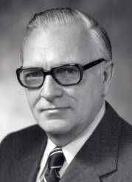 ABFO Founding Member**

**Certificate 010 Certified 1976-Retired 2000**

## DAVID B. SCOTT, D.D.S. DECEASED

Born in Providence, Rhode Island, he received his AB from Brown University in 1939 and his DDS in 1943 from Baltimore College of Dental Surgery, University of Maryland. in 1944, he was awarded an M.S. from The University of Rochester where he was a Carnegie Fellow in dental research. Dr. Scott has been a member of many professional organizations, including the American Association for Dental Research, and the International Association for Dental Research of which he is a past president. He was a fellow of the American College of Dentists, and the American Academy of Forensic Sciences. He has also served as a consultant to various scientific organizations, and has been a member of the board of directors of the ABFO. Dr. Scott was awarded honorary doctor of science by the Medical and Dental College of New Jersey in 1979, and the Louis Pasteur, Strasbourg, France in 1981. The recipient of numerous other awards, he received the Arthur S. Flemming Award in 1955, which is presented annually to 10 outstanding young persons in Federal service. Others honors include the Award in Forensic Odontology from the American Academy of Forensic Sciences, and the International Association for Dental Research Award for Research in Mineralization. Dr. Scott has authored 80 scientific publications, and has served on the editorial staff of three dental journals. Dr. Scott was appointed director of the National Institute of Dental Research in 1976 and Assistant Surgeon General in the U.S. Public Health Service, ending that career in 1981; which included 27 years of service in the NIDR. Dr. Scott was one of the earliest scientists to use electron microscope in a systematic study of the microstructure of enamel and dentin. His pioneering work in forensic dentistry is widely recognized. His contributions to the determination of personal identity and the estimation of chronologic age through evaluating dental features, as well as developing new laboratory techniques for studying dental evidence, has been of value to medical legal scientists.

06/05

*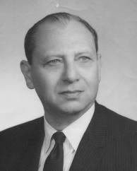* **ABFO Founding Member**

**Certificate 011 DECEASED**

## MANUEL M. MASLANSKY, D.D.S.

## A native of New York City, Dr. Maslansky attended New York University and received his dental degree from Columbia University in 1928. A native of New York City, Dr. Maslansky attended New York University and received his dental degree from Columbia University in 1928. He was a recipient of Columbia’s distinguished alumni award. He entered the army in 1940 as a lieutenant colonel and served in both European and Pacific theaters and later became national vice commander of the Jewish War Veterans. He was the founder and president of the dental section of the Westchester Academy of Medicine. Dr. Maslansky held numerous professional and community positions including chief of oral surgery at Grasslands Hospital, forensic consultant to Westchester County medical examiner, the directorship of oral surgery at St. Agnes Hospital in White Plains, clinical professorship at Columbia University, director emeritus of Westchester Medical Center, past president of the Ninth District Dental Society in Westchester, chairman of the Westchester Chapter of the March of Dimes, member of the executive board of the American Cancer Society, chairman of the Rotary International Committee of White Plains, president of the White Plains Rotary and member of the President’s Council for the College of White Plains. Dr. Maslansky was founder of the Israel Dental School at Hebrew University. He died at the age 77 in November 1980.

01/05

*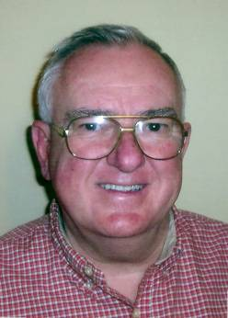* **ABFO Founding Member**

**Certificate 012 Certified 1976- Retired 1995**

## GEORGE T. WARD, D.D.S.

Dr. Ward graduated from the University of North Carolina School of Dentistry in 1964. He served as a dentist in the U. S. Public Health Service, assigned to the U. S. Coast Guard, from 1964 to 1992. Dr. Ward is a founding member of the ABFO becoming a diplomate in 1976. Dr. Ward was vice president of the ABFO from 1976 to 1979. He retired from the ABFO in 1997.

01/05

*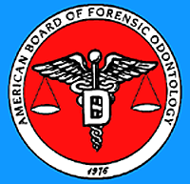*

**Certificate 013 REVOKED**

JOHN P. WILLIAMS, D.D.S., M.S.

**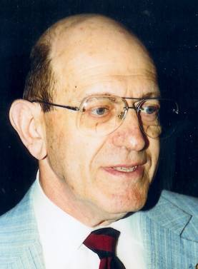**

**Certificate 014 DECEASED**

## LESTER L. LUNTZ, D.D.S.

Dr. Lester Luntz was the co-author (with his wife Phyllys) of the first American textbook on Forensic Odontology in the United States, "Handbook for Dental Identification”. He founded the Odontology section of the American Academy of Forensic Sciences and co-founded the American Society of Forensic Odontology. Dr. Luntz was a Clinical Professor of Oral Diagnosis at the University of Connecticut School of Dental Medicine and an adjunct associate professor at the University of Pennsylvania School of Dental Medicine. For more than 20 years, Dr. Luntz served as a consultant to the Connecticut State Medical Examiner's Office and as Director of the Connecticut State Dental Association Dental Disaster Squad. He held the rank of Captain, Connecticut State Police Surgeon, for 24 years. He received the City of Hartford Award for Outstanding Service in 1971. He began practicing dentistry in 1947. He passed away in 1996 at the age of 72.

01/05

**

**Certificate 015 REVOKED**

DUANE T. DEVORE, D.D.S.

**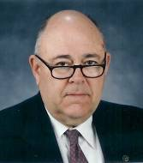**

**Certificate 016 RETIRED**

## EDWIN E. ANDREWS, D.M.D., M.E.D.

Dr. Andrews is a 1956 graduate of Syracuse University and was commissioned as a 2nd Lt. in the USAF. He entered pilot, navigator and bombardier training and flew B-47’s in SAC as a triple rated crewman before entering dental school. During his schooling, internship and residency, Dr. Andrews continued flying (C-119's, C-121's, T-33's and C-97's). He became an inter­national aircraft commander in the C-97 and flew worldwide. He is a Viet Nam veteran. After several years of private practice, Dr. Andrews taught at the University of Missouri at Kansas City and University of Okla­homa College ofDentistry (OU). While at OU, he successfully completed his boards in prosthodontics, becoming the first U.S. board certified doctor in the area ofmaxillo-facial prosthsdon­tics. Dr. Andrews started the Department ofProsthodontics at OU. Dr. Andrews became involved in forensics as a result ofa child bitemark case which required dental impressions of two live dogs. This case is in the Helprin Museum in NYC. From 1973 to 1984, Dr. Andrews acted as a consultant to the Oklahoma State Medical Examiner's office working on 50 to100 identifications per year. After leaving Oklahoma, he practiced for 15 years in Arkansas until his retirement in 2002but remains on staff as a deputy coroner for Benton County. Dr. Andrews is presently working with the office of the Ohio District Attorney on a case where a 3 day old infant was attacked by three dogs resulting in the infant's death. Dr. Andrews is a diplomate ofthe American Board ofProsthodontics, a Diplomate ofthe American Board of Forensic Odontology, Past President of the American Society of Forensic Odontology and Lt. Col. USAF, ret.

01/05

**

**Certificate 017 REVOKED**

JOHN BECKSTEAD, D.D.S..

**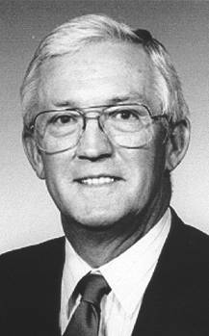**

**Certificate 018 DECEASED**

## HOMER R. CAMPBELL, JR., D.D.S.

Homer R. Campbell Jr., DDS, was an Associate Professor for the Department of Pathology at the University of New Mexico School of Medicine, a consultant for the New Mexico State Office of the Medical Investigator, and an advisor to the Armed Forces Medical Examiner at the Armed Forces Institute of Pathology in Washington, D.C. He was a member of the Association of Military Surgeons, the American Board of Forensic Odontology and the International Society of Forensic Odontostomatology. Dr. Campbell had been an active member of the American Academy of Forensic Sciences for over 40 years. Be became a Fellow in 1977. His long record of service to the Academy includes committee activities with the Odontology Section and service on the Academy's Long Range Planning, Internal Audit and Nominating Committees. He was the Odontology Section representative on the Academy Executive Committee from 1980 to 1983 and has served continuously since 1987 on the Editorial Board of the Journal of Forensic Sciences. He was Chairman of the Academy's 1986 Annual Meeting Program. He also has been a member of the Board of Trustees of the Forensic Sciences Foundation. In 1988 he served as the Chairman of the Academy’s Dele­gation to the USSR. Dr. Campbell has held the elected offices of Academy Treasurer, Vice President and was the Academy President from 1991 to 92. He is a distinguished fellow of the AAFS. Dr. Campbell was posthumously presented with the Lester Luntz Award by the Odontology Section of the AAFS on 02/23/2011

02/11

**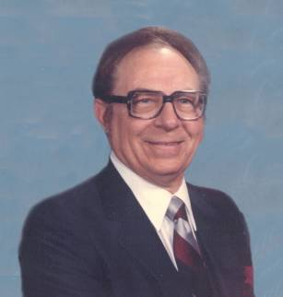**

**Certificate 019 DECEASED**

## EDWARD V. COMULADA, D.D.S.

Dr. Comulada was a native of Washington, DC. He was a graduate of Maryland University and Baltimore College of Dental Surgery. He was a member of the American Academy of Forensic Sciences, American Society of Forensic Odontology, Contra Costa Sheriff’s Posse and Diablo Valley Philharmonic. He played the violin.

01/06

**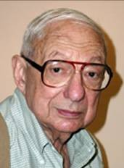**

**Certificate 020 DECEASED**

## B. KALMAN FRIEDMAN, D.D.S.

Dr. Friedman is a graduate of Hunter College receiving a BA in chemistry with honors of Phi Beta Kappa cum Laude. He received his dental degree from New York University College of Dentistry. He has been the chief consultant in forensic odontology for the Suffolk County Medical Examiner since 1961 and president of the Suffolk Society of Forensic Dentistry since 1989. Dr. Friedman has been a visiting attending at Long Island Jewish Medical Center since 1957. He is a clinical assistant professor in the Department of Oral Biology and Pathology at the State University of New York at Stony Brook. Dr. Friedman was a member D.S.S.N.Y. Mass Disaster Task Force. Dr. Friedman was the chief of the dental identification team for the TWA 800 Incident and was a member of the DMORT effort that worked both the Egypt 990 Incident in Providence, RI and WTC Incident in New York City. Dr. Friedman is a Fellow of the American Academy of Forensic Sciences and the American College of Dentists. Dr. Friedman has coauthored, A Web Base Real-Time Alert System for Secondary Responders, Journal of Emergency Management; summer 2003 and a full scale drill of a Hazmat Recovery Operation, Journal of Emergency Management, and fall 2003.

01/05

*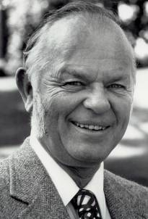*

**Certificate 021 DECEASED**

## WILLIAM S. GILES, D.D.S., MSD

Dr. Giles attended Santa Rosa Junior College, UCSF Dental School and received his

Masters from San Francisco State. He had a private dental practice in San Francisco and Burlingame. After retiring from private practice, he taught at the UCSF Dental School. He was a forensic odontologist and deputy coroner for San Mateo County. President of the American Board Forensic Odontology and a member of the American Academy of Forensic Science. He was a marine navigator in World War II. A member and president of the senior golf division of the Olympic Club, member of the Fountain Grove Country Club, and President of the UCSF Dental Alumni. Dr. Giles was an avid golfer; played a lot of bridge, loved music, art, and was a Giant's baseball fan.

01/05

**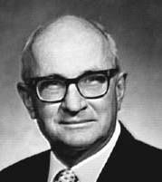 DIPLOMATE EMERITUS**

**Certificate 022 DECEASED**

## THOMAS C. KRAUSS, D.D.S.

Dr. Krauss is a 1955 graduate of Northwestern University Dental School. He served in the Army, stationed at Fort Riley, KS, ITF-7 Eniwitok Atoll in the Marshall Islands and Fitzsimons Army General Hospital, Denver. Colorado. Entering private general practice in 1960 in Grand Junction, Colorado. He moved to Phillipsburg, Kansas in 1977. He is a Fellow in the following: International College of Dentists, American Academy of General Dentistry (state president in 1987) and the American Academy of Forensic Sciences. As a member of the ASFO, he served in many capacities including president (1987). He became a diplomate of the ABFO in 1976. He was a past member of the planning, nominating, research (chairman)-1990), bylaws, and executive committees. He has served the ABFO as vice-president (1984) and president (1989). He was the bite mark workshop chairman when the bite mark guidelines were adopted and during his term as president, the body identification guidelines were adopted. A pioneer in the use of reflective ultraviolet photography, co-originator of the ABFO No. 2 Reference scale, and author of many scientific papers, he feels that the ABFO is the leader in the development of a scientific forensic odontology.

06/04

*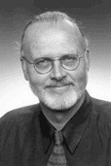*

Certificate 023 **Certified 1977- RETIRED**

GERALD F. PROHASKA, D.D.S., MS

1964 Forensic Dentistry Course; Southwestern Medical School; Dallas, Texas  
1965 Forensic Identification and Mass Casualty Team – First Marine Air Wing  
1967 Danang, Chulai, Quangtri - VietNam  
1975 Associated with OMI at the University of New Mexico Dept. of Pathology  
1976 Course – Armed Forces Institute of Pathology; Washington, D.C.:

Forensic Science  
1980 Course – University of California San Francisco: Bite Mark Identification  
1982 Naval Reserve – 2 weeks – Active Duty  
 U.S. Naval Hospital – Mass Fatality and Bite Mark Identification  
 Walter Reed Hospital – Mass Fatality and Bite Mark Identification  
1985 Naval Reserve Active Duty – AFIP – Washington, D.C.; Oral Pathology,

Bitemark and Identification   
1988 Retired from Forensic Odontology

**Degrees:**

1960 University of New Mexico – B.S.  
1964 Baylor College of Dentistry – DDS  
1969 University of Southern California – MS  
 Orthodontics and Oral Facial Biology  
1977 Diplomate of American Board of Orthodontics  
1977 Diplomate of American Board of Forensic Odontology  
2004 Re-certification – American Board of Orthodontics

06/05

**

**Certificate 024 RESIGNED**

JAMES D. PURVES, D.D.S.

*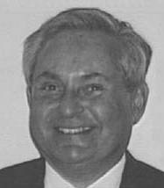*

**Certificate 025 RETIRED**

## NEAL R. RIESNER, D.D.S.

Dr. Riesner became a Diplomate of the ABFO in 1977. He has served

as a Director as well as a member of the ABFO Nominating Committee and the Continuing Education Committee. In 1955, he received his dental degree from the University of Pennsylvania. After completing his active duty tour in the Navy, He returned to the Graduate School of Medicine at the University of Pennsylvania for orthodontic training. He is a Scientist in Residence at Lehman College, Department of Anthropology and a member of the Metropolitan Forensic Team. He is a Fellow of the following: American College of Dentists, International College of Dentists, New York Academy of Dentistry and the AAFS. Currently, he is serving on the Board of governors of the Ninth District Dental society of New York State. He is a member of the Dental society of the State of New York, Council of Insurance (Chairman 1991), Chairman of the Insurance committee of the 9th District Claims (malpractice) Committee. He is the Chief Forensic Dentist for the Office of the Medical Examiner, Westchester county. He is also a CAPT (DC) USNR (Ret.). His supportive wife, Pat, is also his office manager.

06/04

**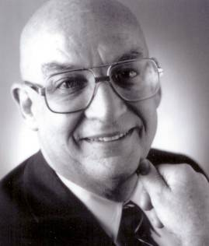**

**Certificate 026 DECEASED**

## ROBERT SIEGEL, D.D.S.

Dr. Robert Siegel was born in New York City on June 19, 1924. He received a BA from Brooklyn College, a BS from City College of New York and his DDS from New York University. He served in the United States Air Force from 1942 to 1945 as a meteorologist in India, Burma and China. Dr. Siegel was an assistant professor of bacteriology at NYU in 1953/54. He was a member of the San Diego Dental Society board. Dr. Siegel was active in forensic dentistry in the greater San Diego area from 1971 to his death on December 24, 1984. Dr. Siegel was in charge of the antemortem dental section during the identification process of the midair crash of Pacific Southwest Airlines (PSA) #182 in September of 1978. Dr. Siegel co-authored the first article in the *Journal* *of Forensic Sciences* on computerized dental identification procedures. Dr. Siegel was instrumental in developing the first state missing and unidentified persons (MUPU) central repository for dental records in the United States in California. Dr. Siegel is survived by his wife Paula Becker Siegel and three children: Jonathan Siegel, MD, Karen Siegel, PHD and Michael Siegel, MD.

06/04

***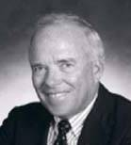* DIPLOMATE EMERITUS**

**Certificate 027 RETIRED**

## NORMAN D. SPERBER, D.D.S.

Dr. Skip Sperber is a practicing dentist in San Diego. He is the Chief Forensic Dentist for San Diego and Imperial Counties, and the Chief Forensic Dentist for the California Department of Justice's Dental Identification System and Missing/Unidentified Persons Unit. He was the dental team leader responsible to the San Diego Coroner in the 1978 San Diego Midair Collision. A 1996 NBC Monday night movie "Murder or Memory" detailed one of the cases that he investigated in Chicago. Dr. Sperber has conducted over 1500 forensic dental examinations and has testified in over 175 bite mark, ligature and other object marks, age determination and body identification cases in twenty states, from California to Maine and Florida to Washington. He was an expert witness/consultant in the Florida vs. Bundy case; in New York's "Preppie" murder case; the Jeffrey Dahmer serial murder case as it related to two Milwaukee patrol officers and many other high profile cases. He has written several articles for the FBI Law Enforcement Bulletin and has contributed several chapters on forensic dentistry to major private and government publications. Dr. Sperber lectures to many law enforcement organization and related groups, including the California Department of Justice and the San Jose State University's Criminal Justice Department on a regular basis. In 1998 he was designated a Distinguished Fellow of the American Academy of Forensic Science), one of only three forensic dentists to receive this highest honor.

06/04

**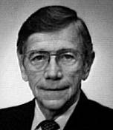**

**Certificate 028 DECEASED**

## S. MILES STANDISH, D.D.S.

A distinguished alumnus of Indiana University School of Dentistry, Prof. Emeritus S. Miles Standish(DDS '45, MS '56) had devoted more than 40 years of service to the University at the time of his retirement in 1988. During that time, Dr. Standish held many key positions at IUSD, including professor of Oral Pathology, Chairman of Oral Diagnosis/Oral Medicine, and Associate Dean for graduate and postgraduate education. A 13th generation direct descendant of Captain Myles Standish, he served in the U.S. Navy from 1945 to 1947 and in the U.S. Naval Reserve, Dental Corps until his retirement with the rank of Captain in 1983. He was a diplomate of the American Board of Oral and Maxillofacial Pathology, the American Board of Oral Medicine, and the American Board of Forensic Odontology; a fellow of the American Academy of Oral and Maxillofacial Pathology (AAOMP) and the American Academy of Forensic Sciences (AAFS); a member of the American Dental Association, Indiana Dental Association and component societies; a charter member of the American Society of Forensic Odontology and Indiana Society of Forensic Odontology (ISFO); and a past president of the AAOMP, the AAOMP's board, the ISFO, and the Organization of Teachers of Oral Diagnosis. He served as a consultant to, or as a member of the board of directors for, a wide range of national and state organizations including the American Cancer Society and the Indiana Medical History Museum. He held special appointments and received awards and honors too numerous to mention; chief among them was the AAFS Odontology Section Award he received in 1991. Dr. Standish made over 200 presentations, authored or contributed to 64 articles or published abstracts and 18 books including Oral Diagnosis/Oral Medicine (1969, 1971, 1978), Outline of Forensic Dentistry (1982), and both volumes of The Indianapolis (District) Dental Society - an Historical Perspective, 1878-1978 and 1979-2000 (1994, 2000). Dr. Standish earned a national reputation for his work as a forensic odontologist. During a murder trial in the 1970s, he gave testimony as an expert witness on bite marks. The suspect was convicted, largely on the basis of Dr. Standish's testimony. The trial established a precedent in Indiana for admission of bitemark evidence into a court of law and is cited as a landmark case in this state. Dr. Standish was appointed an honorary lieutenant colonel by the Indiana State Police for his work in forensic dentistry. 06/04

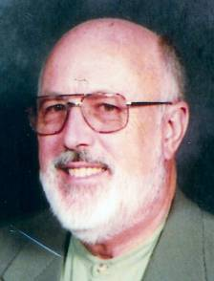 **DIPLOMATE EMERITUS**

**Certificate 029 DECEASED**

## JAMES D. WOODWARD, D.M.D., M.Ed.

Dr. Woodward retired from the active practice of dentistry in 1998, although continuing a part time relationship with the University of Louisville School of Dentistry as Professor Emeritus. This part time relationship has been with the Department of Prosthodontics and the Office of Admissions. Dr. Woodward came to the University of Louisville School in the spring of 1981 as a Professor of Prosthodontics. While teaching, he maintained a private practice in prosthodontics and as a consultant in the fields of prosthodontics and forensic odontology in Kentucky, Texas and Oklahoma. Dr. Woodward earned his DMD degree at the University of Louisville and attended undergraduate school at Western Kentucky University and the University of Louisville. Dr. Woodward did graduate work at the University of Texas Dental Branch Houston where he received a certificate in prosthodontics in 1974. He received his M.Ed. degree in Higher Education Administration from Central State University at Edmond, Oklahoma in 1977. He returned to his home state as Professor of Prosthodontics at the University of Louisville. Dr. Woodward has twenty-three publications in professional journals and textbooks. He was honored with the Distinguished Teaching Professor Award at the Dental School at the University of Louisville and was chosen "Outstanding Career Teacher" by the Oral Roberts University School of Dentistry Alumni Association. Dr. Woodward was involved with forensic dentistry for many years, (since 1969). He has given numerous C.E. courses on identification of the decreased and participated in many training programs for coroners, medical examiners, and police. Dr. Woodward has made hundreds of dental identifications on burn victims, skeletons, decomposed bodies, and fragmentation cases from air plane crashes. The most publized cases were the 27 victims, of the Carrolton Bus Crash in 1988 and the 27 teenage boys in Houston mass murder case in 1973.

01/05

**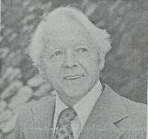**

**Certificate 030 DECEASED**

## REIDAR F. SOGNNAES, D.D.S., M.S., Ph.D.

Dr. Reidar Sognnaes was born in Bergen, Norway, on November 6, 1911, the youngest of six sons. He received his dental education at the University of Oslo before coming to America in 1938 as an intern at the Forsyth Dental Infirmary for Children in Boston. He continued on as a Carnegie Dental Fellow at the University of Rochester School of Medicine and Dentistry in New York where he earned a Master of Science Degree in Physiology and a Ph.D. in Pathology in 1941. Following World War II, in which he served as a captain in the Royal Norwegian Air Force, Dr. Sognnaes accepted a teaching position at Harvard University. There he occupied an endowed chair as the Charles A. Brackett Professor of Oral Pathology and eventually served as the Associate and Acting Dean of the Harvard School of Dental Medicine between 1952 and 1960, when he came to UCLA. Dr. Sognnaes guided the founding of the UCLA School of Dentistry which was established in 1960. He served as Dean until stepping down in 1968 to continue his research as Professor of Anatomy and Oral Biology in the UCLA Schools of Dentistry and Medicine. A world renowned scholar in his field, Dr. Sognnaes' most recent research established him as a leader in forensic dentistry. He is perhaps most well ­known for his examination of George Washington’s dentures. Dr. Sognnaes disproved the theory that America's first president wore wooden teeth. He is also credited with verifying the remains of Adolf Hitler and his infamous associate, Martin Bormann, through examination of classified American and Soviet dental records. Dr. Sognnaes' early research focused on hard tissue pathology and calcifi­cation in biological systems, and that research placed him in an elite circle of international scholars. He published more than 300 articles in his lifetime. Among other achievements, Dr. Sognnaes was the first dentist elected a Fellow of the American Academy of Arts and Sciences, and the first dentist elected to senior membership in the Institute of Medicine of the National Academy of Sciences. He held honorary membership in several national and foreign professional societies and served as President of the International Association for Dental Research, the American Institute of Oral Biology, and the International Society of Forensic Odontostomatology. A man who was never idle, Dr. Sognnaes pursued his work until a heart attack claimed his life on September 21, 1984. He accomplished his dream of founding the UCLA School of Dentistry, designing its quarters and establishing it as an integral part of the UCLA Center for Health Sciences. He laid the groundwork for the UCLA Dental Research Institute and started the Venice Dental Clinic in Los Angeles which provides low cost dental care to children and adults.06/04

*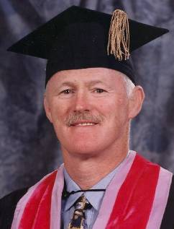*

**Certificate 031 Certified 1977- Retired 2/07**

## LAURENCE S. CHEEVERS, D.D.S.,

Dr. Cheevers was born in Galway, Ireland in 1943. His early childhood education was by the Jesuits and Vincentian Fathers. He graduated in dentistry from University College Dublin, 1968. During his university days he competed internationally in Rugby, Boxing, and Track and Field. Dr. Cheevers has practiced in England, South Africa (Cape Town) prior to immigrating to Canada. He started practice in Vancouver in 1972 and became involved in Coroner’s Office shortly there after. Dr. Cheevers was Chief of Forensic Odontology for British Columbia from 1973 to 1998. During his tenure he was involved in over 2500 cases involving every facet of forensic dentistry. Dr. Cheevers has been awarded Fellowships by the American College and the International College of Dentistry. He has been recognized by the Canadian Dental Association and the British Columbia Dental Association for his community and personal contribution on behalf of the profession.

01/05

**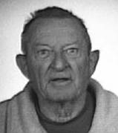**

**Certificate 032 DECEASED**

## EDWARD R. BULPITT JR., D.D.S.

Dr. Bulpitt was born in Loma Linda, CA on October 3, 1914, and raised in Bishop, CA. He attended USC for both his undergraduate studies as well as dental school. He graduated from USC School of Dentistry in 1939, where he was president of his graduating class. He started his practice in Bishop, CA in early 1940 as the only dentist in the Inyo valley. In 1953 Dr. Bulpitt volunteered for service in the Korean War, going as a major in the Air Force. He received the Air Force Medal of Honor for his service. After returning from Korea Dr. Bulpitt studied forensic odontology at Walter Reed Hospital (AFIP) in Washington, DC. During his career he preformed in excess of 300 dental identifications. Dr. Bulpitt was an active member of the Bishop Rotary Club, Elks Lodge, Veterans of Foreign Wars Post and the medical staff of the Northern Inyo Hospital.

01/05

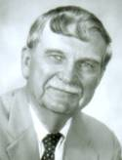

**Certificate 33**

## L. THOMAS JOHNSON, D.D.S. Certified 1977 – Retired 02/2012

Active in Forensic Odontology since 1961 and a Diplomate of the ABFO since 1977, he is a Fellow of the AAFS, the International and the American College of Dentists. An Associate Medical Examiner for Milwaukee County since 1961, he played a significant role in establishing bite mark case law in Wisconsin with State vs. Stinson (1985) and in Illinois with People vs. Holmes (1990). He is certified as a Senior Crime Scene Analyst by the International Association for Identification and has served as a consultant to both the Crime Laboratory Bureau and the Criminal Investigation Division of the Wisconsin Department of Justice. Past and present positions held are: member of the Board of Governors of the ASFO, ABFO Board of Directors, Chair of the Certification and Examining Committee, the Mass Disaster Committee and the Continuing Education Committee and currently is President of the Wisconsin Division of the International Association for Identification. He developed and chaired both the 1996 and 2001 joint ABFO/ADA highly successful symposia on Forensic Dentistry. He has served as the Secretary, Vice President. President-Elect and President of the ABFO. A professor of pathology at Marquette University, he became the University’s first professor of Forensic Dentistry in 1988.

06/04

**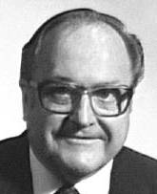**

**Certificate 034 DECEASED**

## WILLIAM E. ALEXANDER, D.M.D.

Dr. Bill Alexander practices forensic odontology exclusively. He retired from an oral and maxillofacial surgery group practice. Undergraduate schools attended are University of Oregon, Dartmouth College, University of California, and Multnomah College. In 1950, he earned a DMD degree from Oregon Health Sciences University and was certified by the Armed Forces Institute of Pathology in 1969. Bill is past president of the Lane

County District Dental Society, the Oregon Dental Association and the Oregon Society of Oral and Maxillofacial Surgeons. He is a fellow of the American and International Associations of Oral and Maxillofacial Surgeons, the American and International Colleges of Dentists, American Academy of Forensic Sciences and is a member of the Northwest Association of Forensic Scientists and the International Association for Identification. Bill is a Diplomate of the ABFO since 1977 and has held the offices of secretary, treasurer, vice president, president elect and president of the ABFO. Dr. Alexander is a deputy medical examiner for Lane County and the State of Oregon, an assistant professor of pathology and forensic studies at the Oregon Health Sciences University and coordinates the Pacific Northwest Forensic Study Group which is sponsored by OHSU. His wife’s name is Dorothy and they have three grown children, Scott, Wendy and Todd.

06/05

**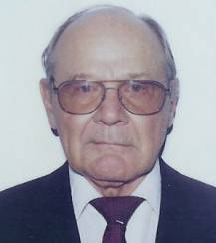**

**Certificate 035 Certified 1977- Retired**

## WILLIAM P. WEBSTER, D.D.S., MS

William P. Webster, D.D.S., M.S. obtained his D.D.S. in 1959 and his M.S. in general pathology in 1967 both from the University of North Carolina at Chapel Hill. He became a member of the North Carolina Medical Examiner’s System in 1968. He stayed at UNC throughout his medical/dental career. He taught dental students, nursing students and physical therapy students general pathology and forensic medicine. He obtained the rank of full professor in the School of Medicine in 1971 and in the School of Dentistry in 1973. Dr. Webster’s major research area was in the field of thrombosis and hemorrhage, and published more than 100 articles in the basic science of thrombosis and hemorrhage and the management of patients with bleeding disorders.

06/04

**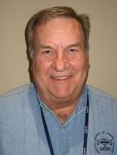**

**Certificate 036**

## WILLIAM L. FARRELL, D.D.S.

No biographical information or photo submitted.

06/06

**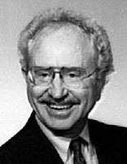**

**Certificate 037 RETIRED**

## JIM B. HALES, D.D.S.

Dr. Hales completed his undergraduate studies in 1961 at Oklahoma University. He was a medical laboratory technician in the U.S. Army and was stationed in Japan from 1957 to 1960. Following the Service he returned to school at Washington University in St. Louis and graduated with his DDS degree in 1965. During his dental education he was class president in his sophomore, junior and senior years. He had a general practice in Irving, Texas from 1965 to 1990 when he sold that practice and set up a portable dental practice and services families and nursing homes in the community of Argyle, Texas. He received his AFIP training in 1973 and is the Chief Dental Consultant for the Dallas County Medical Examiner. He participated in the identification of the victims of the Delta #191 crash in August of 1985. Dr. Hales hopes to sell his Argyle practice and move to Alaska where he plans to set up a similar portable dental practice but also do more fishing, hiking, bicycling, nature exploration, skiing, boating, flying, and Bible study. He has two children, both of whom have or are attending Texas Tech. University.

06/04

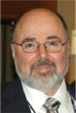

**Certificate 038**

## EDWARD E. HERSCHAFT, D.D.S., M.A.

Dr. Herschaft became a Diplomate of the ABFO in 1978.  He completed undergraduate studies at Queens College of the City University of New York in 1965.  Receiving his dental degree from West Virginia University in 1970 and certification in Oral and Maxillofacial Pathology from the Medical University of South Carolina in 1975, he was conferred the M. A. Degree in Curriculum and Instruction from the University of New Orleans in 1978.  Dr. Herschaft has served on the faculties of the LSU School of Dentistry and the Medical University of South Carolina, College of Dental Medicine.  He retired from the latter institution as Professor Emeritus in 2003 and is currently Professor of Clinical Sciences at the UNLV School of Dental Medicine in Las Vegas, Nevada.  He has held various offices in professional organizations including:  ABFO (Board of Directors, Bite Mark Analysis Guidelines Committee Member, and Ethics Committee! Member and Chairperson, Treasurer, Vice-President); ASFO (Board of Governors, Treasurer, President-Elect, President, Editor - Forensic Odontology Workbook, 4th edition); AAFS ( Odontology Section program Chairperson, Secretary, Chairperson, Academy Board of Directors, Vice-President); ADEA (Council of Faculties Member representing MUSC, Council of Faculties - Chairperson); OKU (Zeta Eta Chapter - President, Psi Omega Chapter - Charter Member, Vice-President.)  Dr. Herschaft is a Diplomate of the American Board of Oral Medicine and a Fellow of the American College of Dentists, AAFS and the Pierre Fauchard Academy.  He has held several forensic dental consultant ships with state and local law enforcement agencies in South Carolina.  He currently serves as a consultant to the Clark County Coroner's Office in Las Vegas, Nevada. Honors include: OKU, Phi Kappa Phi, Outstanding Clinical Lecturer - ASDA, Distinguished Associate in Forensic Odontology - South Carolina Law Enforcement Division, Odontology Section Award - AAFS, Literary Award - ASFO.  Dr. Herschaft has two sons and is active in volunteer work and enjoys motorcycle riding.

06/04

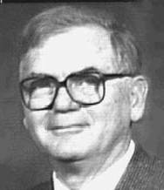

**DIPLOMATE EMERITUS**

**Certificate 039 RETIRED**

## HARRY H. MINCER, D.D.S., PhD

Dr. Mincer is a native of Memphis, Tennessee having attended public schools there. From the University of Tennessee he received his predental education, a DDS, and an MS and PhD in pathology. He is currently a Professor in the University of Tennessee Department of Biologic and Diagnostic Sciences of the College of Dentistry, and an Associate Professor in the Department of Pathology of the College of Medicine. Dr. Mincer also serves as Director of the Oral Pathology Division. He is dental consultant to the Shelby County Medical Examiner and formerly to the Tennessee State Medical Examiner. Dr. Mincer is a diplomate of the American Board of Forensic Odontology since 1978 and of the American Board of Oral Pathology.

06/04

**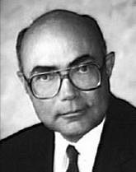**

**Certificate 040**

## RAYMOND D. RAWSON, D.D.S., M.A.

Dr. Rawson received his DDS from Loma Linda University in 1968 and his MA in physical anthropology in 1978 from the University of Nevada. He became a Diplomate of ABFO in 1978. He maintains a private dental practice in Las Vegas, he is Deputy Coroner and Chief Dental Examiner in Las Vegas, and since 1984 he is the Nevada State Senator for District 6. Dr. Rawson has received numerous research grants in a variety of health-related topics. He lectures extensively as well as teaching specialized courses dealing with criminal justice and forensics. He is recognized state-wide as a hard-working senator who is approachable and perceptive in meeting the needs of the people. He has served as Assistant Majority Leader and Chairman of Human Resources in Nevada as well as numerous positions nationally. His emphasis has been on budget reform, health care cost containment, and excellence and accountability in education. Ray and his wife, Linda, have seven children and five grandchildren.

12/01

*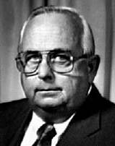*

**Certificate 041 Retired**

## DAVID R. SIPES, D.D.S., M.F.S.

Dr. David Sipes completed his undergraduate studies at Roanoke College in Salem, Virginia in 1956, receiving a Bachelor of Science degree in Biology. He received his DDS from the Medical College of Virginia in 1960.Dr. Sipes was the first Forensic Dentist in the United States to earn the degree of Master of Forensic Science which was

obtained from the George Washington University in 1981. Dr. Sipes is a Fellow of the American Academy of Forensic Sciences and became a Diplomate of the American Board of Forensic Odontology in 1978. He became a member of the American Society of Forensic Odontology in 1974. He was a private practitioner from 1960 until he retired from Dentistry in 1998. He currently serves as a consultant in Forensic Dentistry to the Office of the Chief Medical Examiner of the Commonwealth of Virginia. He has lectured on Forensic Dentistry at the FBI Academy in Quantico, Virginia, the U.S. Air Force Investigators School, the Northern Virginia Criminal Justice Police Academy and the D.C. Metropolitan Police Homicide Investigators School. Dr. Sipes has served the ABFO as a member of the Planning Committee, Chair of the Forensic Organization Subcommittee, member and Chairman of the Credentialing/Examining Committee, Chair of the Ethics Committee, Board of Directors, Treasurer, Secretary, and Vice-President, President-Elect and President. In 2002, Dr. Sipes was awarded the Odontology Section's Lester Luntz Award for his service to the field of Forensic Odontology.

06/04

*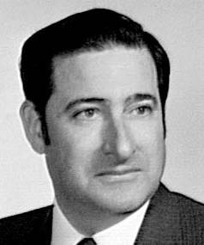*

**Certificate 042 DECEASED**

## HASKELL ASKIN, D.D.S.

Haskell Askin was born in Buffalo, New York on January 12, 1936. His pre-dental studies were taken at the University of Detroit and he received his D.D.S. degree from Temple University School of Dentistry in 1959. He practices general dentistry in Brick Town, New Jersey and is a dental consultant for numerous agencies including the Philadelphia Medical Examiner's Office and the New Jersey State Department of Law and Public Safety. His hospital affiliations include the Medical Center of Ocean County, Point Pleasant, New Jersey and Kimball Medical Center in Lakewood, New Jersey where he was a long term member of the Credentials Committee and former Chief of the Dental Staff. He is a consultant to the New Jersey State Board of Dentistry and has served as a member of the New Jersey Association Peer Review Council. He is a Fellow of the American Academy of Forensic Sciences, a past president of the New York Society of Forensic Dentistry, and past president of the American Society of Forensic Odontology.

12/92

*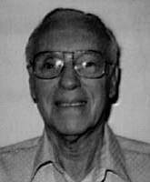*

**Certificate 043 DECEASED**

## GEORGE FURST, DDS

Dr. George Furst is a native son of New York City. He received his dental degree from the University of Pennsylvania School of Dentistry in 1942 and served in the United States Public Health Service from 1942 to 1946. Dr. Furst was in private practice from 1946 to 1983. Forensic dentistry became his avocation when he was appointed forensic odontology consultant to the Medical Examiners’ office for the Borough of Queens in New York City and Rockland County in New York State. Dr Furst was a well know forensic dentist and made many contributions to forensic dentistry both locally and nationally. In 1974 Dr. Furst presented a paper at the AAFS meeting on “Prosthetic Identification Markings”. Because of this paper and through his efforts 21 states now have mandatory laws requiring markings on all removable dental prosthesis. In 1980 he became a diplomate of the ABFO. He served as editor of the ASFO Newsletter for 11 years (1985 to1996) being name editor emeritus in 1996. Dr Furst received the Life Time Achievement Award from the odontology section of the AAFS in 1996 for his dedicated service as editor of the ASFO Newsletter. Dr. Furst has lectured at Columbia University Schools of Dentistry and Medicine, NYU School of Dentistry, Indiana Dental Association, Greater New York Meeting on forensic odontology. In 1992 Dr. Furst started a Saturday morning session of the odontology section of the AAFS which was primarily for new members of the AAFS to present their first paper. This Saturday morning session became know as “The Furst Word Society”. Upon retirement and moving to Arizona he served as a mentor to Dr. John Piakis. Dr. Furst could tell a joke like no one else. His moaning audience never stopped George. George’s wife Geri survived him and is alive and very active, living in Sun City Arizona.

06/04

**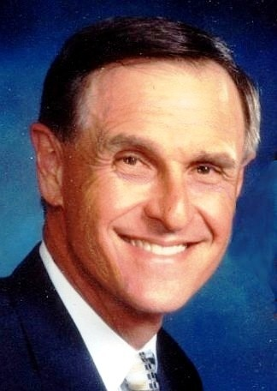**

**Certificate 044**

## EDWARD J. PAVLIK, D.D.S., M.S.

Dr. Pavlik received his dental degree in 1966 from Northwestern University Dental School and masters degree in science with a certificate in orthodontics from Northwestern University, Department of Orthodontics in 1968, and is board certified by the American Board of Orthodontics. He started forensic activities in 1967. Dr. Pavlik was consultant, Deputy Coroner, Chief of Forensic Dentistry, and dental identification team leader for the Cook County Coroner’s Office from 1967-1976. From 1971-1979 Dr. Pavlik was Special Deputy Sheriff, Identification Section of the Lake County Indiana Sheriff’s Office. He became board certified by the American Board of Forensic Odontology in 1980. Dr. Pavlik received a board certification from the National Board of Forensic Dentistry in 1981. Since 1976 he has been forensic odontologist, consultant, lecturer in criminalistics, Deputy Sheriff and Chief of Forensic Sciences for the Cook County Sheriff’s Police, and retired after 25 years of service in 2001. From 1977 through 1988 he had been chief consultant, lecturer in forensic odontology and dental identification team leader for the Cook County Medical Examiner’s Office. From 1967 through 2001 he was a consultant and lecturer in the criminalistics section of the Chicago Police Department. From 1979 through 2005 Dr. Pavlik lectured in forensic dentistry and malpractice avoidance at the University of Illinois Chicago Campus. Since 1996 Dr. Pavlik has served as chief consultant and lecturer in forensic odontology for the Will County Coroner’s Office. He is also a consultant and lecturer for the Will County Sheriff’s Police Criminal Investigation Division. He has also been a malpractice consultant for the Illinois Department of Financial and Professional Regulation. In Illinois he has written two major pieces of forensic odontology legislation. He lectures in the fields of bite marks, mass disasters, pre-reconstructive orthodontics and malpractice avoidance, and is currently a featured speaker with the American Dental Association Seminar Series. He headed the dental identification teams in the John Wayne Gacy mass murder case (33 victims) and the American Airlines Flight 191 air crash (274 victims). Dr. Pavlik has received the “Excellence in Law Enforcement Award” from the office of the Cook County State’s Attorney, an “Award of Merit” from the Cook County Board, and a letter of commendation from the Office of the Attorney General of the State of Illinois. Dr. Pavlik serves as a consultant for the American Dental Association Council on Dental Practice in forensic odonotology. He was elected Dentist of the Year in 1986 by the American Association of Forensic Dentists.

11/10

*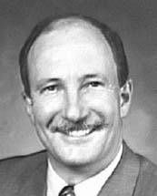*

**Certificate 045**

## JOHN W. BLAIR, D.D.S.

Dr. Blair graduated with a DDS in 1969 from the University of Alberta and has been in private practice since graduation. He became a diplomate of ABFO in 1980 and a fellow of AAFS in 1986. Dr. Blair is a consultant in Forensic Odontology to the Medical Examiner of Alberta, the Calgary Police Services, Lethbridge Police Department, Regina City Police, the Chief Coroner of Saskatchewan and the Royal Canadian Mounted Police. He is a guest lecturer at the University of Alberta. Dr. Blair is married to wife, Pat, and they have two active teenage sons.

06/04

**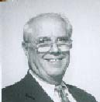**

**Certificate 046**

## ALVIN W. KAGEY, D.D.S. Certified 1980 - RETIRED

Dr. Kagey became a Diplomate of the ABFO in 1980. He received his dental degree from the University of Maryland in 1961and was a dental officer in the USFA. He has maintained a private practice in general dentistry in Roanoke, Virginia since 1963. Dr. Kagney is a consultant to the Chief Medical Examiner of the Commonwealth of Virginia, Virginia State Police and many law enforcement agencies throughout Virginia. He has lectured on bitemarks at the FBI Academy at Quantico, Virginia, Virginia State Police Academy in Richmond, Virginia and at regional law enforcement academies across the Commonwealth. He has also lectured at the Medical College of Virginia School of Dentistry and the University of Virginia School of Medicine. In 1997 Dr. Kagey was the Commonwealth of Virginia's expert witness in the Marv Albert case in Arlington,

Virginia.

12/98

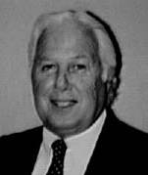

**Certificate 047 DECEASED**

## RODNEY MICHAEL CROW, D.D.S.

Dr. Crow began his career upon graduating from Baylor University College of Dentistry in 1959. His private practice spanned a 30 year period. In 1979, Dr. Crow joined the staff of the Chief Medical Examiner as the Chief of Identification Services. In 1981, Dr. Crow joined the Medical Examiner's Mass Disaster Response Team. He assembled and directed a Dental disaster Squad consisting of 34 members which was the fore runner in the State of Texas. Dr. Crow directed the team's efforts during one of the two major air disasters which occurred at the Dallas/Fort Worth International Airport. He is an assistant professor at both the Texas College of Osteopathic Medicine and Baylor University College of Dentistry where he lectures on Forensic Dentistry. In addition, he is a faculty member of the Fire and Police Academy's of Forth Worth lecturing on Forensic Dentistry and its application to criminal investigation. Dr. Crow is a fellow of the AAFS and member of the ASFO. In 1989, he became the full time Forensic Odontologist for the Medical Examiner's District for Tarrant, Denton and Parker Counties. In 1982, Dr. Crow became a Diplomate of the ABFO. Dr. Crow's expertise in Forensic Odontology and bite mark evidence has been used throughout the state of Texas.

06/05

**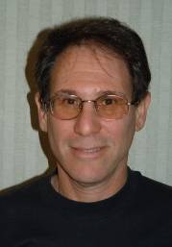**

**Certificate 048**

## MARK L. BERNSTEIN, D.D.S.

Mark L. Bernstein is a faculty member at the University of Louisville School of Dentistry as Professor of Oral Pathology. He has been involved in forensic dentistry since 1978 and gives an annual 16-week elective course in forensic odontology for senior dental students as well as periodic, University-sponsored continuing education courses. He has been an Assistant Medical Examiner and Forensic Dental Consultant to the Chief Medical Examiner of the Commonwealth of Kentucky for the past 11 years. He is Chairman of the Forensic Dental Medicine Committee and a member of the Peer Review Committee of the Louisville Dental Society. Dr. Bernstein was awarded his ABFO Diplomate status in 1981. Past and present service to the ABFO includes 2 nonconsecutive terms as Director, Member and Past Chairman of the Credentials and Examining Committee and participation in the Bite Mark Workshops I and II. Additional forensic odontology activities have included presentation of 14 abstracts of AAFS meetings, an Annual Bite Mark Breakfast and moderator of two Odontology section meetings. Dr. Bernstein's contributions to forensic dental literature include: Reviewer of dental forensic articles for JADA and past co-editor of the ABFO Forensic Odontology Workbook. He has authored four forensic dental articles in JADA, Dental Clinics of North America, Journal of Forensic Sciences and the 2nd edition of the Forensic Odontology Workbook. Dr. Bernstein's hobbies include photography, skiing, scuba diving, hiking, camping and fishing.

06/04

*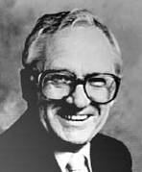*

**Certificate 049 RETIRED**

## RODNEY F. BROWN, D.D.S.

Dr. Brown became a Diplomate of the ABFO in 1982. After graduation from the University of Indiana School of Dentistry, he began an active full time private practice of general dentistry spanning a period of 41 years. He is a Life member of the ADA. He is a Fellow in the AAFS, and a member of the ASFO. Dr. Brown is a Deputy Coroner, Deputy Sheriff, Co-Captain of the Indiana Disaster "Go-Team", President of the Indiana Society of Forensic Odontology, consultant to the Indian State Police, and the Evansville Police Department. As a non-academician, to date, he has held no appointed committee or elected positions in the ABFO, AAFS, or ASFO.

06/04

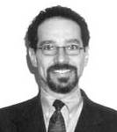

**Certificate 050**

## PHILIP R. GERON, D.M.D.

Dr. Geron became a diplomate of the ABFO in 1982. He received his DMD degree in 1979 from UMDNJ in New Jersey, and then attended the UMDNJ/JCMC residency program; becoming a certified oral and maxillofacial surgeon in 1982 Dr. Geron was appointed Director of Forensic Medicine and Dentistry at the UMDNJ dental school. He has served as a consultant to the New Jersey State and county medical examiners offices, prosecutor's office, state police and the New Jersey Commissioner of Insurance. Dr.Geron was the first in the State of New Jersey to have bite mark evidence used in the Superior Court toward the conviction of murderer and rapist. The original case involved bite marks on human anatomy, and other bite marks in food substance, and both were considered landmark cases for the state. Dr. Geron presently practices out of Westfield, New Jersey.

12/02

**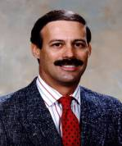**

**Certificate 051**

## GREGORY S. GOLDEN, DDS

## Dr. Golden received his dental degree from the University of Southern California in 1975 and now practices general dentistry four days a week in Rancho Cucamonga, California. Upon developing an interest in Forensic Dentistry in 1980, he soon became a Diplomate of the American Board of Forensic Odontology in 1982 and continues to support the ABFO, having served as a Director, and a member of numerous committees. In 1992 he became the Chief Odontologist for San Bernardino County and continues to serve several Southern California Counties as a forensic consultant for bite mark evaluations. As a fellow and past Odontology Section Chairman of the American Academy of Forensic Sciences and former Trustee to the Forensic Sciences Foundation, he has presented numerous papers, is a contributing author to several textbooks, and has published several articles applicable to his field, including research in Fluorescent and Ultra-Violet Photography. He has served as a guest editorial reviewer for the Journal of Forensic Sciences, is currently an instructor at Loma Linda University School of Dentistry, and has taught advanced photographic techniques at the Symposium of Forensic Dentistry at the University of Texas, San Antonio, and at the International Forensic Photography Workshop held in Miami, Florida. Dr. Golden has qualified as an expert witness numerous times in Superior Courts of five Southern California Counties, as well as others out of state. Other accomplishments include his assistance in identification of victims of the World Trade Center disaster, receiving the Meritorious Service Medal from the San Bernardino County Sheriff, and multiple commendations from the California Attorney General for his help in implementing the Computer Assisted Post-Mortem Identification program at the Department of Justice. Outside interests include waterfowl and upland game hunting, fishing, and general aviation.

06/04

**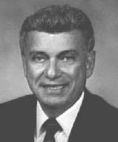**

**Certificate 052**

## GEORGE M. ISAAC, D.D.S.

## Dr. Isaac became a Diplomate of the ABFO in 1982. He has served the Board in several capacities. He has had two terms as a Director of the Board and has been a member and chairman of the Bylaws Committee. He served the ABFO in the positions of Treasurer 1993-94, Vice President 1995, President-Elect 1996 and President 1997. Dr. Isaac graduated from the University of Texas School of Dentistry in 1963 and maintains a full-time dental practice in El Paso. He started in the field of Forensic Dentistry in 1975 and is a Fellow in the AAFS and a member of the ASFO. He teaches Forensic Odontology at El Paso Police Academy and has been certified as an expert witness by the El Paso County Courts. He is the dental consultant to the El Paso County Medical Examiner for dental identifications and bite mark evidence. He receives much support from his wife, two sons and four grandchildren.

06/04

**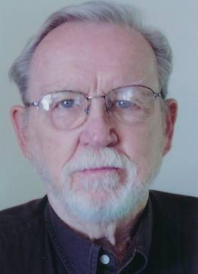**

**Certificate 053 Certified 1982- Retired**

## THOMAS L. JOHNSON, D.D.S.

## Dr. Johnson became a Diplomate of the ABFO in 1982. He retired from the private practice of dentistry in 1986. He has been a member and chairman of the Bylaws Committee. He became a Fellow of the AAFS and a member of the ASFO in 1980. Dr Johnson graduated from the University of Southern California in 1942 and practiced General Dentistry in Southern California for 41 years. He was an Associate Professor of Forensic Odontology at Loma Linda University School of Dentistry through the Department of Oral Pathology. He was a Deputy Coroner/Odontologist for San Bernardino County from 1980 to 1993. During this period he qualified and testified as an expert witness in numerous Superior Court trials. He was a past president of the Tri-County Dental Society. He is happily married, has 4 children and 6 grandchildren.

06/04

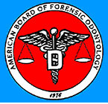

**Certificate 054 Revoked 2/2007**

## ELIZABETH M. ROBINSON, D.D.S.

**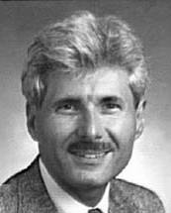**

**Certificate 055 Certified 1984- Retired**

## JAMES A. COTTONE, D.M.D., M.S.

No biographical information submitted.

06/06

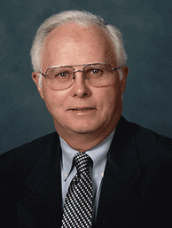

**Certificate 056**

## PETER F. HAMPL, DDS

Dr. Hampl received his dental degree from the University of Minnesota in 1967. He spent three years in the oral and maxillofacial surgery training program at Bellevue Hospital and New York University in New York City. His first forensic dental experience was in conjunction with the New York City Medical Examiner's office while in oral surgery training. Upon completion of his oral and maxillofacial surgery training in 1970, Dr. Hampl moved to Tacoma, WA, where he maintained a private practice in oral and

maxillofacial surgery until his retirement in July, 1998. He now devotes all of his professional activity to his forensic odontology practice. Dr. Hampl has been instrumental in the founding of the Washington State Dental Association's Dental Identification Team, the formation of the Washington State Patrol's Missing and Unidentified Persons Unit and the passage of the Washington State law mandating marking of removable dental prostheses with the patient's name. Dr. Hampl is a member of the ADA, WSDA, Pierce County Dental Society (past trustee), American Association of Oral and Maxillofacial Surgeons (retired member) and the Washington State Society of Oral and Maxillofacial Surgeons (past president). Dr. Hampl is a diplomate of the American Board of Oral and Maxillofacial Surgery (1974) (retired). He became a diplomate of the America Board of Forensic Odontology in 1984. He was elected to the Board of Directors of the ABFO in 1990, 1997 and again in 2002. He was a member of the Credentialing and Examining Committee of the ABFO serving as its chairman in 1997. In 2004 he was elected secretary of the ABFO. He was also elected to the board of directors of the American Society of Forensic Odontology in 1990 and served as president of the ASFO in 1993. Dr. Hampl is a forensic odontologist on DMORT for region X. Dr. Hampl has been qualified as an expert witness in Alaska, Colorado, North Carolina, Oregon and Washington.

06/04

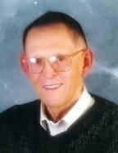

**Certificate 057 Deceased 2007**

## ROBERT PARKER KELLY, D.D.S.

Dr. Robert P. Kelly, DDS, received an associate of arts degree from Compton College in 1950 and his dental degree from the University of Southern California in 1958. He served in the US Army Dental Corps and received an honorable discharge in 1954. Dr. Kelly has maintained a private general dental practice in Orange County California since 1959. In 1969 Dr. Kelly became the chief forensic dental consultant to the Orange County Coroner’s office. He is a member and or fellow of the ADA, CDA, American College of Dentists, International College of Dentists, Pierre Fauchard Academy, Academy of General Dentistry (Master), AAFS and ASFO. Dr. Kelly has been active in the Orange County Dental Society being that organization’s president in 1982/83. In 1990 he was president of the Southern California Academy of General Dentistry. Dr. Kelly was a delegate to the ADA from the CDA from 1989 to 1992. He became a diplomate of the ABFO in 1984 and has served on the mass disaster dental identification committee.

01/05

**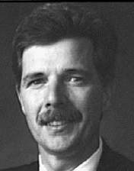**

**Certificate 058**

## JOHN D. McDOWELL, D.D.S., MS

Dr. McDowell received his DDS in 1974 from Loyola University in Chicago. He has completed a Dental Diagnostic Science residency with emphasis in forensic odontology at the University of Texas Health Science Center at San Antonio School of Dentistry. He has a Master's Degree from the Graduate School of BioMedical Sciences at UTHSCSA He has completed a fellowship in geriatric dentistry with training received at the University of Texas Health Science Center and Audie Murphy Memorial Veteran's Hospital in San Antonio, TX. He has held the position of assistant professor at both the UTHSCSA School of Dentistry and the University of Colorado School of Dentistry. He is a Diplomate of the ABFO and a Fellow of the AAFS. He has served in several positions within the AAFS, presently serving as Odontology Section Representative to the AAFS Board of Directors and is a member of the AAFS Executive Committee. He has previously served on the Board of Directors of the ABFO. Dr. McDowell serves as a reviewer for professional journals and is a member of the Board of Editors of the American Journal of Forensic Medicine and Pathology. He is active in the field of oral medicine with special emphasis on diagnosis and treatment of patients with HIV infection.

12/93

**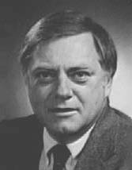**

**Certificate 059**

## JAMES B. McGIVNEY, D.M.D.

## James McGivney, D.M.D. has been a forensic dentist in St. Louis, MO since 1979. He is a fellow of the American Academy of Forensic Sciences and has been a Diplomate and a former Board Member of the American Board of Forensic Odontology. Dr. McGivney has a degree in computer science and has developed and released several computer programs that can be used in forensic dentistry. He is on the faculty of the St. Louis University Medical School's Medico-Legal Death Investigators course. He gave lectures on forensic dentistry to the student Academy of Forensic Sciences for seven years. Dr. McGivney is a member of the Missouri Dental Board and an examiner for the Central Regional Dental Testing Service (CRDTS). Passing the CRDTS examination allows the candidate to be eligible for licensure in thirteen northern and mid western states.

06/04

**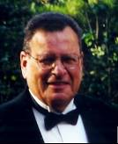**

**Certificate 060 DECEASED**

## EDWARD R. MOFSON, D.D.S.

Dr. Mofson is a native of Brooklyn, NY. He received his DDS from New York University in 1962 and then served three years in the United States Army Dental Corps. He has maintained a private practice in Syracuse, NY since 1965. Dr. Mofson is the forensic odontologist in the Office of the Medical Examiner of Onondaga County, NY and is a consultant in forensic dentistry to law enforcement agencies throughout New York State. He is chairman of the Mass Disaster committee of the Onodaga County Dental society and is a member of the Task Force on Forensic Dentistry of the Dental "society of the State of New York. He has been a guest lecturer at St. Joseph's Hospital in Syracuse and has lectured throughout the State before many study clubs and component societies. He is a member of the ASFO, a Fellow of the AAFS and has been a Diplomate of the ABFO since 1984. Dr. Mofson is also interested in veterinary dentistry and is the consulting dentist at the Burnet Park Zoo in Syracuse.

01/05

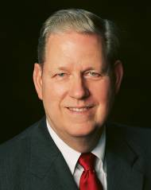

ertified June 10, 1984 - Retired

**Certificate 061 Certified 1984 - Retired**

## FRANK A. MORGAN, DDS

Dr. Morgan is in general practice in Spokane, Washington, and is Chief Forensic Odontologist for Spokane County Medical Examiner’s Office. He also serves a wide area of Eastern Washington and Northern Idaho in forensic consulting and in teaching forensic law enforcement classes. He received his dental degree at the University of Washington in 1969, and thereafter spent two years as a dentist in the U.S. Army during the Viet Nam war. He is a member of the American Academy of Forensic Sciences since 1981 and is a fellow in AAFS. Dr. Morgan served in several positions in ASFO, culminating in his service as President of ASFO in 1990. He has also served on the ABFO Board of Directors, as well as several ABFO committees. In the mass disaster arena, he has served on the Washington State Dental Identification Team as co-chair since 1993 and as a member of the Spokane Department of Emergency Management Council since 1990. As a member of DMORT, Region 10 for many years, he was activated and deployed to New York City to assist in the World Trade Center disaster in October, 2001. He enjoys his forensic work, his forensic associates, and continues to be active in all of the above organizations.

06/04

*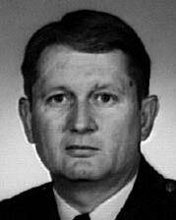*

**Certificate 062 Retired/Deceased**

## WILLIAM M. MORLANG, D.D.S.

Dr. Morlang serves as a forensic consultant to the Armed Forces Medical Examiner, Armed Forces Institute of Pathology (AFIP) and Air Force Office of Special Investigation. He is an adjunct Associate Professor, School of Dental Medicine, Tufts University, and Associate Clinical Professor, School of Medicine, Wright State University. He is also a faculty member at the AFIP. Dr. Morlang is a graduate of the University of Florida, West Virginia University, Armed Forces Staff College, National Defense University, and Inter-Agency Institute for Federal Healthcare Executives at George Washington University. He trained in oral pathology, forensic dentistry, aerospace pathology, and advanced forensic pathology at the Armed Forces Institute of Pathology and FBI Academy. He served in the U. S. Air Force from 1966 until 1996 where he served as the Consultant in Forensic Dentistry to the Surgeon General. He served on the ABFO Board of Directors, ABFO Research, Mass Disaster, Bitemark, Certification and Examining, and Ad Hoc Validation Committees. Dr. Morlang was the 1996 president of the American Society of Forensic Odontology. He is a fellow of the American Academy of Forensic Sciences, Academy of General Dentistry, American College of Dentists, and International College of Dentist. He is a member of the American College of Legal Medicine, and American Academy of Oral and Maxillofacial Radiology.

06/04

**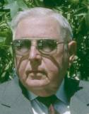**

**Certificate 063**

## GERALD M. REYNOLDS, DDS Certified 1984 – Retired/DECEASED

I was born in Los Angeles, March 7, 1929. My college education was completed June 8, 1952, at La Sierra University now in Riverside, California. My major emphasis was in Biology, with minors in Chemistry and Secondary Education. After a time in the Army of the United States (1953 to 1955) as a Clinical Laboratory Technologist in which capacity I never picked up a test tube! I went east to Howard University for a Master's degree in Pharmacology. Having completed that, I engaged in applied research in inhalation toxicology testing what later was known as Agent Orange on guinea pigs, not one of which died as a result of two years exposure 5 days a week! From there to dental school (Loma Linda University) and the completion of that curriculum in June, 1969, saw me establish a private practice in Yuba City, CA. It was there that in May 1972, the Juan Corona mass murders came to the attention of the county. This event set the course for the Naval Reserve unit, in which I was drilling, sending me back to the A.F.I.P. for the formal course in Forensic Odontology, October, 1972. At that time, I learned of the American Society of Forensic Odontology and I applied for membership. The Society had only been formally organized two years earlier. Dr. Lester Luntz appointed me as Parliamentarian at the Chicago meeting in 1975. From there it was "through the chairs" until in 1982 to 1983, I was elected to the presidency of that organization. Also, in 1974, I applied for and was accepted as a Provisional Member of the A.A.F.S. at the February, 1975 meeting. The group who met together that year seemed so few in number that we were able to sit about a collection of tables in a lower room of the hotel where the Academy was meeting that year, also in Chicago 1976, and the A.A.F.S. meeting was in Washington, D.C. and it was there that I took pictures of the first members of the newly formed American Board of Forensic Odontology! What an event that was. My enthusiasm was stirred and I went home promising myself that I would begin to qualify myself for application to that august group of people! It was not until June, 1984, that I was able to sit for the exams, and was accepted as a diplomate. Space precludes further elucidation of the work done since then. But I can say that I have appreciated the work this group is doing, and admire them everyone. Thank you for including me in your fraternity.

06/04

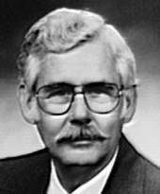

**Certificate 064 DECEASED**

## WILBUR B. RICHIE, D.D.S.

Dr. Richie earned his Doctor of Dental Surgery degree from the University of Missouri. He was in private practice for 33 years in Golden, Colorado. Dr. Richie served as Jefferson County Coroner from 1982 to 1998 and was instrumental in designing a state of the art facility for the Coroner’s Office that opened in 1997. He was a member of DMORT Region VIII and was deployed to Guam in 1997 to assist in the identification of plane crash victims. He assisted in the identification process of several other mass disasters in Colorado. He was a member of the Rocky Mountain Division of the IAI, American Society of Forensic Odontology, a retired fellow of the American Academy of Forensic Sciences and a Diplomate of the American Board of Forensic Odontology. He served a President of the ABFO from 1993 to 1994. He was the father of three sons. Dr. Richie’s hobbies included sailing, photography and motorcycle riding.

06/04

**

**Certificate 065 RESIGNED 6/2006**

## MICHAEL H. WEST, D.D.S.

**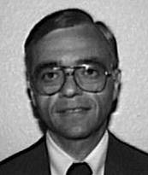**

**Certificate 066 Certified 1985- Retired 2005**

## JOSEPH A. ANSELMO, D.D.S.

Dr. Anselmo became a Diplomate of the ABFO in 1986. To date, he has held no elected or appointed positions in the ABFO, ASFO or AAFS. Dr. Anselmo received his D.D.S. from Marquette University School of Dentistry in 1967. He completed his Oral Surgery Residency at Temple University Hospital and School of Dentistry in 1974. He currently holds the rank of Colonel in the U.S. Air Force Reserves and is the Director of the Oral Surgery Outpatient Clinic at the Los Angeles County USC Medical Center. Dr. Anselmo is a Deputy Coroner and Consultant in Forensic Dentistry at the Los Angeles County Medical Examiner/Coroner's Office. He is a Diplomate of the American Board of Oral & Maxillofacial Surgery and a Fellow of the American Society of Oral & Maxillofacial Surgeons as well as the AAFS and the Southern California Academy of Oral Pathology. Besides his impressive log of Forensic Odontology case work, he has lectured and taught on numerous occasions to a variety of agencies and groups.

06/05

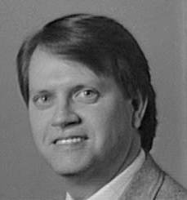

**Certificate 067**

## ROBERT E. BARSLEY, D.D.S., J.D.

Dr. Barsley became a Diplomate of the ABFO in 1986. He is a member of the Board of Directors of the ABFO and a member of the Board of Governors of the ASFO. He has held the position of Chairman of the ABFO Continuing Education Committee and is the

Former Chairman of the Committee to draft educational guidelines for the AADS. He is a member of the Credentials and Examination Committee. Dr. Barsley is a Fellow of the American Academy of Forensic Sciences. He holds the rank of Professor in the Department of Oral Diagnosis, Medicine and Radiology at the Louisiana State University School of Dentistry in New Orleans, LA where he has been a faculty member in excess of ten years. Dr. Barsley was admitted to the practice of law in Louisiana in 1987.

06/04

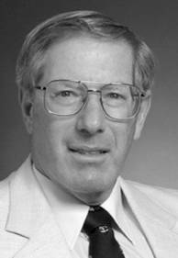

**Certificate 068**

## ALAN S. BENOV, D.D.S. RETIRED

Graduated from School of Dentistry, UOP in 1970 and have been in private practice since 1971. Fellow of AAFS Diplomate of ABFO since 1986 Member of California Society of Forensic Dentistry. Forensic Odontologist - Fresno County Coroner’s Office. Dental consultant to Fresno County Sheriff’s Dept. & Fresno Police Dept. Consultant to Calif. Dept. of Justice Missing/Unidentified Persons Section Guest lecturer in forensic dentistry for the Fresno Police Academy I have had the privilege of consulting on numerous cases for various departments in Fresno County and some surrounding counties.

06/04

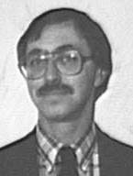

**Certificate 069 RESIGNED**

## JOHN K. BERK, D.D.S.

Dr. Berk has been active in forensic dentistry since 1978 and currently serves as a consultant to the Alameda County and Contra Costa County Sheriff-Coroners. He is responsible for the dental identifications in those counties and has worked with both prosecution and defense in bite mark analysis. Further, he has been involved in dental identification in several mass disasters including the Loma Prieta Earthquake of 1989, the Eastbay Firestorm of 1990, and the crash of PSA 1771 in 1987. Dr. Berk has been a Diplomate of ABFO since 1985. He has lectured on Forensic Dentistry for several continuing education programs and as a quest lecturer at the University of California at Berkeley. Dr. Berk maintains a private practice as a general dentist in Castro Valley, CA.

12/01

**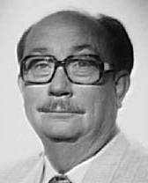**

**Certificate 070 Certified 1985- Retired**

## DONALD D. JEFFRIES, D.D.S.

Dr. Jeffries was born in 1932 in Galena, Kansas. He was a member of the Army Medical Corp in Germany from 1954 to 1956. On returning from military duty, he attended college at Walla Walla, Washington where he received a B.S. Degree in 1960. He graduated from Loma Linda University School of Dentistry in 1964 and entered private practice. He retired from private practice in December 1997. He is a member of the American Dental Association, California Dental Association and Kern County Dental Society.  He served the Kern Society in all board positions and as its president in 1980. He served as the forensic dental consultant to the Kern County Coroner's office for 25 years. Dr. Jeffries became a fellow of AAFS in 1978 and a diplomate of ABFO in 1986. He was invited to join CHIA, California Homicide Investigators in 1992.  He is still a member of AFSO and AAFS. He began his forensic education in 1972 by attending the AIFP and continued with a study group at UC San Francisco and various forensic courses at University of Texas, Northwest University and annual courses at ASFO and AAFS. In 1990, by invitation he attended sessions at the FBI Academy in Quantico, Virginia. He is a member of the American Association of Dental Consultants and currently serves in that capacity for 3 different organizations. From 1990 to 1993 he was an examiner for the California State Board of Dental Examiners.

01/05

**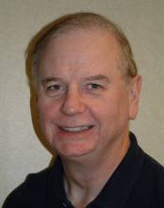**

**Certificate 071**

## JOHN P. KENNEY, D.D.S., M.S.

Dr. Kenney received his DDS in 1977 from Loyola, completing his postgraduate specialty in Pediatric Dentistry and a MS with the thesis topic of Orofacial Injuries in Child Abuse in 1979 from the same institution. He attended his first course in forensic odontology at AFIP in 1976, and shortly thereafter joined ASFO. He became a member of IOFOS in 1978 and served as its Vice-President/Secretary from 1984-1987. In 1979 he returned to AFIP to take the Aerospace Pathology course literally returning home to the Chicago DC-10 disaster. His continuing forensic education includes the Southwest Symposium on Forensic Dentistry, The Master’s Course in Death Investigation at St Louis U, FBI Mass Disaster/Crime Scene Reconstruction, Mass Fatalities Response at FEMA’s NETC, AFIP Forensic Anthropology, US ARMY CILHI Advances in Human Identification, and ADA conferences on Mass Fatality and Child Abuse. In 1980 he joined AAFS and holds the rank of Fellow. He was section representative to the Student Academy from 1991-2001, and was elected this year to the Board of Trustees of the Forensic Sciences Foundation. He also serves on the Editorial Board of the Journal of Forensic Sciences and has been a guest editor for the IAI Journal. Jack was ABFO Certified in 1986, and served on the Board of Directors from 1990-1995 and 2000-2003. He was elected Treasurer in 1991, moving up chairs to ABFO President in 1995. Dr. Kenney will again assume the office of President of the ABFO for 2006/2007. He served for five years as the odontology/child abuse consultant to the ADA Council on Dental Practice. He is also a Certified Senior Crime Scene Analyst from IAI. He was Chief Forensic Odontologist and Disaster ID Team Director for the Cook County Medical Examiner’s office for 14 years, and currently is a Deputy Coroner/Director of Identification Services for the DuPage County IL Coroner’s Office. He has participated in 8 mass fatality incident investigations over the past 25 year and is one of three civilian dental consultants to JPAC-CIL, (ex CILHI) the Military’s Identification Laboratory in Hawaii. Hobbies include fishing and model trains with his son David along with working around a new house 01/06

*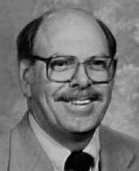*

**Certificate 072 DECEASED**

## PHILLIP E. O'SHAUGHNESSY, DDS, MSD

Dr. O'Shaughnessy was born in 1934 in Chicago, Illinois. He graduated from the Indiana University Dental School in 1960 and went on to Graduate School at Indiana University and received his MSD in Oral Diagnosis/Oral Medicine in 1962. He is a member of the American Dental Association. Isaac Knapp Dental Association (past president), American Academy of Oral Pathology, Christian Dental Society, American Association for the Advancement of Science, American Academy of Periodontology, Indiana Society of Periodontists (past president), American Society of Forensic Odon­tology, Indiana Society of Forensic Odontology (president), Na­tional Board of Forensic Dentistry (Diplomate and past president), American Academy of Forensic Sciences (Fellow), Indiana Coro­ners Association (president) and the American Board of Forensic Odontology (Diplomate and Director). He is also the past Chairman of the American Heart Association Hypertension Screening Program, past president and Director of the Family and Children Counseling Service, Director of the Mental Health Association of Allen County, Director of the Samaritan Center of Fort Wayne and the Chairman of the Violence Taskforce. He has received many awards over the years including the American Academy of Oral Roentgenology Award, a USPHS Post-Graduate Fellowship and Outstanding County Coroner. He has published papers in several national journals. Dr. O'Shaughnessy is an Assistant Professor at the Indiana University School of Dentistry, an adjunct Assistant Professor to the School of Medicine at Indiana University, the Coroner of Allen County, a consultant to the Governor's Commission for Forensic Sciences and an Associate Instructor at the Fort Wayne Police Academy. In addition to all this he maintains a private practice limited to periodontics and a family of six children and a very understanding wife.

06/04

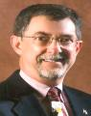

**Certificate 073**

## DUANE E. SPENCER, D.D.S.

Dr. Spencer received his DDS from the University of Southern California in 1965. He then served four years active duty as a U. S. Naval Dental Officer, retiring from the Naval Reserve in 1991. His military awards include the Viet Nam Service Medal. He completed his Pediatric Dental Residency at the University of Pacific, School of Dentistry, in 1972 and has a private practice of pediatric dentistry in Walnut Creek CA. He has served as Pediatric Dental Consultant to the U. S. Naval Hospital, Oakland; Chief of Dentistry at Children’s Hospital, Oakland; and as assistant Professor, Dept. of Growth & Development, Univ. of California, San Francisco, School of Dentistry. He has been a forensic dental consultant since 1978, serving the counties of Alameda, Contra Costa, Santa Clara and San Mateo, as well as numerous northern California law enforcement agencies and has been admitted as an expert witness in municipal, superior and U.S. District courts. Dr. Spencer is a consultant to the California Department of Justice, Missing and Unidentified Persons Unit and the California P.O.S.T. (Peace Officers’ Standards and Training). He has lectured internationally and is a regular presenter in the field of forensic odontology and child abuse to universities, colleges, health and law enforcement groups in California. He is a member of the Contra Costa County Child Death Review Team and a volunteer educator/trainer for the Contra Costa County Child Abuse Prevention Council. Dr. Spencer has authored numerous articles in his two specialties, has been a peer reviewer for the Journal of the California Dental Association and was Contributing Editor of the August 2004 CDA Journal issue (Bioterrorism and Forensics). He was a member of the AAFS delegation to the USSR in 1988 and worked at the U.S. Army Central Identification Lab (CILHI) in March of 1989. He has been a Diplomate of the ABFO since 1985 serving as both chair of committees and on the Board of Directors. He is a member of the ASFO, a Fellow of the AAFS, an officer and founding member of the California Society of Forensic Dentistry, Inc., and a Fellow of both the American College of Dentists and the Pierre Fauchard Academy. His mass disaster experience includes the 1989 Loma Prieta 7.1 earthquake/freeway collapse and the 1991 East Bay Firestorm. He is a member of the California Dental Identification Team. His outside interests have been coaching youth sports and Boy Scouts (1987 Silver Beaver recipient). He is married, has a son and daughter and two young granddaughters.

01/05

**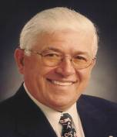**

**Certificate 074A DECEASED 12/07**

## RONALD J. WICKUM, D.D.S.

## Dr. Wickum received his dental degree from UCSF in 1968. He is a member of the ASFO, a fellow of AAFS, and elected to fellowship in the Royal Society of Medicine in 1992. He became a Diplomate of the ABFO in 1986. Dr. Wickum is consultant to Santa Cruz County Sheriff's Department and several city police and sheriff's departments. Dr. Wickum assisted in the identification of PSA 1171 victims in 1987 as well as victims of the Oakland firestorm of 1991.

01/06

*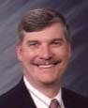*

**Certificate 074B**

## GARY L. BELL, D.D.S.

Dr. Bell became a diplomate of the ABFO in 1986. He was a director (1988-91), treasurer (1989-90), secretary (1990-92) and vice president (1992-93) of the ABFO. He began his career in Dentistry in 1976 upon graduation from the University of Washington Dental School. He maintains a general practice in Seattle, Washington. Dr. Bell joined the Seattle Police Department Reserve Unit in 1971 and initially worked in the Patrol Division and has been assigned to the Crimes Against Persons Division for assistance with their forensic investigations since 1979. In 1989, he was selected to be the Washington State Patrol's Forensic Advisor for their Missing and Unidentified Persons Unit. His expertise in the forensic field has grown and his accomplishments, besides those mentioned above, include, Fellow in the AAFS, Co-Chairman of the Washington State Dental Identification Team, Chairman of the Seattle/King County Dental Identification Team and Chairman of the Washington State Missing and Unidentified Persons Committee. Dr. Bell has taught and continues to teach Forensic Odontology, specifically dealing with bitemark evidence collection, mass disaster preplanning and forensic evidence analysis and transmission via electronic media, to a variety of agencies. He has been certified as an expert witness by numerous Washington, Oregon, California and Alaska courts and has preformed dental identifications and bitemark comparisons for numerous coroner/ME's offices and law enforcement agencies. He has developed a written protocol for the dental section involved in mass disasters that has been used in the formation of many disaster teams that have been organized in the US. His Forensic Information Transmission System (FITS) is currently being implemented in the Pacific Northwest Region of the US to aid in the identification of unidentified remains. For the past couple of years Dr. Bell has spent much time organizing, editing and updating the ABFO Diplomate Reference Manual. Fortunately, he has a very understanding wife and two children that support his efforts in a profession that he enjoys.

06/04

**

**Certificate 075 REVOKED**

JOHN L. BRIGGLE, D.D.S.



**Certificate 076 REVOKED**

JOSEPH W. BRIGGLE, D.D.S.

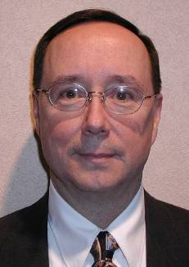

**Certificate 077**

## JON CURTIS DAILEY, D.D.S.

Dr. Dailey became a Diplomate of the ABFO in 1986. He is currently a resident in the prosthodontic program at William Beaumont Army Medical Center in El Paso, Texas. He gained considerable forensic experience during his tour of duty at CILHI. He has published seven papers on various forensic odontology topics since 1987 and has presented four papers at the AAFS meetings. Dr. Dailey has lectured quite extensively on forensic odontology in both military and civilian circles since 1985. To date, he has not held any offices in the AAFS or the ABFO.

01/05

**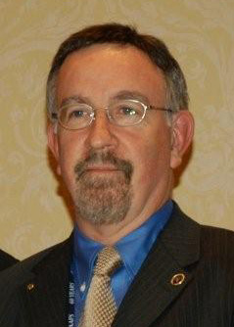**

**Certificate 078 Certified 1986**

## THOMAS J. DAVID, D.D.S.

Tom graduated from Emory University School of Dentistry in 1977. He became a member of the ASFO and the AAFS in 1983. He became a Diplomate of the ABFO in 1986 and a Fellow of the AAFS in 1988. He is a member of DMORT Region IV since 1995. He has served as Program Chair, Secretary and Chair of the Odontology Section of the AAFS from 2002 through 2008. He also serves as a Member of the Editorial Board of the “Journal of Forensic Sciences”, the flagship publication of the AAFS. He became a Fellow of the American and International College of Dentists in 2006. He currently serves as President of the ABFO.

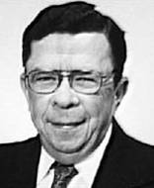

**Certificate 079 Certified 1986- Retired**

## DONNELL C. MARLIN, D.D.S.

Dr. Marlingraduated from Indiana University School of Dentistry in 1956. He served as an active duty Lieutenant in theU.S. Naval Reserves from 1957 to 1961. Twenty-five months of that time was spent as an assistant dental officer in U.S.S. Ticonderoga. This tenure included two enjoyable Westpac cruises, two typhoons, and three shipyard periods, which were not enjoyable at all. Upon his return to Indiana, he entered private practice in Noblesville, IN. He joined the faculty of Indiana University School of Dentistry as a part-time member of the Oral Diagnosis Department in 1974 and continued a part-time practice in Noblesville, IN, until 1981 when he joined the faculty as a full-time assistant professor in the Dental Diagnostic Sciences Department. At that time, Dr. S. Miles Standish was department head and he encouraged Dr. Marin's interest in Forensic Odontology. Dr. Marlin became a Diplomate of the American Board of Forensic Odontology in 1987 and taught the Forensic Dentistry course at IUSD after Dr. Standish retired. Dr. Marlin acted as director of a Comprehensive Care Clinic in the IUSD department of Restorative Dentistry from 1995 until his retirement in 1999. During his career, he was affiliated with a number of organizations, which included: American Academy of Forensic Sciences (Member), American Society of Forensic Odontology, Indiana Society of Forensic Odontology, American Board of Forensic Odontology and the usual local and national dental societies. He was appointed a Kentucky Colonel in 1965 and a Research Associate of the Archaeology and Forensics Laboratory at the University of Indianapolis in 1997.

06/04

*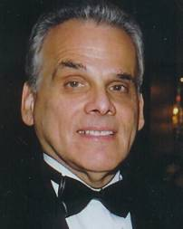*

**Certificate 080**

## IRA R. TITUNIK, DDS

Dr Titunik received a BS from the University of Maryland and his DDS from Temple University. He is a general dental practitioner, commissioned as Ensign, USNR, retired as Commander, DC, USNR.  A lecturer and consultant for various law enforcement agencies and organizations in the fields of forensic odontology and dentistry, including occlusion and myofascial therapy. He is Adjunct Professor of Forensic Sciences at John Jay College of Criminal Justice, a graduate course director and lecturer in forensic human identification. He is also a graduate research project mentor. A Fellow in a number of organizations including the American Academy of Forensic Sciences, American College of Dentists, International College of Dentists and the Academy of General Dentistry. He is active in organized dentistry including the Greater New York Dental Meeting and the New York County Dental Society. A dental consultant with several agencies includes the Medicolegal Investigations Unit-New York State Police, Nassau County Medical Examiner, Connecticut State Medical Examiner and is the Chief Dental consultant for the New Jersey Regional Medical Examiner. 06/0

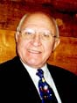

**Certificate 081**

## JOSEPH R. GENTILE, D.D.S.

A Colorado native, Dr. Gentile attended Regis College, Denver, CO and received his DDS degree from Creighton University in 1955. He is currently in private general practice in Colorado Springs, CO. His memberships in organized dentistry include ADA, CDA, and the Colorado Springs Dental Society of which he served as President. He is a Fellow of the American College of Dentists. He holds the rank of Captain USNR-R. He is a Fellow of the AAFS, member of ASFO, and Diplomate of the ABFO. He is forensic consultant for Dentac, US Army, Fort Carson and was awarded a Public Service Citation by the Colorado Springs Police Department. He is a Deputy Coroner for El Paso County, CO and was dental coordinator of United flight 585 crash 1991, Colorado Springs, and a member of the Body ID Team, IAI, Storm King Mountain Fire, 1993, Glenwood Springs, CO. He is a member of the Mass Fatality Incident Management Team which conducts annual courses for the State Emergency Management Agency and also a member of NDMS. He served as Director of the ABFO and served as Secretary of the ABFO.

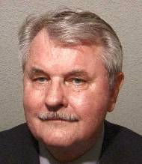

**Certificate 082**

## GEORGE A. GOULD, DDS

Dr. Gould is a native Californian. He obtained his dental degree at University of

California School of Dentistry in 1960. He maintained a private general dental practice from 1960 to1993 in Sacramento, CA. His military service saw him promoted to colonel in 1989 with the 175th Medical Brigade General's Staff. He ended his military career with the National Guard in 1993. Dr. Gould has had extensive forensic training including University of California Medical Center School of Dentistry post-graduate continuing education under the direction of Drs. John Beckstead and Robert Giles (1980), Armed Forces Institute of Pathology Bethesda, Maryland Forensic Odontology (1987), Armed Forces Institute of Pathology New Technology and advanced techniques in Human Identification (1994), St. Louis University School of Medicine Masters Course in Death Investigation (1985) and Smithsonian Institution Washington D.C. 1993 Course on Forensic Anthropology under direction of Drs. Bass and Ubelaker. Dr. Gould is affiliated with the American Dental Association, California Dental Association, Sacramento District Dental Society, American Society of Forensic Odontology, American Academy of Forensic Sciences and the United States Army Central Identification Laboratory Hawaii from March 1993 through August 1995 as a civilian forensic dentist. Dr. Gould is currently full time with Delta Dental as a consultant in the Utilization, Quality Review and Fraud investigations for the Denti-Cal government program. Dr. Gould is an expert witness giving testimony on identification and bitemark analysis in the counties of Sacramento, El Dorado, and Placer in the state of California and also in Hawaii, representing both defenseand prosecution**.** Dr. Gould also was a Sacramento County Deputy Sheriff (reserve) for 15 years, which included patrol services and CSI.He has formulate and conducted training programs for mass disaster response teams of the Sacramento District Dental Society, Los Angeles Medical Examiner, University of Tennessee, Mass Disaster Team Pensacola, Florida and Minneapolis MN. Dental Society emergency response team. Dr. Gould has lectured extensively on dental fraud, missing and unidentified persons, mass disaster planning, human abuse and bitemark analysis. 06/04

**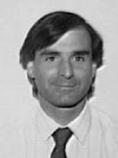**

**Certificate 083**

## MITCHELL M. KIRSCHBAUM, D.D.S.

Dr. Kirschbaum graduated from NYU College of Dentistry in 1974 and then completed an externship in Oral Surgery at Lenox Hill Hospital and a General Practice Residency. At present, he is in general practice and is a consultant to the Morris County Medical

Examiner's Office, as well as the Morris Co. Sheriff's Office, Prosecutor's Office, and the Warren and Sussex Co. Medical Examiner's Offices. He is also an independent forensic consultant to several insurance companies and attorneys. Dr. Kirschbaum became

a Diplomate of the ABFO in 1988 and is a Fellow of the AAFS. He is a member of ASFO and co-director and co-organizer of the New Jersey State Mass Disaster Identification Team. He has presented several papers before the Odontology Section of the AAFS as well as to local dental and law enforcement organizations about General Forensic Dentistry, Mass Disaster Planning, Civil Injury Cases, Child Abuse and Forensic Dentistry and the Homicide Investigation.

12/92

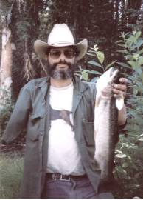

**Certificate 084 Certified 1988- Retired**

## STUART A. REDER, D.D.S.

No biographical information submitted.

06/06

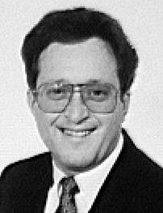

**Certificate 085 RETIRED**

## ALLAN J. WARNICK, D.D.S.

Dr. Warnick became a Diplomate of the ABFO in 1989. He is a past member of the ABFO Nominating Committee and was elected to the ASFO's Board of Governors in 1990 for a three year term. He is also a member of the AAFS Odontology Section Strategic Planning Subcommittee. Dr. Warnick is the Chief Forensic Dental Consultant to the Wayne County Medical Examiner's Office in Detroit. He is also the forensic dental consultant to Oakland County, Monroe County, Macomb County and the Michigan State Police. He is the Team Leader of the Michigan Dental Association's Forensic Dental Identification Team and was so at the time of the Northwest Flight 255 disaster on August 16, 1987. He is an Assistant Clinical Professor in the Department of Comprehensive Dentistry (Forensic Dental Program) at the University of Detroit School Of Dentistry.

12/01

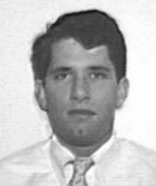

**Certificate 086 Resigned**

## DAVID C. AVERILL, D.D.S.

Dr. Averill became a Diplomate of the ABFO in 1989. He has been a director of the ABFO from 1991 to present time. He currently is the Secretary/Treasurer of the ASFO having been elected in 1991. He was elected to the ASFO Board of Governors in 1989. Dr. Averill is editor of the Manual of Forensic Odontology which was published by the ASFO in 1991. He is also Associate Editor of the ASFO Newsletter. Dr. Averill graduated from the University of Maryland, Baltimore College of Dental Surgery in 1984. After graduation he became a general Dental Resident at the Medical Center Hospital of Vermont. After completing the one year residency he joined his father in the practice of dentistry and was then later joined by a younger brother. His great-grandfather was also a general dentist practicing from 1904 to 1956. His expertise in the forensic field has grown and his accomplishments include Fellow in the AAFS, Chief Forensic Dentist to the Chief Medical Examiner (State of Vermont), and forensic consultant to the Vermont State Police and numerous other police agencies throughout the State of Vermont. He has been admitted as an expert in Forensic Odontology in Vermont courts many times. Dr. Averill has a teaching appointment at the University of Vermont where he teaches Dental Materials at the School of Dental Hygiene. He is also a Clinical Preceptor in the Dental Residency program at the Medical Center Hospital of Vermont where he teaches Forensic Dentistry. He has also lectured extensively on these subjects in Vermont, Maine, and Maryland. Dr. Averill is a past president of the ABFO.

06/04



**Certificate 087 RESIGNED**

## C. MICHAEL BOWERS, D.D.S., J.D.

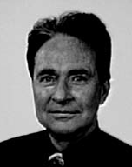

**Certificate 088 RETIRED**

## REED L. HOLT, DDS

Dr. Holt was born in Salt Lake City, Utah and graduated from Northwestern Dental School. Before attending dental school, he received a BS in vertebrate zoology from the University of Utah. After completion of his dental degree, Dr. Holt spent four years on active duty with the US Army in Munich, Germany. Upon his return home, he opened a private dental practice in Salt Lake City. He continued his military career by joining the reserves, where he was Commander of the 143rd Medical Detachment for nine years, Chief of Dental Service for the 328th General Hospital (1000 bed) for 15 years and

Deputy Commander of the 328th General Hospital for 4 years. He began an annual dental reserve symposium for dentists in Utah, Wyoming and Idaho in 1972. In 1990, the symposium drew over 300 dentists from the area. Dr. Holt retired from the reserves as a Colonel in 1989. During his military service, he received numerous awards and decorations, including the Meritorious Service Medal and the Legion of Merit. On the Civilian side, Dr. Holt was active with the district dental society, serving on its board of directors and peer review committee. Dr. Holt first became interested in forensic dentistry in 1978. He attended the AFIP course and then began working with the medical examiner for the state of Utah. At present, he is the dental consultant to the medical examiner for the State of Utah. Many interesting forensic cases have come across his desk, including the Wilberg mine disaster and a midair collision over the Salt Lake Valley. Dr. Holt lives in Salt Lake City with his wife Rosemary and has three grown children, Lawrence, Colby and Heather and two grandchildren, Ariel and Andrea.

06/04

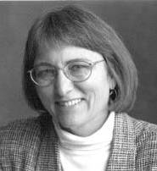

**Certificate 089**

## ANN L. NORRLANDER, DDS

Dr. Norrlander became a Diplomate of the ABFO in 1989. She has served in numerous positions with the Board, including acting as its president in the 1996-97 term of office. She has also served on the Board of Governors for the ASFO. Since 1985, Dr. Norrlander has been a Deputy Medical Examiner and Forensic Dental Consultant for Ramsey and Hennepin Counties. She has also lectured frequently to local law enforcement, dental organizations and students at the University in forensic dentistry. She is the originator of the area disaster ID team with which she is still an active member. Dr. Norrlander maintains a general dentistry practice in downtown Minneapolis and lives within the metropolitan area with her husband and two active children.

06/04

**

**Certificate 090 REVOKED**

C. JACK RANDEL, DDS



**Certificate 091 REVOKED**

## HARVEY A. SILVERSTEIN, DDS

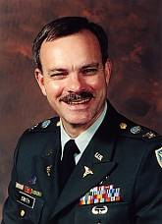

**Certificate 092 RETIRED**

## BRION C. SMITH, DDS

Colonel Brion Smith was born in Front Royal, Virginia and graduated with distinction from the Virginia Military Institute with a Bachelors Degree in Biology in 1978. After receiving his Doctorate of Dental Surgery (DDS) from the Medical College of Virginia in 1982, he joined the United States Army and completed his general practice internship at Moncrief US Army Hospital at Fort Jackson, South Carolina. Brion Smith completed a residency program in Oral and Maxillofacial Pathology at the National Naval Dental Center in Bethesda, Maryland in 1993 and a Callender-Binford Fellowship in Head and Neck Pathology at the Armed Forces Institute of Pathology (AFIP) in Washington, DC in 1994. Colonel Smith’s formal military education includes the AMEDD Officers Advanced Course, the Combined Armed Services Staff School, and the Command and General Staff College. His previous assignments include the 326th Medical Battalion of the 101st Airborne Division in Fort Campbell; the Multinational Force and Observers in the Sinai, Arab Republic of Egypt; Schofield Barracks Dental Clinic in Hawaii; two tours with the US Army Central Identification Laboratory, Hawaii; US Army Dental Activity, Walter Reed Army Medical Center, Washington, DC; and the Armed Forces Institute of Pathology, Washington, DC. Colonel Smith is the recipient of the 1993 Chief of the Naval Dental Corps Award for Outstanding Resident and the 1994 Boyers-Cumaloda Award for forensic research. His personal awards include the Defense Meritorious Service Medal (two awards) and the Meritorious Service Medal (three awards). He is also holds the Expert Field Medical Badge and is Air Assault qualified

06/04

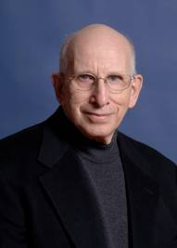

**Certificate 093**

## MICHAEL N. SOBEL, DMD

Dr. Sobel has served in the capacity of Chief Forensic Odontologist for the Allegheny County Coroner's Office since 1970 (currently the Medical Examiner’s Office). He has been appointed as a Special Investigations Advisor to the Pittsburgh and Allegheny County Police Departments, and acts as a Forensic Dental Advisor to the Pennsylvania State Police. He has been a Diplomate in the ABFO since 1989 and served on the ABFO Continuing Education Committee. He was the Chairman of the subcommittee on Forensic Odontology (E30.06) of the ASTM from 1992-2001. Following graduation from the University of Pittsburgh School of Dental Medicine in 1962, he completed residencies in both oral pathology and orthodontics. Dr. Sobel is a Clinical Associate Professor and Director of Forensic Odontology Studies at the University of Pittsburgh School of Dental Medicine, where he has taught oral pathology, orthodontics and forensic dentistry. In addition, he is on the consulting staff of Children's Hospital of Pittsburgh, where he serves as a consultant to the Suspected Child Abuse and Neglect (SCAN) Committee. Dr. Sobel has served as the original director and co-founder of the Pennsylvania Dental Association's Dental Identification Team, and more recently as coordinator of the Western Pennsylvania Dental Identification Team. He also participates with the Greater Pittsburgh International Airport Emergency Planning Committee. As the author of a number of professional papers and articles and book chapters on forensic odontology, Dr. Sobel remains active with his main forensic research interests including: child abuse evaluation and photographic and computer enhancement of patterned skin markings. He was the original investigator in the first fingernail scratch identification case adjudicated before the courts. In the 2000 case of Sheppard Estate v. State of Ohio he was a forensic science expert witness for plaintiff in the historic trial to determine wrongful imprisonment of Dr. Sam Sheppard accused of homicide in the1954 Marilyn Sheppard murder case, February-April, 2000. Dr. Sobel is active in community affairs and is on the boards of several regional organizations. 06/06

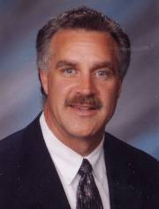

**Certificate 094 RESIGNED**

## FRANKLIN D. WRIGHT, DMD

Dr. Wright received his DMD from the University of Kentucky in 1984. He has a general dentistry practice in Cincinnati. He became a Diplomate of ABFO in 1989 and he is a member of ASFO and AAFS. He is a member of the American Dental Association (ADA), the Ohio Dental Association (ODA) and the Cincinnati Dental Society (CDS). He is a delegate of the Ohio Dental Association and is the Chairman of the ODA Forensic Dental Team as well as serving on the CDS Council and is the Chairman of the CDS Forensic Dental Team. Since 1986, he has been the forensic dental consultant for the Hamilton County (Cincinnati) Coroner’s Office and is a Chief of the Hamilton County Coroner’s Office Forensic Dental Team. As a Diplomate of the ABFO, Dr. Wright is the Chairman of the ABFO Strategic Plan Committee, a member of the Human Abuse Committee, which he chaired from 2000-2002, the Bitemark Committee, the Mass Disaster Committee and the Missing and Unidentified Persons Committee. He is a Fellow of the Odontology Section of the American Academy of Forensic Sciences (AAFS), where he has served as the Odontology Section Program Chairman, Secretary and Section Chairman. Within the AAFS, he has also served on the Local Arrangements Committee (Cincinnati, 1990), the Continuing Education Committee, the Nominating Committee, the Ethics Committee and as a member of the AAFS Council. He is a member of the American Society of Forensic Odonotology (ASFO) where he is a member of the Editorial Board and has served on the ASFO Board of Governors. He is the national dental advisor for the Parents of Murdered Children (POMC) and is a member of the Disaster Committee at the Cincinnati/Northern Kentucky International Airport. Research and publishing interests include the use of visible & non-visible light photography and digital imagery in the documentation of bitemarks and other patterned injuries

06/04

**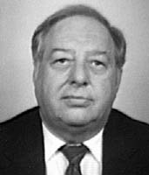**

**Certificate 095 DECEASED**

## BERNARD L. HARMELING, DMD

Dr. Harmeling became a Diplomate of the ABFO in 1989. He has been a member of the ABFO Nominating Committee but has held no elected positions in the ABFO, ASFO or AAFS. He received his DMD from the University of Louisville School of Dentistry in 1959. He spent two years in the US Air Force Dental Corps, where he was first introduced to Forensic Odontology in 1960. He has been in private practice as a general dentist since 1961. Dr. Harmeling has been the chief forensic dentist in five major disasters, including the Beverly Hills Supper club disaster in 1977. He is presently the chief forensic dental consultant to the Cincinnati/Northern Kentucky International Airport, forensic dental consultant to the Hamilton County Coroner's Office, Cincinnati, Ohio, and to the Boone County Coroner's Office, Florence, Kentucky. Dr. Harmeling is the chairman of the Northern Kentucky Dental society's Dental Identification Team which he formed in 1966. He is a Fellow of the ICD and a member of the AAFS and ASFO.

12/93

**

**Certificate 096**

**REVOKED**

JEFFREY R. BURKES, DDS

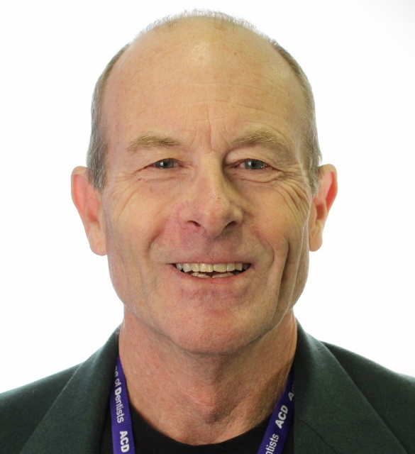

**Certificate 097**

## RICHARD H. FIXOTT, DDS

Dr. Fixott was born in Portland, Oregon and grew up in California near San Francisco. He attended undergraduate school in UOP in Stockton and Dental School at UOP in San Francisco. He graduated in 1977 and spent eight years active duty in the US Army, four in Germany and four in Hawaii. Dr. Fixott left active duty in 1986 and worked in private practice in Waianae and Maui until 1989. He then worked full time at the Central Identification Laboratory until 1992. He became a Diplomate of the ABFO in 1991. He moved to Oregon in 1992 working in the Portland area until moving to Redmond Oregon in 2005 to start his own practice. He retired as a Colonel in the Army Reserve after deployments to Bosnia, Missouri and Iraq. Dr. Fixott sold his practice in 2016 and does pro bono work with community clinics. He is a member of the Pierre Fuchard Society and American College of Dentists, and is a Fellow in the AAFS. Other interests include running and multi-sport events and keeping up with the dogs and wife Tamara. 04/18

*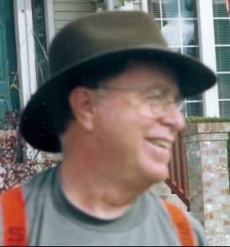*

**Certificate 098 Certified 1992- Retired 2002**

## GERALD F. JONES, D.D.S.

Dr. Jones grew up near Bakersfield, CA. He attended undergraduate school at UC Santa Barbara and dental school at UCLA. He received his DDS degree in 1970 and then served two years with the US Navy at Camp Pendleton, before entering private practice in McCloud, CA. In 1977 he and his family moved to Priest River, Idaho, where he continues in private dental practice. He currently is a member of the ASFO, ADA, the Idaho Dental Association and the North Idaho Dental Society. He is founder and state chairman of the ISDA Mass Disaster Identification Committee. He is a fellow in the AAFS and a Diplomate of the ABFO. He is a consultant to several coroner and law enforcement offices in Idaho and Washington State. He holds the position of Deputy Coroner, Bonner County, Idaho. Dr. Jones has worked with CAPMI for a number of years and has written and lectured about its potential value to law enforcement.

01/05

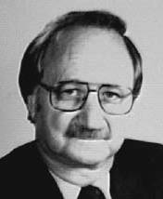

**Certificate 099 DECEASED**

## PHILIP J. LEVINE, DDS

Dr. Levine has a B.A. and M.A. from Vanderbilt University and a D.D.S. from the University of Tennessee. He has maintained a private practice of dentistry in Pensacola, Florida since 1963. He is currently a member of the ADA, the FL Dental Association and the Federation Dentaire Internationale, a fellow in the AAFS and the International College of Dentists and a Diplomate of the ABFO. He is also a consultant to the Medical Examiner, District One State of Florida and to the Florida Department of Law Enforcement. as well as team leader of the Northwest Florida Forensic Dental Identification Team.

05/98

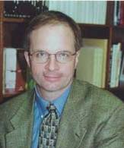

**Certificate 100**

## JOHN A. LEWIS, JR., D.D.S.

A native of Wisconsin, Dr. Lewis completed his undergraduate studies at the University of Wisconsin-Madison and graduated from Marquette University School of Dentistry in 1981. He was commissioned as an Ensign in the U.S. Navy Dental Corps during his third year of dental school and began active duty upon graduation. He retired from the Navy in January 2009 as a Captain and is currently serving as a consultant to the Mississippi State Medical Examiner’s Office in Jackson, MS.  He has been a forensic consultant to a number of organizations including the Florida State District IV Mass Disaster ID Team, Guam International Airport Authority, Naval Criminal Investigative Service, San Diego & Imperial County Coroner's Office, and the Autopsy Service of Naval Hospital San Diego. He became a Diplomate in 1992 and has served the ABFO in a number of capacities including as President of the organization in 2004.

12/09

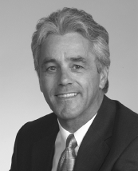

**Certificate 101**

## DAVID SWEET, OC, DMD, PhD

Dr. Sweet is a tenured professor at the UBC Faculty of Dentistry and Director of the UBC Bureau of Legal Dentistry laboratory. He is a consultant odontologist to the Office of the Chief Coroner, Province of British Columbia; Royal Canadian Mounted Police; and several international police agencies. Among other awards and distinctions, Dr. Sweet has received the UBC Killam Excellence in Teaching Award, the UBC Faculty Citation for Community Service, Her Royal Highness Queen Elizabeth II’s Golden Jubilee Medal for Service to Canada, and the College of Dental Surgeons of British Columbia Certificate of Merit. He is a six time recipient of UBC's Meritorious Service Award for excellence in research and service.

06/04

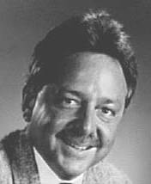

**Certificate 102**

## MICHAEL P. TABOR, DDS

A native of Oak Ridge, Tennessee, Dr. Tabor received his B.S. degree from Carson Newman College and his D.D.S. from the University of Tennessee College of Dentistry. He has practiced general dentistry since 1975 and is a Fellow of the Academy of General Dentistry, a member of the American Academy of Dental Practice Administration, and in 1989 was appointed to the Tennessee State Board of Dentistry. He has also served in several capacities with the Nashville Dental Society, the Tennessee Dental Association and the American Dental Association. In the field of forensic dentistry, Dr. Tabor is a Fellow in the American Academy of Forensic Science and a Diplomate of the American Board of Forensic Odontology. He serves as Chief Dental Consultant for the Office of the Medical Examiner for the State of Tennessee. Dr. Tabor is also active in community and civic activities as a high school football coach and a member of the Hendersonville Chamber of Commerce and Sertoma Club.

06/04

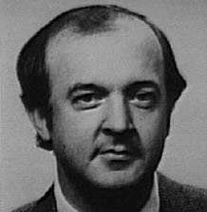

**Certificate 103**

## DONALD O. SIMLEY II, DDS

## Dr. Simley has been involved in forensic dentistry since 1981. He serves as a consultant in forensic dentistry to the Dane County Coroner's Office and the Wisconsin Department of Justice's Crime Laboratory Bureau and the Division of Criminal Investigation. He is a Fellow in the AAFS. He is a member of the ASFO and in 1993 was elected to a term on the Board of Governors of that organization. He is a Fellow in the International College of Dentists. He is a member of the Wisconsin Association for Identification and a member of the National Disaster Medical System (DMORT Team). Dr. Simley serves as the Alternate Team Leader and the Postmortem Examination Supervisor of the Wisconsin Dental Association's Disaster Identification Team. He is also a member of disaster identification teams in the state of Minnesota, Cook County, Illinois and Lake County Illinois.

05/98

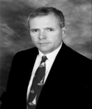

**Certificate 104**

## BRYAN CHRZ DDS.

Dr. Bryan Chrz has a private dental practice in his home town of Perry, Oklahoma. He graduated from the University of Oklahoma College of Dentistry in 1978. Dr. Chrz is a member of the staff of Perry Memorial Hospital, Dental Consultant to the Office of the Chief Medical Examiner of the State of Oklahoma, Independent Medical Examiner for the Workers’ Compensation Court of the State of Oklahoma, and consults for Kenyon International Emergency Services. Dr. Chrz is a member of Omicron Kappa Upsilon and Alpha Omega both honorary dental fraternities. He is a recipient of the Masonic Lodge’s Good Citizen Award. He received numerous certificates of recognition for his activities during the Alfred P. Murrah bombing including a proclamation from the Governor of Oklahoma and a certificate from the U.S. Department of Treasury and U.S. Customs. He was honored by the Oklahoma Dental Association with the Benjamin Franklin Scroll Award for his contributions to the ODA Journal. Dr. Chrz has been interested in forensic odontology for the past sixteen years. He is a member, past director, and reviewing editor of the American Society of Forensic Odontology. He is a fellow of the American Academy of Forensic Sciences. Dr. Chrz is a diplomate and President-elect of the American Board of Forensic Odontology. He is a member of the DMORT region VI team and has been activated numerous times for disaster response. He was activated for both the World Trade Center Terrorist attack and the American Airlines Flight 587 crash in Queens. He has written numerous articles and is active in lectures across the country on forensic odontology and computer assisted identification. Dr. Chrz was invited to teach a course for the Armed Forces Institute of Pathology in Washington. DC in March 2002. Dr. Chrz taught a section for the Southwest Symposium on Forensic Dentistry at The University of Texas at San Antonio in the summer of 2002. The University of Oklahoma School of Law used Dr. Chrz’s expertise in a seminar on admission of evidence in the courtroom. He is currently working on digital radiography and photography applications in forensic investigations. Most recently he has been involved in writing a procedure manual for the Department of Justice relating to human identification in mass fatality incidents. Dr. Chrz also wrote a section of the Dental Clinics of North America that concentrated on Forensic Odontology. He acts as an expert witness in criminal and civil trials. He has been qualified as an expert in State and Federal courts. 06/04

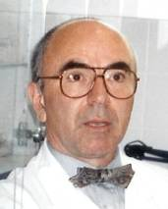

**Certificate 105 DECEASED 7-99**

## MICHEL EVENOT, DDS, MS

Dr. Evenot was born on May 17, 1946 in Paris, France and died on July 13, 1999. Dr. Evenot received his BS in general science and experimental science from the Faculty of Medicine in Paris in 1968. In 1972 he received his dental degree from the Faculty of Medicine and completed his post graduate training in endodontics and oral biology from the University of Paris Dental School in 1974. Additional national certificates in prosthetics, periodontology, and forensic odontology were received during 1974/76 from University of Paris Dental School. In 1980 Dr. Evenot received a MS degree from University of Paris with honors (silver medal). He attended numerous courses in North America including the 1977 individual short program in endodontics at Boston University, 1992 AFIP Forensic Dentistry Program, 1992 Southwest Symposium on Forensic Dentistry and the 1993 workshop in Forensic Anthropology at the Smithsonian Institution. In 1983 he received his certificate in medical and dental expertises. Dr. Evenot received his University Certificate in Criminalistics from the University of Paris Medical School in 1990. He became a diplomate of the ABFO in 1995. From 1975 to his untimely death he maintained a part time private practice limited in endodontics while also being head of the Forensic Odontological and Anthropological Laboratory R. Poincaré Hospital at the University of West Paris. Dr. Evenot has been an invited speaker and lecturer both in France and international. He has 34 publications, 45 abstracts, and over 200 lectures to his credit.

01/05

**

**Certificate 106**

## CURTIS S. HANSFORD, DMD REVOKED

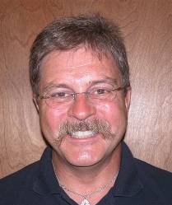

**Certificate 107**

## ROBERT G. WILLIAMS, DDS

Dr. Robert Williams is a practicing dentist in Dallas where he is currently the Chief Forensic Odontologist for the Southwestern Institute of Forensic Sciences. He is consultant to the Attorney General’s office of the State of Texas, the U.S. District Attorney’s Office, Texas Rangers, and the Judge Advocate General’s Office, U.S. Dept. of the Navy. He is an Associate Clinical Professor for the Baylor College of Dentistry, and is an Associate Research Professor for the Laboratory of Human Identification of the University of North Texas Department of Biological Sciences. He is also a member of D-Mort Region VI under the direction of the Health and Human Services Department.

06/04

*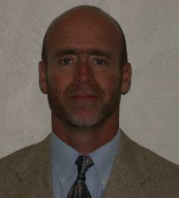*

**Certificate 108 RETIRED**

## DANIEL M. WINTER, DDS

Dr. Daniel M. Winter received his D.D.S. from the University of Colorado. He completed a two year general practice residency at Charity Hospital of New Orleans in association with Louisiana State University School of Dentistry. Dr.Winter relocated to Manhattan Kansas where he currently maintains a general dental practice. In addition to Board Certification in Forensic Dentistry, Dr. Winter is a Fellow in the Academy of General Dentistry, The American Association of Hospital Dentists and the American Academy of Forensic Science. Dr Winter serves as a forensic dental consultant to the Shawnee County Coroner office, the Sedgwick County Coroner office, the Kansas Bureau of Investigation as well as numerous other law enforcement agencies. Dr. Winter currently serves as chief of the Kansas Dental Identification Team.

06/04

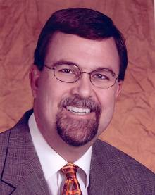

**Certificate 109 RESIGNED**

## RICHARD D. DIAL, DDS

Dr. Dial is a 1987 graduate of the University of Colorado School of Dentistry. He completed a general practice residency in 1988 and has maintained a general practice in Lakewood, Colorado since 1989. Dr. Dial served as Deputy Coroner of Jefferson County from 1989 to 1992. He is currently the Coroner of the same county. Dr. Dial is a forensic consultant to many Colorado counties and law enforcement agencies. He is an active member of the American Society of Forensic Odontology, the Rocky Mountain Division of the International Association for Identification and a fellow of the American Academy of Forensic Sciences. A member of DMORT Region VIII, Dr. Dial has assisted in the identification of victims of the World Trade Center and Hurricane Katrina disasters. Dr. Dial has served two terms on the ABFO Board of Directors and is the current President-elect of the organization. He enjoys playing golf, basketball and gourmet cooking.

06/06

*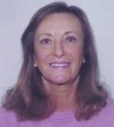*

**Certificate 110**

## PAMELA W. HAMMEL, DDS

Dr. Hammel is a Fellow of the American Academy of Forensic Sciences, a Fellow of the American College of Dentists, a Fellow of the International College of Dentists, and a Fellow of the Pierre Fauchard Academy. She served eight years on the Michigan State Board of Dentistry, from 1992­ 2000, and was a Dental Examiner for the Northeast Regional Board of Dental Examiners. She is the Forensic Dental Consultant to the Oakland County Medical Examiners Office, and to Children's Hospital of Michigan, and was a consultant to the Wayne County Medical Examiner's Office from 1985-2000. Dr. Hammel is also an advisor to the Medical Advisory Board to the Family Independence Agency (of Michigan). She has been the Assistant Team Leader to the Michigan Forensic Dental Identification Team, head of the Postmortem Section since 1985, and has participated in three aviation disasters, and the WTC Identification unit. She has been a member of DMORT since 1996, and was Board Certified the same year. Dr. Hammel served on Board of Directors to the ASFO, 1991-1994; and served as Program Chair for the Odontology Section AAFS 1998-2000; Section Secretary 2000-2002; Section Chair 2002-2004. She was elected to the Board of Directors of the ABFO in 2001, and re-e1ected in 2004. Dr. Hammel was a member of the policy planning committee of the ADA to explore "Does Dentistry have a Role in the Event of a Bioterrorist Attack?" Chicago, 2002. Her publications include Journal of the Michigan Dental Association, May, 1995. Archives of Pediatric and Adolescent Medicine, April 1996 (cover story) and The New England Journal of Medicine, Sept. 11, 2003.

06/04

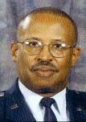

**Certificate 111**

## ERNEST JACKSON, DMD

Dr Jackson is a 1988 graduate of the School of Dental Medicine at Southern Illinois University. In addition to a DMD degree, he holds a Masters Degree in Criminal Justice. His many certifications include clinical immunology and interpretation and forensic pathology investigation. Dr. Jackson is a Fellow of the American College of Dentists, Fellow of the International College of Dentists and a Fellow of the Pierre Fauchard Academy. Over the years Dr. Jackson has used his dental expertise to provide service to many U.S. law enforcement agencies, including the Federal Bureau of Investigation. He has worked as a special consultant for the U.S. Department of Justice, Attorney General's Office as a forensic odontology consultant. He is an expert at determining identity of disaster or crime victims based on dental records. He has worked for the Air Force Office of Special Investigation, the Armed Forces Institute of Pathology, and as the Washington, D.C., Forensic Dentistry Consultant. He was the assistant chief of forensic odontology in Operation Desert Shield and Desert Storm. The U.S. Air Force has conferred upon Dr. Jackson the title of Distinguished Medical Consultant in Forensic Odontology and presented him with two medals for Meritorious Achievement and Meritorious Service. Dr. Jackson has taught two workshops at a conference in France. Most of Jackson's work is spent managing dental services for the Missouri prison inmates. He's in charge of 35 to 40 dentists throughout the state and has been working in dental services for inmates about 15 years. In the 1993 flood of the Missouri River Dr. Jackson and a forensic anthropologist identified over 300 cadavers that had washed out of a cemetery

01/05

***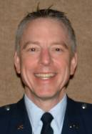***

**Certificate 112**

## DAVID W. JOHNSON, DDS

Dr. David Johnson is a 1974 graduate of the University of Iowa College of Dentistry. Upon graduation he served two years on active duty with the U.S. Air Force and was stationed at Malmstrom AFB Montana. Following his active duty commitment, he continued his education with a year of hospital training at Charity Hospital in New Orleans. In 1977 Dr Johnson returned to Great Falls Montana where he established his practice of General Dentistry.

Dr. Johnson received his initial forensic dental training at the Armed Forces Institute of Pathology in 1977 as a member of the Air Force Reserve. In 1981 he was accepted as a member of the American Academy of Forensic Sciences (AAFS) and the following year, as a member of the American Society of Forensic Odontology (ASFO). He completed his preceptor ship in Forensic Sciences at the Oregon Health Sciences University in 1985 and became a Fellow in the AAFS that same year. Since 1981 Dr. Johnson has taught dental identification and bitemark evidence collection at the Montana Law Enforcement Academy and serves as a consultant to the Montana Department of Justice Medical Examiner’s Office and to Montana’s County Coroners. Dr. Johnson became a Diplomate of the American Board of Forensic Odontology in 1996. In year 2000 he was elected to a three year term on the ASFO’s Board of Governors and in 2005 he was elected their President.

Dr Johnson holds the rank of Colonel in the Air Force Reserve Dental Corps. He received his commission in 1971 and throughout his Reserve career has been attached to various Air Force clinics and Headquarter Commands. His leadership and experience led to his selection from 2002-2004 as the Mobilization Assistant to the Assistant Surgeon General for Dental Services …the most senior Air Force Reserve Dental Corps advisor position at Air Staff. His current Reserve attachment is to the Armed Forces Medical Examiners Office as a Forensic Dental Investigator.

Dr. Johnson was elected 2005-2006 President of the Montana Dental Association (MDA) and is a past member of the MDA Board of Directors. He is a Fellow of the American Academy of General Dentistry, a Fellow of the International College of Dentists, a member of the American Dental Association and a member of the Association of Military Surgeons of the United States.

01/06

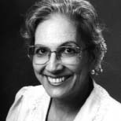

**Certificate 113**

## ARACELI ORTIZ, DMD, MSD DECEASED

Dr. Ortiz is a full professor at the University of Puerto Rico, School of Dentistry and is the Forensic Odontologist of the Institute of Forensic Sciences of Puerto Rico. She has been engaged in forensic odontology since 1968. She is a Diplomate of the American Academy of Oral and Maxillofacial Pathology (1967), the American Board of

Oral Medicine (1975) and became a Diplomate of the American Board of Forensic Odontology in 1996. She is a Fellow of the American Academy of Forensic Sciences and the American Academy of Oral and Maxillofacial Pathology. A researcher and author of several publications, she has lectured extensively in North, South and Central America as well as Spain and the Caribbean. She has been the producer and host of international and local award winning television programs on oral health (1978-1990). A member of many professional and civic organizations, she has been a member of the board of governors and active on committees in most of them. Dr. Ortiz has been the recipient of numerous awards for professional, civic and personal excellency and outstanding performance.

05/02

**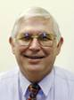**

**Certificate 114 Certified 1999- Retired 2006**

## MARDEN E. ALDER, DDS, MS

Dr. Alder is a graduate of Loma Linda University School of Dentistry 1965. He was in private practice in Safford, Arizona from 1966-1987. While practicing in Arizona, he served as a consultant to the Graham County Coroner. In 1989, he received a Masters degree in Dental Diagnostic Science from The University of Texas Health Science Center at San Antonio, Graduate School of Biomedical Studies. He was on faculty at UTHSCSA School of Dentistry from 1989-2002. While there he taught Advanced Imaging Systems to the Graduate Dental Diagnostic Science students and Forensic Odontology to the Undergraduates. Additionally, he helped develop the Center for Education and Research in Forensics at UTHSCSA. While in San Antonio, he served as a consultant to the Bexar County Medical Examiner's office. He is currently a professor and director of Oral Maxillofacial Radiology at UNLV School of Dental Medicine. He is a past president of the American Society of Forensic Odontology and a Fellow of the Odontology section of the American Academy of Forensic Science. He is a Diplomate of the American Board of Forensic Odontology and also a Diplomate of the American Board of Oral and Maxillofacial Radiology. He has the support of his wife, Sharon and their 5 children.

01/06

**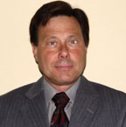**

**Certificate 115 RETIRED**

## DOUGLAS M. ARENDT, DDS, MS

Dr. Arendt is a Captain in the United States Navy, currently assigned as Chief Forensic Odontology and staff pathologist at the Armed Forces Institute of Pathology. Doug serves as the Specialty Leader to the Surgeon General (Navy) and has served on the ASFO Board of Governors. He most recently directed the AFIP 2000 Forensic Course. Prior to this assignment he was the laboratory officer for three years at the Naval Dental School in Bethesda, Maryland.. Doug was awarded his DDS from the Medical College of Virginia in 1976. Subsequent to graduation he was assigned as the Dental Officer on a helicopter carrier (USS Inchon LPH12). His residency in Oral Maxillofacial Pathology began in 1979 and was completed in 1984 at which time he successfully challenged the board certification exam. During his residency he was awarded an MS while at Georgetown University.

12/02

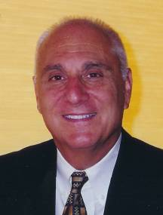

**Certificate 116**

## JOHN A. PIAKIS, DDS

Dr. Piakis is a graduate of Georgetown University Dental School. He is currently the forensic odontologist and consultant to the Maricopa County Medical Examiner's Office in Phoenix, Arizona. His interest in forensic odontology began in 1970 as an army dental officer in Chu Lai, Viet Nam. Dr. Piakis is the founder and supervisor of the Arizona Mass Disaster Dental Identification Team along with being a member of DMORT, district nine. He has been a member of the ASFO since 1988 and is a Fellow in the Academy of Forensic Sciences. He became a Diplomate in the American Board of Forensic Odontology in 1999 and served as chairman of Accounts Committee for the Section since 1994. Dr. Piakis has added the missing and unidentified persons dental records throughout the state of Arizona into the California Department of Justice Computer Assisted Post Mortem Identification Program CAPMI system. In addition to being an active lecturer in the state of Arizona, he has a private practice in general dentistry in Phoenix.

06/04

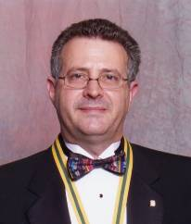

**Certificate 117**

## GARY M. BERMAN, DDS

Dr. Berman is a 1981 Graduate of the University of Michigan Dental School. He is a general dentist in private practice in Belleville, Michigan. He became a Fellow of the AAFS in 1997 and a Diplomate of the ABFO in 2002. He has served a three year term on the Board of Governors for the ASFO from 1999- 2001, and was elected president-elect in 2002. He is a consultant to the Wayne and Oakland Counties Medical Examiner’s Office in Michigan, and the assistant team leader to the Michigan Dental Association’s Forensic Dental Identification Team. Dr. Berman is a member of DMORT Region V, and was activated during the World Trade Center disaster. He has lectured on Mass Disaster throughout the United States, and is one of the instructors for the University of Detroit-Mercy Forensic Odontology course held every spring.

06/04

**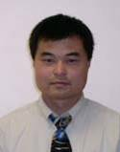**

**Certificate 118**

## KIM M. LOOK, DDS

Dr. Look was born and raised in Seattle, Washington. He did his undergraduate studies at the University of Washington and received his dental degree for Creighton University. He is in private practice in Colorado Springs, Colorado where he is a consultant to the El Paso County Medical Examiner’s Office. He is a member of DMORT Region VIII, the Rocky Mountain Body ID team, ASFO, and a fellow in the AAFS and diplomat in the ABFO since 2002.

06/04

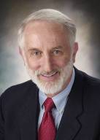

**Certificate 119**

## DAVID R. SENN, DDS

David R. Senn, D.D.S., D.A.B.F.O., Clinical Assistant Professor, University of Texas

Health Science Center at San Antonio. At UTHSCSA he is Director, Center for Educationand Research in Forensics (C.E.R.F), Director (15th through 19th sessions), Southwest Symposium on Forensic Dentistry, and Director, Postdoctoral Fellowship in Forensic Odontology (2000-present). Dr. Senn is Chief Forensic Odontologist for the Office of the Bexar County Medical Examiner, Director of the Bexar County Forensic Dental Team, DVI, and a member DMORT region VI. He is a Diplomate of the American Board of Forensic Odontology, a Fellow in the American Academy of Forensic Sciences, and a member of the American Society of Forensic Odontology. He is a Fellow of the American College of Dentists, a Fellow of the International College of Dentists, a member of the American Dental Association, Texas Dental Association, and the San Antonio District Dental Society. Dr. Senn practiced general dentistry in the U.S. Army for three years and in private practice in San Antonio, Texas for 21 years. He has practiced and taught forensic odontology exclusively since 1992.

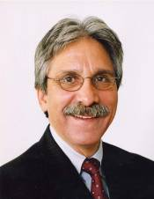

**Certificate 120**

**BARRY E. LIPTON, DDS**

## Dr. Barry Lipton earned his dental degree from Temple University School of Dentistry in 1971 and did post graduate work in anesthesia and pain control at the University of Pittsburgh School of Dentistry. He presently maintains a private practice in general dentistry in Largo, Florida and serves as a Dental Examiner for the Florida Board of Dentistry. Dr. Lipton is the Chief Forensic Odontologist, Office of the Medical Examiner, for the Fifth, Tenth and Thirteenth Judicial Districts, State of Florida and serves as a consultant to the State’s Medical Examiners Commission and the Florida Department of Law Enforcement. Dr. Lipton became a Diplomate of The American Board of Forensic Odontology in February of 2004. He is a fellow in the American Academy of Forensic Sciences and the International College of Dentists. He is a member of D-Mort-4, the Florida Association of Medical Examiners, the American Society of Forensic Odontology and the International Association for Identification.

06/04

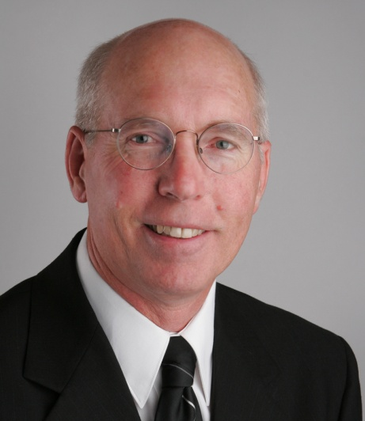

**Certificate 121**

## PETER W. LOOMIS, DDS

Dr. Loomis received his dental degree from the University of Missouri at Kansas City School of Dentistry in 1972. After completing a one year general practice residency with the U.S. Public Health Service at the Alaska Native Medical Center in Anchorage, he spent two years on active duty with the Indian Health Service. He opened his general dental practice in his hometown of Albuquerque in 1975, which kept him busy until his retirement from clinical dentistry in 2002. He received his formal training in forensic odontology at AFIP and the University of New Mexico, School of Medicine and has been a forensic odontology consultant for the Office of the Medical Investigator in Albuquerque, New Mexico since 1976. He is a fellow of the AAFS, a member of the ASFO, and is the founder and director of the New Mexico Mass Disaster Dental Identification Team. He is a forensic odontologist for DMORT Region 6, where he served as a team member during the aftermath of hurricane Katrina and hurricane Ike. In 2004 he became a Diplomate of the American Board of Forensic Odontology. He is a member of the NDIR review panel and is the SW regional forensic odontologist for NamUs. As well as his consultative and research work at OMI, he presents the annual odontology training to the forensic pathology Fellows at the UNM School of Medicine and is the forensic odontologist for the UNM Hospitals Child Abuse Response Team. Dr. Loomis is married and has five children and seven grandchildren.

06/09

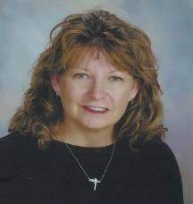

**Certificate 122**

**JAN J. WESTBERRY, DMD**

## Dr. Westberry received a B.A. in biology from the University of North Carolina in 1975 and a B.S. in Radiologic Sciences from the University of Central Florida in 1977.  She graduated from the University of Florida Dental School in 1984.  Dr. Westberry is a member of the Florida mass disaster team, FEMORS, and the national mass disaster team DMORT, region IV.  She has practiced general dentistry for twenty years in New Smyrna Beach Florida. For fourteen years she has been the chief forensic odontology consultant for the 7th and 24th Florida Medical Examiners Districts. Dr. Westberry and her husband, Dr. Rich Westberry, also a general dentist, have three children.

06/04

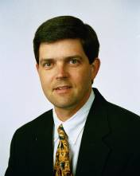

**Certificate 123**

## JAMES D. WOOD, DDS

A native Californian, Dr. James Wood is a family practice dentist in Cloverdale, California. He is a 1982 graduate of the University of California at Riverside and a 1986 graduate of the Loma Linda University School of Dentistry. He is a Fellow of the Academy of General Dentistry, a Fellow of the Academy of Forensic Sciences, and a Fellow of the American College of Dentists. He has been in private practice since 1986.Dr. Wood is a Past President and the current Legislative Chair of the Redwood Empire Dental Society. He is the Chair of California Dental Association’s Council on Legislation (2003). In addition he is active in national legislative issues affecting dentistry with the American Dental Association. He is also a trustee to the California Dental Association and an ADA delegate. He has been involved in the field of forensic dentistry since 1994. Currently Dr. Wood is a Forensic Dental Consultant to the Mendocino, Lake, and Sonoma County Sheriff’s Departments and the Santa Rosa Police Department. He is also a consultant to the California Department of Justice

Missing/Unidentified Persons Unit and the Missing Persons DNA Task Force. He is a member of DMORT Region IX. He is also one of the founders of the California Dental Identification Team. Dr. Wood became a Diplomate of the American Board of Forensic Odontology in 2004.

06/04

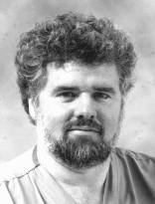

**Certificate 124**

## ROBERT E. WOOD, DDS, MS, PhD

## Dr. Wood became a Diplomate of the ABFO in 2004. He is an Associate Professor and member of Graduate Faculty at the Faculty of Dentistry, University of Toronto. He is Chief Forensic Dentist for the Coroners Office of the Province of Ontario in Toronto, Canada.  He holds specialty and general practice certification in Ontario where he has a full-time hospital appointment at the Princess Margaret Hospital, the University of Toronto. His clinical practice is limited to treating Oncology patients, and patients who are medically unwell. He has been active in forensics since 1986. He is a member of the Province of Ontario Dental Identification Team.

06/04

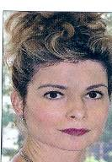

**Certificate 125**

**KATHLEEN M. CROWLEY, DMD**

No biographical information submitted.

06/06

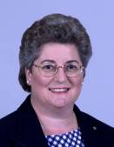

**Certificate 126**

**VERONIQUE F. DELATTRE, DDS**

Dr. Delattre is Associate Professor in the Department of Restorative Dentistry and Biomaterials at the University of Texas Dental Branch at Houston. She is director of the forensic dentistry course, and presents continuing education courses in the field of forensic dentistry. She serves as the chief forensic dental consultant to the Harris County Medical Examiner’s Office. Dr. Delattre received her Doctor of Dental Surgery degree from the University of Texas Dental Branch at Houston in 1986. She had previously received a Bachelor of Science degree in Biology and a Bachelor of Science degree in Chemistry from Houston Baptist University. Dr. Delattre was active in the private practice of dentistry until she joined the faculty of the Dental Branch in 1994. She is the author of over 30 refereed scientific publications. Her specific areas of interest are the field of forensic dentistry including dental morphology, dental anthropology, bitemark analysis, and forensic dental identification. Dr. Delattre is a fellow of the American Academy of Forensic Sciences and a fellow of the Academy of General Dentistry.

06/05

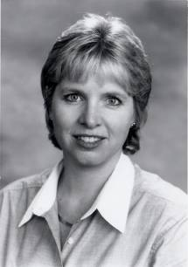

**Certificate 127**

**CATHY A. LAW, DDS**

Dr. Law obtained a degree in cellular biology from the University of California, Berkeley before completing her D.D.S at the UCLA School of Dentistry in 1986. A general practice residency certificate was received from the Veteran’s Administration Hospital in Sepulveda, CA. in 1987. After dental school graduation, Dr. Law spent a brief time as a visiting lecturer at the UCLA School of Dentistry. She became a Fellow of the Academy of General Dentistry in 1993. Dr. Law was drawn into dental forensics by her mentor, Dr. Gerald Vale, during a 1986 lecture at UCLA. She was trained in forensic dentistry at the Armed Forces Institute of Pathology. Dr. Law is a member of the ASFO and a Fellow in the Odontology Section of the American Academy of Forensic Sciences. Her affiliation with the Los Angeles County Department of Coroner began in 1995 and continues to the present time. Dr. Law has also consulted with law enforcement agencies, district attorneys and defense attorneys in the Southern California region. She has lectured to community groups, law enforcement, dental hygiene students and dental students on various topics in forensic dentistry. Dr. Law has been published in the Journal of Forensic Sciences and the ASFO Manual. Dr. Law maintains a full time general dental practice in Upland, CA.

06/05

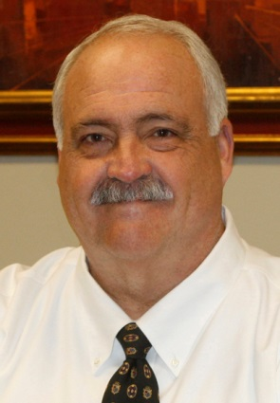

**Certificate 128**

**RICHARD A. WEEMS, DMD, MS**

Dr. Richard (Dick) Weems is a native of Birmingham, Alabama and received his DMD from the University of Alabama School of Dentistry (UAB) in 1977. After graduating dental school he served in the U. S. Army Dental Corps at Fort Jackson, South Carolina from 1977-1979 and received the Army Commendation Medal. Subsequently, he was in private practice in Birmingham, Alabama for three years. He returned to the UAB School of Dentistry to earn a Master's Degree in Dental Radiology in 1982, completing his program in 1984. His first position as full-time dental educator was at the Medical University of South Carolina College of Dental Medicine in Charleston, South Carolina from 1984-1987. He returned to the University of Alabama School of Dentistry as a faculty member in 1987. Currently, he is an Associate Professor and serves as Director of Dental Radiology and Director of Clinical Operations at the University of Alabama School of Dentistry. In addition to his teaching position, Dr. Weems has been a dental consultant to the Alabama Department of Forensic Sciences from 1987- 2013, covering approximately twenty counties in the northern third of the state. He is also the Chief Forensic Odontologist for the Jefferson County (Alabama) Medical Examiner's Office which includes the state's largest metropolitan area, Birmingham. He is the Co-Founder and Director of the Alabama Dental Mass Disaster Identification Team and is also a member of the national mass disaster response team, DMORT, and was deployed to the World Trade Center disaster in September of 2001 and Hurricane Katrina in 2005. He also co-edited the 5th Edition of the ASFO Manual of Forensic Odontology. Dick has been married for forty-two years to his wife, Nancy; and has two children, and four grandchildren.

06/05

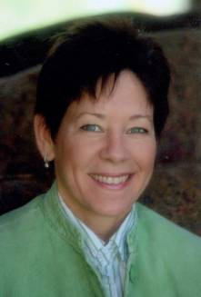

**Certificate 129**

**CYNTHIA BRZOZOWSKI, DMD**

Dr. Cynthia Brzozowski is a graduate of the University of Pennsylvania and Boston University Dental School. She has been a practicing general dentist in New York for 20 years and a Forensic Dental Consultant for the Suffolk County Medical Examiner’s Office since 1995. Dr. Brzozowski is a Diplomate of the American Board of Forensic Odontology, a Fellow of the American Academy of Forensic Sciences and a member of the American Society of Forensic Odontology since 1993. She is currently an Vice President of the Suffolk Society of Forensic Dentistry and helps to train and maintain the Suffolk County Medical Examiner’s Dental Identification Team. Dr. Brzozowski is also a member of DMORT Region 2 team, a division of Homeland Security. Her forensic experiences include forensic dental identifications, mass disasters including TWA Flight 800, WTC, United Flight 587, Hurricane Katrina, missing persons cases as well as consultations in bitemark cases involving domestic abuse and violent crimes.

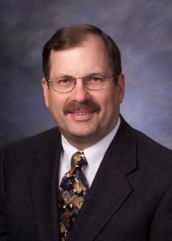



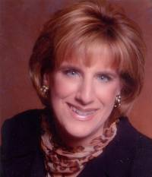

**Certificate 131**

**LILLIAN A. NAWROCKI, MA, DDS**

Dr. Nawrocki received her BA in Biological Sciences from Cornell University in 1976 and completed her MA in Human Anatomy and Histology at SUNY , Buffalo in 1981. She graduated in 1984 with her DDS from the University of Buffalo Dental School. She is a forensic dental consultant to the Suffolk County Medical Examiners, Hauppauge, New York and a member of the Suffolk County Medical Examiners Mass disaster Identification Team. This allowed her the opportunity to work extensively during the TWA Flight 800 incident in 1996. For many years, she was attending staff for St. Charles Hospital and Rehabilitation Center’s Residency Program.

She is secretary of the Suffolk Society of Forensic Dentistry, a study group, a member of the Board of Governors of the American Society of Forensic Odontology (ASFO) and a Fellow of the American Academy of Forensic Sciences (AAFS). Presently, she is also on the Board of Delegates for the Suffolk County Dental Society. As a member of DMORT Region 2, she was deployed to New York City to work at the World Trade Center tragedy. In addition, she assisted during the American Airlines Flight 587 crash.

Dr. Nawrocki has co-presented several paper at the AAFS Annual Meetings on tissue excision and stabilization and child abuse. She has also lectured to various groups on forensic odontology.

Dr. Nawrocki has co-authored “A Full Scale Drill of a Haz-mat Recovery Operation” in the Journal of Emergency Management in 2003 and the American Society for Clinical Pathology’s Check Sample Series “Forensic Pathology”, an article on bite mark recognition, January 2006. She maintains a general dentistry practice in Mount Sinai, Long Island, NY and resides there with her husband and son.

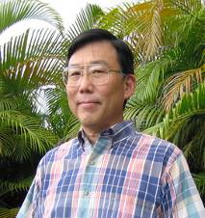

**Certificate 132**

**ANTHONY K. Y. SUR. DDS**

Dr. Sur was born and raised in Honolulu, Hawaii. He received a BA degree from the University of Washington in 1971 and subsequently did his predental studies at the University of Hawaii. He graduated from Northwestern University Dental School in 1983 with a DDS degree. At the V.A. Medical Center in Milwaukee, Wisconsin he completed a General Practice Residency from 1983-84 and from 1984 to 1986 he completed his Prosthodontic Residency.

He has been in private practice in Hilo since he returned to Hawaii in 1986 and limits his practice to prosthodontics. He is the forensic dental consultant to the Hawaii County Police Department and is a member of DMORT 9. He is also a member of the American Society of Forensic Odontology and a Fellow in the American Academy of Forensic Sciences. He is a member of the American Dental Association, the Hawaii Dental Association, the Hawaii County Dental Society (President, 1999-2002), the American College of Prosthodontics, and the Academy of Osseointegration. He is on staff at the Hilo Medical Center and is a member of the State of Hawaii’s Dental Advisory Committee. His wife, Lyn Thorsen, is a registered nurse at the Hilo Medical Center.

His hobbies includes dogs, dogs, and dogs.

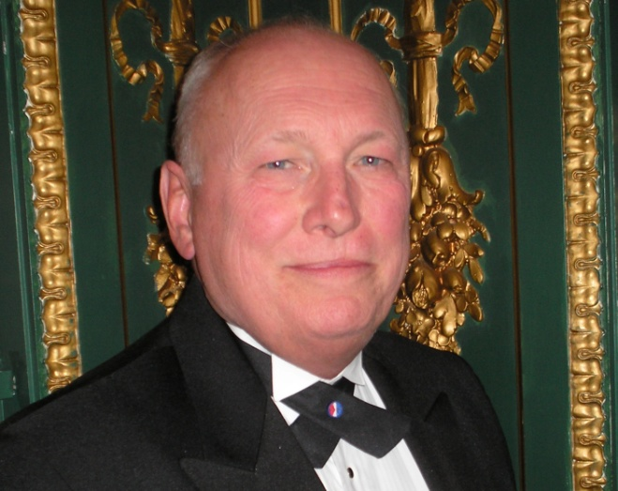

**Certificate 133**

**WARREN TEWES, DDS, MS**

Native of Annapolis, Dr. Tewes earned his DDS and MS degrees at the University of Maryland, in 1975 & 1982 respectively. From 1978 to 2008, he was full time faculty of restorative dentistry at this dental school. In 2003 the University of Maryland Board of Regents presented him with their Award of Excellence in Public Service for establishing and maintaining the Maryland Dental Database for Missing and Unidentified Persons and co-coordinating marylandmissing.com through the Doe Network.

Dr. Tewes has served the National Center for Missing and Exploited Children and the National Transportation Safety Board. Also serving in the Disaster Mortuary Operational Response Team of the Department of Homeland Security, he was assigned to Region III and advanced to training officer in the Family Assistance Center Team. He has been deployed to a number of disaster sites including the 9/11/01 United Flight 93 event in Shanksville, PA and the 2005-06 Hurricanes Katrina/Rita operations in Mississippi and Louisiana. From 2007 to 2010, he was the lead forensic odontologist assisting dental web page development for the National Missing and Unidentified Persons System (NamUs) in the National Institute of Justice.

Currently, Dr. Tewes is the chief forensic odontologist in the Office of the Chief Medical Examiner, State of Maryland, lecturing and consulting in the Forensic Pathology Fellowship Program and the Harvard Associates in Police Science. He also lectures in the University of Baltimore’s Department of Criminology. Since 2007, he has been team teaching the NCIC Dental Coding Workshops for Criminal Justice Information Services Division of the FBI. In this service, Dr. Tewes was presented the US Attorney General’s Award for Outstanding Contributions to Community Public Safety Partnerships.

Dr. Tewes is a member of The Vidocq Society in Philadelphia who hear unsolved homicide cases of law enforcement investigators from across the country, for pro-bono resolution assistance. He is a Fellow of the American Academy of Forensic Sciences and a member of the American Society of Forensic Odontology.

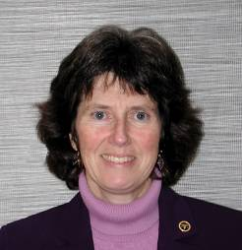

**Certificate 134 RETIRED**

**STEPHANIE KAVANAUGH, DMD, MS**

Dr. Kavanaugh obtained her dental degree in 1983 from the University of Pennsylvania. Originally from New Jersey, after attending the University of Washington for her orthodontic training, she switched coasts and considers the Puget Sound area her home. She has been in private orthodontic practice since 1986 in Issaquah, WA.

Her undergraduate degree was a double major in biology and anthropology from the University of Delaware (1976). Anatomy and forensics have always been an interest. After being a member of the state and local dental identification teams since 1991, she became the official chair of the Seattle-King County Dental Society Forensic Committee in 1997 and co-chair of the Washington State Dental Association Dental ID Team in 2003.

She is a full Member of the AAFS and a member of the ASFO. Currently, she is a forensic dental consultant for the Snohomish County Medical Examiners Office. She thanks Dr. Gary Bell for all his mentoring and support during all of her forensic training to date.

While her husband Bill doesn’t want any details, he is immensely supportive of her forensic activities and their two dogs are always willing to greet her when she comes home.

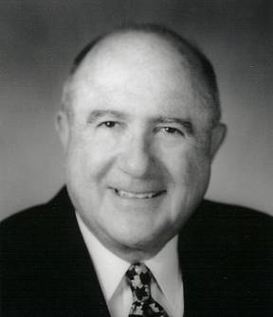

**Certificate 135**

**WILLIAM E. SILVER, DDS**

Born in Boston, Mass in 1929, Bill graduated from Tufts University in 1949 and then entered NYU College of Dentistry. This was followed by Post Graduate Orthodontics at Columbia University and then two years in the US Air Force in Japan. He returned to Boston where he taught at the Forsyth Dental Infirmary and became a Diplomate of the American Board of Orthodontics. In 1962 he moved to Miami where he practiced Orthodontics until retirement in 1998. During that time he served as Chief of Dentistry at Miami Childrens Hospital and later developed the Miami Dental Identification Response Team (DIRT) just before the VALUJET accident. Bill joined DMORT just a month before going to the World Trade Center and then later he participated in the Katrina disaster. He is a member of FEMORS (Florida) and is Deputy Chief, Forensic Odontology , at the Miami Dade Medical Examiner Department. One of a few double diplomates, Orthodontics and Odontology, he is also on the Board of Directors of the ACLU and the Unlicensed Practice of Law Committee of the Florida Bar and lectures to various law enforcement agencies and schools in Miami whenever he is not playing tennis or making ceramics.

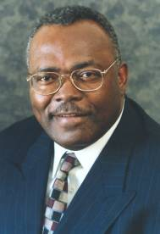

**Certificate 136**

**JOHN M. WILLIAMS, DDS DECEASED 7/2012**

Dr. John M. Williams is a Dentist and has practiced Dentistry in North Minneapolis for 23 years and is a private pilot. Dr. Williams retired from the NFL 1980, after 12 years of service.

John Williams graduated from the University of Minnesota in 1969 with a B.S. degree in Education. Dr. Williams completed his DDS degree from the University Maryland in 1978. Dr. Williams is a member and fellow in the Academy of Forensic Sciences and American Society of Forensic Odontology and served on the Board of Governors. Dr. Williams is a member of Regional 5 D-MORT Team and Minnesota Disaster Dental Identification Team.

Dr. Williams is on staff at North Memorial Hospital, Minneapolis. He is a member of the North Memorial Hospital Dental Unit Study Club, and serves on the board of Children Dental Services of Minneapolis. Dr. Williams is the Chair of the North Minneapolis Health Advisory Committee. He is a member of the University of Minnesota Men’s Athletic Advisory Board.

Dr. Williams’ community service includes former program chair and board member, Community Action Agency of Minneapolis, past board member of the Minneapolis Urban League, Public Health Advisory Committee for the Minneapolis Department of Health and Family Support and former President of the West Broadway Business Association. Dr. Williams leads a Prison Ministry Team and for the past twenty years has been active with the ministry.

In 1992, Minneapolis City Council selected Dr. Williams as a Volunteer of the Year.

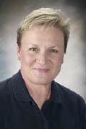

**Certificate 137**

**PAULA C. BRUMIT, DDS**

Dr Brumit is a Clinical Adjunct Instructor at the University of Texas Health Science Center-San Antonio Dental School, Department of Dental Diagnostic Science. She is a consultant to the Bexar County Medical Examiner’s office, Dallas County Medical Examiner’s office,the Immigration & Customs Enforcement (ICE), Child Protective Services, Kenyon Worldwide Disaster Management Specialists, National Dental Image Repository Review panel-FBI, Ft. Worth Police Department and the Texas Department of Public Safety. She is a member of the Bexar County Forensic Dental Team, Dallas County Forensic Dental Team, the DMORT Region VI team, and served as a member of the WTC Dental Identification team for the 9/11 disaster in New York and the Katrina hurricane disaster in Louisiana. Dr. Brumit is a graduate of Baylor College of Dentistry and is in private practice in Graham, Texas. She is a Fellow of the American Academy of Forensic Sciences, a Fellow of the Academy of General Dentistry, and member of the American Society of Forensic Odontology.

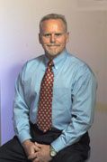

**Certificate 138**

**KENNETH COHRN, DDS**

Dr.Cohrn, a general practitioner in Lady Lake, Florida has demonstrated dedication to forensic odontology through participation in professional, educational and community services. His professional commitments include active participation in the local Medical Reserve Corps, DMORT Region 4, FEMORS Region 3, consultant to the Office of the Medical Examiner Districts Five and Nine as well as various law enforcement agencies in Central Florida. Recent disaster deployments include Hurricane’s Katrina, Charlie and Ivan. He is an active member in AAFS and ASFO and has had the honor to present at the last four annual scientific sessions of the AAFS. In recognition for community service, Dr. Cohrn was awarded “Heroes in Public Health” in Lake County, Fl. in 2006. Dr. Cohrn has achieved mastership status in both the Academy of General Dentistry and American Academy of Laser Dentistry in addition to an MBA in 2001. As an active participant in organized dentistry, he has served as president, peer review chairman and Board member of the Lake County Dental Society. He was a representative to the FDA House of Delegates for five years. Dr. Cohrn is a native of Buffalo, N.Y., having graduated from the SUNY at Buffalo School of Dentistry and a GPR at the V.A. Medical center in Buffalo. Dr. Cohrn welcomes the opportunity to serve as a Board member of ASFO and an ambassador for forensic dentistry.

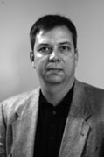

**Certificate 139**

**JAMES M. LEWIS, DMD**

Dr. James (Jim) Lewis received his BS in Chemistry from the University of Alabama in 1981 and his DMD degree from the University of Alabama School of Dentistry (UAB) in 1985. Following graduation he spent one year in Butler, AL as an associate before opening his general dentistry practice in 1986 in Madison, AL where he continues to practice today. Dr. Lewis’ interest in forensic odontology began in 1996 after attending a continuing education course. Subsequently, he completed a Fellowship in Forensic Odontology from the Center for Education and Research in Forensics located at the University of Texas Health Science Center at San Antonio in 2001 and became the Senior Fellow at the Center for Education and Research in Forensics for the following year. Since 2003, Dr. Lewis has been the forensic odontology consultant to the Alabama Department of Forensic Sciences in Huntsville, AL which serves the northern portion of the State of Alabama. He is a member of the Alabama Dental Mass Disaster Identification Team and assisted in the World Trade Center disaster in February and April of 2002. Dr. Lewis is a member of the American Academy of Forensic Sciences, American Society of Forensic Odontology, American Dental Association, Alabama Dental Association and became a Diplomat of the American Board of Forensic Odontology in 2008. He is currently serving as Secretary of the ABFO.

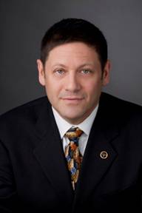

**Certificate 140**

**ADAM J. FREEMAN, DDS**

Dr. Adam Freeman earned his dental degree from Columbia University’s College of Dental Medicine. He completed a fellowship in forensic odontology at the University of Texas Health Science Center at San Antonio and Center for Education and Research in Forensics (CERF) in 2003. While at CERF he did research on the distribution of bite marks in human victims. This research was published in the Journal of Forensic Sciences.

He is a member and dental section chief of DMORT Region 1 where he served as a team member during the aftermath of Hurricane’s Katrina and Ike. Dr. Freeman was proud to receive the DMORT Region 1, Outstanding Member of the year award in 2009. He is the Founder and Director of the State of Connecticut’s Disaster Identification Response Team (D.I.R.T.), and a Consultant to Kenyon International, a worldwide disaster management company. He is the Deputy Chairman of Interpols Odontology Working Group.

Dr. Freeman is a Fellow of the American College of Dentists (F.A.C.D.), Fellow of the International College of Dentists (F.I.C.D.), a Master of the Academy of General Dentistry (M.A.G.D.), a Fellow of the Pierre Fauchard Academy and a Fellow of the American Academy of Forensic Sciences.

He is an Assistant Professor at Columbia University College of Dental Medicine, and the director of the forensic odontology area of concentration

Dr. Freeman currently serves as Secratery of the American Board of Forensic Odontology, and is a Past President of the American Society of Forensic Odontology.

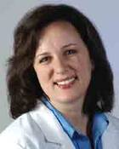

**Certificate 141**

**LAURA A. KAISER, DMD**

Dr. Kaiser has been a consultant to the Florida District 20 (Collier County) Medical Examiners Office since 2005. She is a member if the Florida Emergency Mortuary Operations Response System (FEMORS) and the Disaster Mortuary Operational Response Team (DMORT) Region IV.

Dr. Kaiser is a 1997 graduate of the University of Pittsburgh School of Dental Medicine. She is a member of the American Academy of Forensic Sciences, a Fellow of the Academy of General Dentistry, a member of the American Society of Forensic Odontology, the American Dental Association and the Florida Dental Association.

Dr. Kaiser has a private practice in Bonita Springs, Florida.

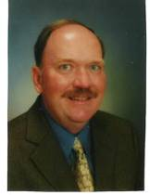

**Certificate 142**

**STEPHEN M. LOJESKI, DDS**

Dr. Stephen M. Lojeski has been in the practice of General Dentistry since 1976. He is the owner of Arcadia Family Dentistry in Arcadia, California. He has been affiliated with Forensic Dentistry pursuits for many years. He is a Fellow of the American Academy of Forensic Sciences and obtained his Diplomate Status in the American Board of Forensic Odontology in 2009. Dr. Lojeski was a 25 year member of the L.A. County Coroner’s Forensic Dental Team under Gerald Vale, D.D.S., and currently is a Forensic Odontology Consultant for the Los Angeles County Coroner’s Office. He also is an active member of the California Forensic Dental Identification Team (CALDIT). In addition he is a member of DMORT IX Federal Disaster Response Team. He has served in mass disasters and was deployed to the morgue operations in the aftermath of Hurricanes Katrina and Rita in St. Gabriel, Louisiana. For this deployment he was a recipient of a Distinguished Service Award presented by the California Legislature in 2005.

In addition to Forensic pursuits Dr. Lojeski is very active in Organized Dentistry having served as President of the 1,000 member San Gabriel Valley Dental Society in 2005, President of the Dental Foundation of California in 2006, and has been a Delegate to the California Dental Association for many years. In addition he is kept very busy as an expert witness for the California Dental Board and as a regional Consultant for Delta Dental of California and Express Dental of Florida. He has many years of Peer Review experience and has testified many times in court room proceedings. He is a regular lecturer and speaker on many Dental topics. Dr. Lojeski has also had experience in teaching. He taught in a Dental Assisting Program for 21 years and currently teaches Forensic Odontology one day per month at the L.A. Coroner’s Office to the resident students.

Dr. Lojeski is also licensed by the State of California as a Qualified Medical Evaluator (QME), and holds licensure in California Real Estate also. In 2006 he was given an award for being the New Home Sales Top Producer by Baldwin Real Estate Services, and is a Distinguished Past President of the Arcadia Kiwanis Club. He is married, has two grown children, and lives in Upland, California. His hobbies are fishing, tennis, participation in all sports activities especially tennis, and the restoration of antique slot machines.

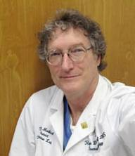

**Certificate 143**

**ROGER D. METCALF, DDS**

Roger Metcalf is the Director of the Human ID Lab and Chief Forensic Odontologist for the Tarrant County Medical Examiner’s District in Fort Worth, Texas. He is a graduate of Baylor University and Baylor College of Dentistry. In addition, he completed the Fellowship in Forensic Odontology at the Center for Education and Research in Forensics at the University of Texas Health Science Center at San Antonio Dental School under Dr. David Senn, and received the J.D. degree from Texas Wesleyan University School of Law. Roger has been a member of the Tarrant County M.E.’s Mass Fatality Dental Identification Team (a.k.a. “Dental Disaster Squad”) since it was established by Dr. Rodney Crow in 1980, and has participated in identification of victims from the Delta 191 and 1141 crashes at D/FW Airport, and from the Mt. Carmel-David Koresh incident in Waco, Texas. Since joining the Tarrant County Medical Examiner’s District in 2004 (when Dr. Crow retired), Roger has supervised the forensic identification by various means of more than 300 unidentified bodies per year. He is still married to his beautiful first wife, Linda, and they have three wonderful children, Roger Jr., Kelli Anne, and Ryan David, and two Golden Retrievers. Roger is commissioned as a Lt. Colonel in the DFW Medical Ranger Group, Medical Reserve Corps, Texas Medical Brigade, Texas State Guard. He is also an active member of the Wesleyan Innocence Project—the group that is responsible for reviewing possible exoneration cases for the Dallas County District Attorney’s Office.

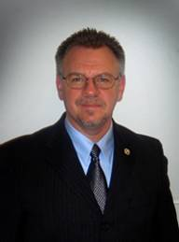

**Certificate 144**

**BRUCE A. SCHRADER, DDS**

Dr. Schrader is a 2001 fellow of the Center for Research in Forensics. He is a 1992 graduate of the University of Texas Health Sciences Center @ San Antonio Dental School and a 1986 graduate of Texas Tech University were he also lettered as a trainer from 1982-1984 while completing his undergraduate studies. Dr. Schrader is a general practitioner who maintains a private practice in Austin, TX.

He is a forensic dental consultant to the Travis County Medical Examiner’s Office in Austin, TX and to the Bexar County Medical Examiner’s Office in San Antonio, TX. He serves as a Clinical Adjunct Clinical Instructor at the University of Texas Health Sciences Center @ San Antonio Dental School. Dr. Schrader serves as a Faculty Member of the Southwest Symposium on Forensic Dentistry and with the Center for Education and Research in Forensics. He serves as a part time federal employee with the National Disaster Management System/Disaster Mortuary Operation Response Team – Region VI. He served in the mass fatality incidents following the World Trade Center and Hurricane Katrina disasters.

Dr. Schrader is a Fellow in the American Academy of Forensic Sciences Odontology Section and a member of the American Society of Forensic Odontology. He also serves the American Society of Forensic Odontology as the organizations’ Executive Director.

**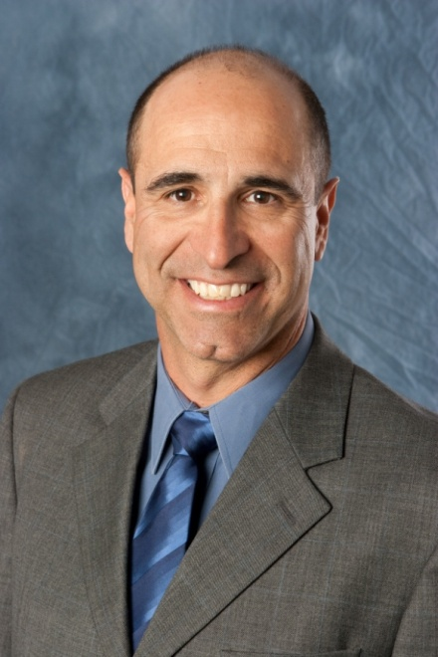**

**Certificate 145**

**ANTHONY R. CARDOZA, DDS**

Dr. Rick Cardoza is a 1981 graduate of California Lutheran University with a BA in Chemistry, and graduated in 1985 with a D.D.S. from Northwestern University School of Dentistry. He maintains a general dental practice in El Cajon (San Diego County) California. Dr. Cardoza began his affiliation with the San Diego County Medical Examiner and the Imperial County Coroner in 1993 under the mentorship of Dr. Norman Sperber, and received his forensic training from the University of Texas Health Science Center, Southwest Symposium in 1996. Dr. Cardoza is a Fellow of the American Academy of Forensic Sciences (AAFS), a Member of the American Society of Forensic Odontology (ASFO), a Member of the California Society of Forensic Dentistry (CSFD) a Member of the American Dental Association (ADA), a Member of the California Dental Association (CDA) and is a Member of the California Dental Identification Team (CalDIT). Dr. Cardoza serves as a forensic dental consultant for the California Department of Justice Missing/Unidentified Persons Unit and the Missing Persons DNA Task Force, the San Diego Police Department and the San Diego County Sheriff's Department. In addition to his forensic case load, Dr. Cardoza has written articles for both professional journals and text books and he lectures extensively on forensic dentistry at dental conferences throughout the United States and Canada. Dr. Cardoza became a Diplomate of the American Board of Forensic Odontology in 2010.

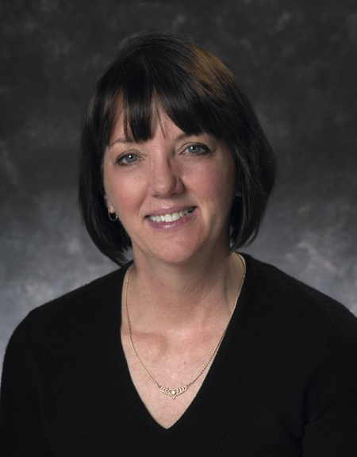**Certificate 146 DECEASED**

**SHEILA M. DASKOW, DDS**

Dr. Sheila Dashkow is a graduate of LaSalle University and received her dental degree from Temple University School of Dentistry. Since that time she has maintained a private dental practice in Pennsauken, NJ. Dr. Dashkow is the Deputy Chief Forensic Odontologist for the City of Philadelphia, Medical Examiner’s Office. She is also a Consultant Forensic Odontologist to the Regional Medical Examiner and several of the county Medical Examiners of the State of New Jersey. She is a member and Fellow in the American Academy of Forensic Sciences, a member of the American Society of Forensic Odontology as well as a Fellow in the Academy of General Dentistry. She is also a member of the Vidocq Society. Dr. Dashkow is Chairperson and a Captain of the New Jersey Dental Association, Dental Victim Identification Team. She is a member of the dental section of the Medical Examiner Special Operations Response Team for the City of New York. She is also a member of DMORT Region 2 and has participated in response to World Trade Center II, Flight 587 and Hurricane Katrina. Dr. Dashkow has been active in the Missing Persons Dental Initiative of the Office of Forensic Sciences of the New Jersey State Police for the past three years as well.

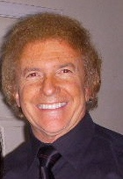**Certificate 147**

**LAWRENCE A. DOBRIN, DMD**

Dr. Lawrence A. Dobrin is the Chief Forensic Dentist for the five boroughs of New York City, Office of Chief Medical Examiner NYC. He is also a forensic dental consultant to the Regional Medical Examiner of the State of New Jersey, and a forensic dental consultant for the Union County Medical Examiner in New Jersey. He is a member and Fellow of the American Academy of Forensic Sciences, a member and former Secretary of the American Society of Forensic Odontology, a member and former President of the New York Society of Forensic Dentistry, a Fellow of the American College of Dentistry, a Fellow and former President of the American Society of Dentistry for Children and a Diplomate of the American Board of Forensic Odontology. Dr. Dobrin is currently an Associate Professor at the University of Medicine and Dentistry of New Jersey, New Jersey Dental School Department of Pediatric Dentistry. He was appointed for twelve years on the Union County Commission of Child Abuse and Missing Children and served as their Treasurer for all those years. For the past twenty years, and currently, he has been a certified provider for the New York State Education Department, Division of Professional License, for the training and recognition of Child Abuse and Neglect. Dr. Dobrin is the Director of Dental Operations on the Medical Examiner Special Operations Response Team for the City of New York. He is also a member of the Federal Governments’ Disaster Mortuary Response Team Region 2. He has been involved in the identification of victims of disaster events since 1990, including both World Trade Center Disasters, flights US Air 405 and American Airlines 587, deployed to the Katrina Hurricane 2005, the Hudson Air Collision 2008, and many other incidents. Dr. Dobrin maintains a private dental practice in Roselle Park, New Jersey for the past 30 years.

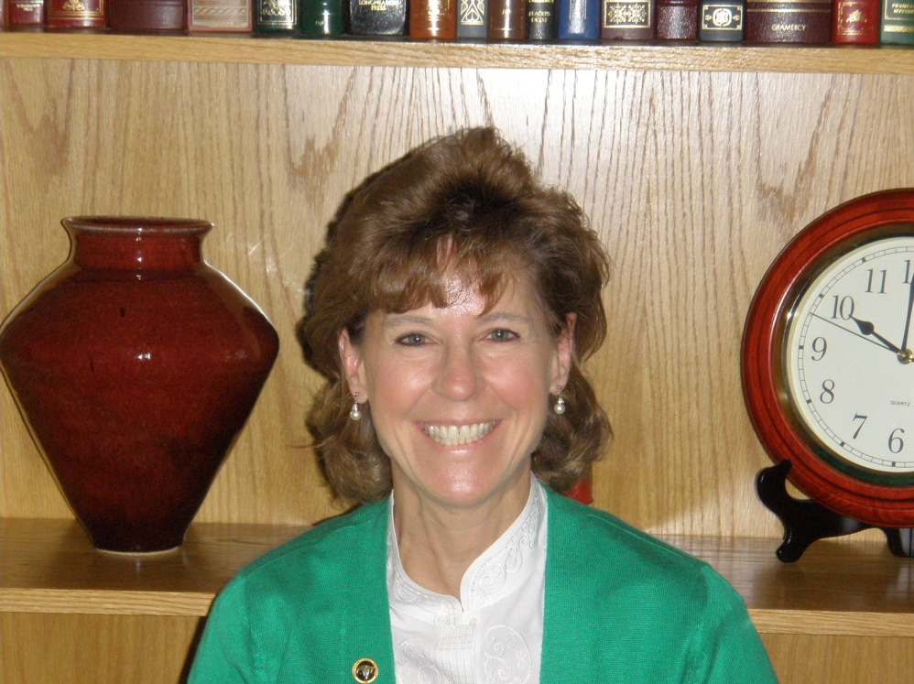

**Certificate 148**

**KATHLEEN A. KASPER, DDS**

Dr. Kasper, in 2005, was appointed Deputy Odontologist to the Tarrant County Medical Examiner’s District in Ft. Worth, Texas. She is a 1986 graduate of the University Of Iowa College Of Dentistry. After dental school, Dr. Kasper served as an active duty dental officer in the United States Air Force. She entered private dental practice in 1994 and currently maintains an active general dental practice in Carrollton, Texas.

Dr. Kasper completed a one year fellowship in forensic odontology at the Center for Education and Research in Forensics (CERF) in San Antonio, Texas in 2003. Her research project from this fellowship, concerning age estimation in a Texas Hispanic population based on third molar development, was published in 2009 in the Journal of Forensic Sciences.

Dr Kasper is a Fellow in the American Academy of Forensic Sciences, a Member of the American Society of Forensic Odontology and became a Diplomate of the American Board of Forensic Odontology in 2010. She is a Member of the American Dental Association and Texas Dental Association.

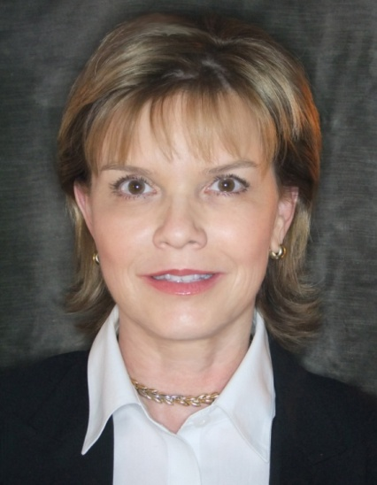

**Certificate 149**

**JANICE KLIM-LEMANN, DDS**

Born and currently residing in Southern California, Dr. Klim-Lemann graduated La Sierra Campus, Loma Linda University in 1981 with a B.S. in Medical Illustrating. She continued on to graduate with a D.D.S. from Loma Linda University School of Dentistry in 1984 and practices general dentistry in San Bernardino County, CA. In 1995 she trained in forensic dentistry at University of Texas Health Science Center, Southwest Symposium. Dr. Klim-Lemann is a Fellow in the American Academy of Forensic Sciences (AAFS), a Member of American Society of Forensic Odontology (ASFO), a Member of California Dental Identification Team (CalDIT), a Member of California Society of Forensic Dentistry (CSFD), a Member of the American Dental Association (ADA), a Member of California Dental Association (CDA) and Tri-County Dental Society. She has volunteered for the Attorney General at the Department of Justice/Missing and Unidentified Persons Unit (MUPS) in Sacramento as an analyst and trainer. She has been published in the ASFO Journal and has guest lectured on Forensic Dentistry at Loma Linda University School of Dentistry. Dr. Klim-Lemann participated in the recovery and identification effort at the World Trade Center NYC, in Sept. 2001 and is a Forensic Consultant through-out California. Dr. Klim-Lemann became a Diplomate in the American Board of Forensic Odontology (ABFO) in 2010.

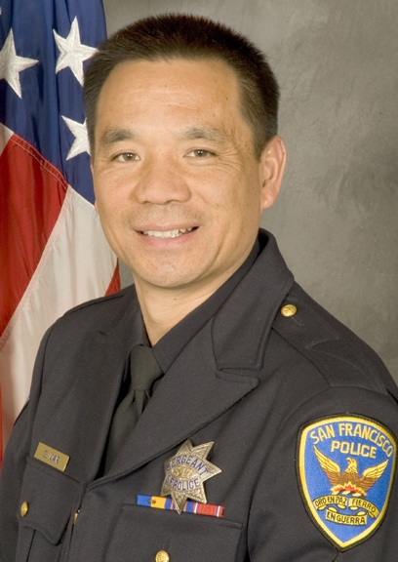**Certificate 150**

**GREGORY L. MAR, DDS**

Dr. Gregory L. Mar received a B.S in Biological Science from the University of California, Davis, his D.D.S. and M.A. from the University of the Pacific Dental School and the University of the Pacific. While attending dental school he was a Police Reserve for the San Francisco Police Department. After graduating dental school he completed an oral surgery fellowship and remained with the University of the Pacific Dental School as an assistant professor in the Oral-Maxillofacial Surgery Department. After a brief stint in private practice, Dr. Mar decided to pursue a full time career with the San Francisco Police Department. He has had several assignments throughout his career including (Patrol, Investigations, consultant to S.W.A.T. EMT, and police academy assistant instructor). He is currently assigned the Crime Scene Investigations Unit and devotes the majority of his time to forensic science. In addition to being a forensic odontologist, he is a crime scene investigator and a latent fingerprint examiner. Other skills include crime scene reconstruction, bullet trajectory analysis, and blood spatter analysis. Dr. Mar still practices dentistry part time in a county hospital in San Mateo. He has two daughters and enjoys hunting, fishing, and riding in the outdoors.

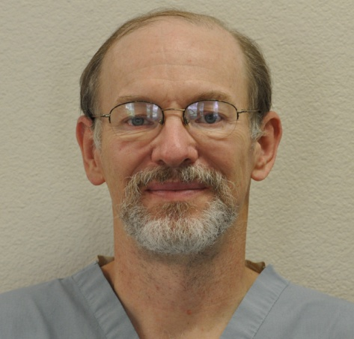

**Certificate 151**

**PETER J. MARSH, DDS**

Peter J. Marsh, D.D.S. received his undergraduate degree in chemistry and his pharmacy degree from Southwestern Oklahoma State University in Weatherford Oklahoma in 1981. As a registered pharmacist, he practiced at Memorial Hermann Memorial City Medical Center Hospital for over ten years. In 1986, Dr. Marsh earned his D.D.S from the University of Texas Health Science Center Dental Branch in Houston. In 2001 he was awarded a Fellowship in the Academy of General Dentistry. Dr. Marsh additionally trained in Forensic Odontology in 2002 at the University of Texas Health Science Center at San Antonio at the Center for Education and Research in Forensics (CERF). He worked at the World Trade Center disaster identifying victims, as well as providing forensic identifications for local disasters such as the BP-Amoco Refinery Explosion. He is currently researching the use of computer analysis of dental radiographs for identification, as well as the x-ray comparison of twin dentition for differentiation of individuals.

Dr. Marsh is a Diplomate of the American Board of Forensic Odontology and a member of the American Academy of Forensic Sciences. He is also a member of the American Dental Association, the Texas Dental Association, the Academy of General Dentistry, the Texas Academy of General Dentistry, the American Pharmacists Association, the Texas Pharmacy Association, and various other professional organizations, boards, and study clubs. Dr. Marsh currently is a forensic consultant for the Office of the Medical Examiners in Galveston and Harris Counties, and is actively involved in general private practice at his dental office in Manvel, Texas.

The Drs. Marsh live in Manvel, Texas and have been married over 30 years. Dr. Sabrina Marsh is an Assistant Professor at the University of Houston in the College of Education. They enjoy traveling the world for work and pleasure, exploring Texas breweries, and teasing the cat.

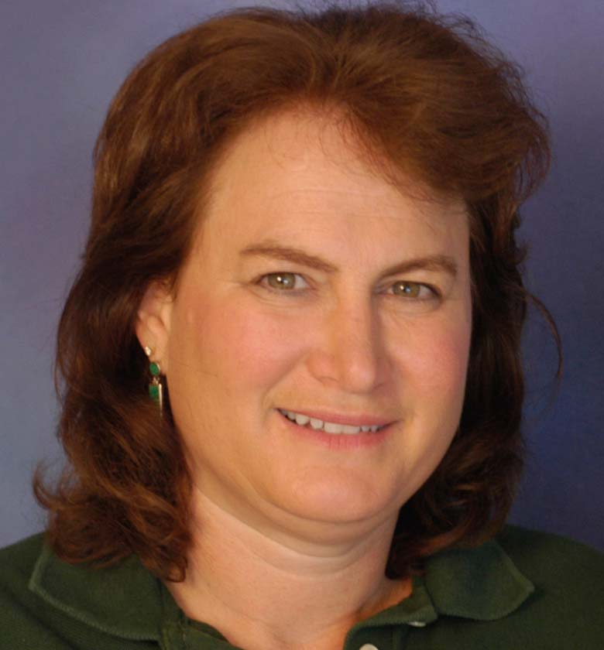

**Certificate 152**

**BARBARA L. NEEDELL, DMD**

Dr. Barbara Needell is a 1979 graduate of Colgate University in Hamilton, NY, and a 1986 graduate of the Goldman School of Dentistry in Boston, Ma. She has been a practicing dentist in South Florida since 1987 and Chief Forensic Odontologist for the Palm Beach Medical Examiner’s Office since 2005. She is also a forensic dental consultant for Miami-Dade and Broward Counties. Besides Diplomate of the American Board of Forensic Odontology, she is a member of the American Academy of Forensic Sciences (AAFS), the American Society of Forensic Odontology (ASFO), National Association of Medical Examiners (NAME), the International Association of Identification (IAI), and the Florida Division of the International Association of Identification (FDIAI). She is also a forensic dentist for the National Missing and Unidentified Person Systems (NamUs) and on the dental review panel for the FBI. She is a founding member of FEMORS (Florida Emergency Mortuary Operations Response System) and a member of DMORT (Disaster Mortuary Operational Response Team) Region 4. Her forensic experiences include dental identifications, bitemark evaluations and testimony, and mass disasters responses including Hurricane Katrina, Hurricane Charley, and Chalks Airline Crash.

Dr. Needell currently lives in Weston, Florida with her husband and twin daughters.

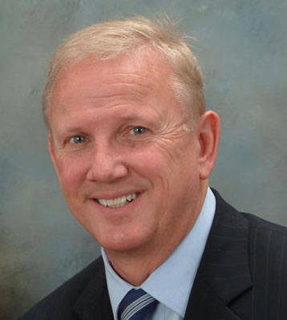**Certificate 153**

**CHARLES E. BERNER, DDS**

Dr. Berner earned his DDS degree from The Ohio State Univ. College of Dentistry. He has been inducted as a Master in the AGD, has earned the Lifelong Learning and Service Recognition award and reviews manuscripts submitted for publication in the AGD’s publication. He also has Sustaining Member status in the American Academy of Cosmetic Dentistry. The Consumer’s Research Council of America has listed Dr. Berner among ‘America’s Top Dentists’ and Northern Ohio Magazine also included him in their ‘Best Dentists’ issue.

Dr. Berner became a Diplomate of the American Board of Forensic Odontology in 2011, is a Fellow of the American Academy of Forensic Sciences and is grateful to have been elected to the Board of Governors of the American Society of Forensic Odontology. Completing his Forensic Fellowship at the Univ. of Texas Health Science Center at San Antonio, Dr. Berner was later designated a Fellow and collaborating scientist with SUNY - Buffalo’s Laboratory for Forensic Odontologic Research. Dr. Berner has received recognition as a founding member of the Department of Homeland Security by his membership in Reg. V of the Disaster Mortuary Operational Response Team under the National Disaster Medical System. Dr. Berner was among the first to be deployed to Louisiana for Hurricane Katrina, helped establish the National Disaster Portable Morgue Unit in St. Gabriel and was honored to have received the Commanders Award for Meritorious Service. Dr. Berner is proud to participate on the National Dental Image Repository review panel and was awarded the Assistant Director's Award for Excellence for his consultation to the Criminal Justice Information Services Division of the FBI. Dr. Berner is affiliated to the Summit Co. Medical Examiners’ Office and is also a team member of the Florida Emergency Mortuary Operations Response System. He is the Forensic Specialist on Team Ohio of NamUs, a member of the National Assoc. of Medical Examiners, the International Association for Identification, the Ohio Identification Officers Association and volunteers with the Ohio Medical Reserve Corps, Tri-City CERT and his local Mass Inoculation Point of Dispensing (MIPOD) team. Dr. Berner enjoys teaching and speaking to local law enforcement, EMS crews and Sexual Assault Nurse Examiners.

Dr. Berner has been regularly speaking in high school classes, training students in his office over decades, contributing to scholarships and school activities and was inducted into his high school Alumni Hall of Fame.

03/2011

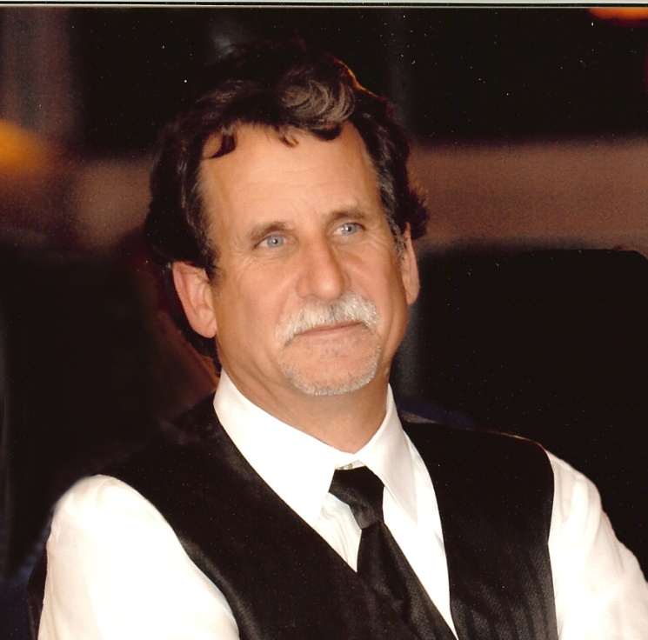

**Certificate 154**

**RAYMOND J. JOHANSEN, DMD**

Dr. Ray Johansen is a 1980 graduate of San Diego State University with a BA in biological Sciences and graduated in 1984 with a D.M.D. from the Washington University School of Dental Medicine in St. Louis, Missouri. He practices general dentistry in Santa Barbara, California. Dr. Johansen has been the dental consultant for the Santa Barbara County Coroner’s Office since 1997. Dr. Johansen is a member of the American Academy of Forensic Sciences (AAFS), a member of the American Society of Forensic Odontology (ASFO), and a member of the California Dental Identification Team (CalDIT). He assisted the Ventura County Medical Examiner’s Office in the identification of victims from the crash of Alaska Air 261 off the coast of Southern California in January 2000. Dr. Johansen has written numerous articles, a text, and has taught and lectured on the subject of forensic dentistry. Dr. Johansen became a Diplomate of the American Board of Forensic Dentistry (ABFO) in February 2011.

03/2011

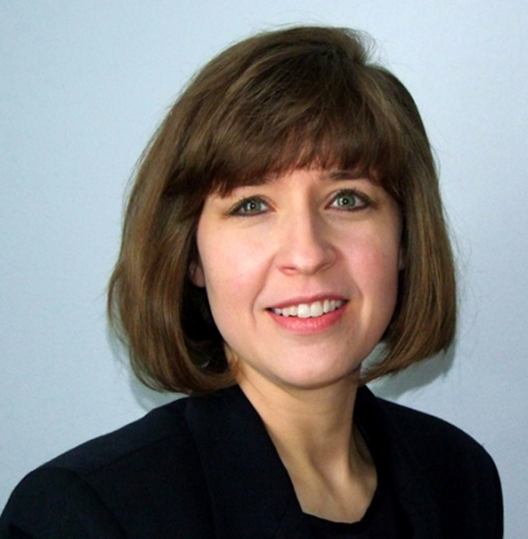

**Certificate 155**

**DENISE C. MURMANN, DDS**

Denise C. Murmann, DDS, DABFO practices general dentistry in Naperville and River Forest, IL. She graduated from the University of Illinois at Chicago School of Dentistry in 1992, 50 years after her maternal grandfather. She became a Diplomate of the American Board of Forensic Odontology in 2011.

She has been a member of Disaster Mortuary Operational Response Team (DMORT) Region V since 1999. In her role with DMORT she has been deployed as a part of the 9/11 World Trade Center Dental Identification Team and to assist after Hurricane Katrina.

Dr. Murmann has been a member of the Cook County Medical Examiner’s Disaster Response Team since 2002. She has served as a consultant in forensic odontology for Kane Co, Kendall Co, and Will Co, IL, and is on the NDIR Review Panel.

In 2004 she participated in the year-long Fellowship in Forensic Odontology at the Center for Education and Research in Forensics (CERF) through the University of Texas Health Science Center at San Antonio. The resultant research project, “A Comparison of Animal Jaws and Bite Mark Patterns,” was presented at the Annual Meeting of the American Academy of Forensic Sciences (AAFS) in 2005 and published in the Journal of Forensic Sciences in July 2006.

Dr. Murmann is a Member and Past President of the American Society of Forensic Odontology (ASFO), a Fellow of the American Academy of Forensic Sciences (AAFS), and a Member of the Academy of General Dentistry (AGD).

03/2011

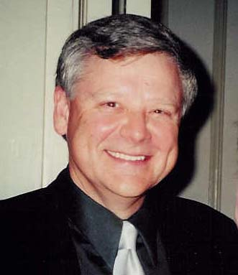

**Certificate 156**

**EDGAR W. TURNER III, DDS, MSHS**

Dr. Edgar W. (Ned) Turner, III graduated in 1975 from the University of Tennessee College of Dentistry. Upon graduation, he entered the United States Navy and during his career, completed a two-year residency in Comprehensive Dentistry at the National Naval Dental Center, Bethesda, MD. He received a Masters Degree in Health Sciences from George Washington University. Upon retirement from the Navy, Dr. Turner returned to his alma mater as an Associate Professor and Director of the Department of Operative Dentistry. He developed the first state approved course in Expanded Functions for Dental Auxiliaries and served as the course director for 7 years. He has published numerous research articles and continues to be actively involved in clinical and forensic research. Dr. Turner is a member of DMORT Region IV and participated in the identification of the victims of Hurricane Katrina. He has lectured extensively on a number of topics including Forensic Odonotology, Restorative Dentistry, Terrorism and Biologic and Chemical Weapons. Dr. Turner is a Master in the Academy of General Dentistry and has been recognized as a Fellow in the International College of Dentists. He continues to be a Consulting Scientist for the Shelby County Regional Forensic Center, a position he has held since 1999. He and his wife Barbara are blessed with two sons and 5 grandchildren.

03/2011



**Certificate 157**

**SCOTT HAHN, DMD**

Dr. Hahn graduated from the Medical College of Georgia, School of Dentistry in 1985, was subsequently commissioned as a Dental Officer in the United States Navy, and currently holds the rank of Captain in the United States Navy Reserves.

Dr. Hahn is currently a Special Agent with the Miami Division of the Federal Bureau of Investigation and the Senior Team Leader for the FBI Miami Evidence Response Team. He has been involved as a presenter with the Armed Forces Institute of Pathology annual Forensic Dentistry/Identification Course for over thirteen years. Dr. Hahn is currently the Odontology Chair for FDIAI, a member of ASFO, and a Fellow of the AAFS, Odontology Section. Dr. Hahn became a Diplomate of the ABFO in 2012.

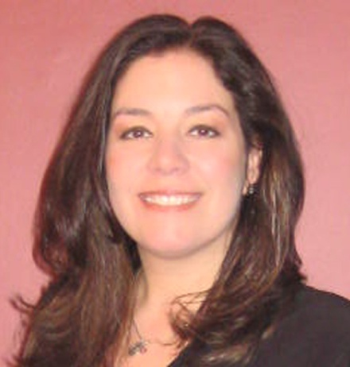

**Certificate 158**

**Jacqueline S. Reid, DDS**

Dr. Jacqueline S. Reid graduated from Case Western Reserve University School of Dentistry in 1996 and did a post graduate hospital-based general practice residency in dentistry at Robert Wood Johnson University Hospital in New Brunswick, New Jersey from 1996-1997. She has been the owner of a private practice in Chatham, New Jersey for the past 15 years.

In 2004, Dr. Reid was appointed Chief of Hospital Dentistry and Director of the General Practice Residency at Robert Wood Johnson University Hospital.

Dr. Reid is a graduate of the Fellowship in Forensic Odontology from the University of Texas Health Science Center in San Antonio, Center for Education and Research in Forensics from 2006-2007.

She is a member of the Academy of General Dentistry (AGD), The American Academy of Forensic Sciences (AAFS) and American Society of Forensic Odontology (ASFO) where she has also served on the Board of Governors. Dr. Reid is affiliated with Middlesex and Monmouth County Medical Examiners Offices in New Jersey and became a Diplomat of the American Board of Forensic Odontology in 2012.

02/2012

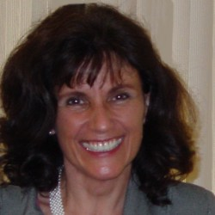

**Certificate 159**

**Delora L. Fletcher, DDS**

Education: In 1979, she received the degree of Bachelor of Science in Dental Hygiene from the University of Southern California, Magna Cum Laude. She practiced full time dental hygiene prior to returning to school and received the degree of Doctor of Dental Surgery, Cum Laude, in 1986 at the University of California at Los Angeles. Post-Doctoral: Dr. Fletcher completed a General Practice Residency at the Veterans Administration Hospital in West Los Angeles followed by private practice as a general family dentist.

She attained the status of ‘Fellow’ in the Academy of General Dentistry in 1996 and in the American Academy of Forensic Sciences in 2012. She was certified by the American Board of Forensic Odontology in 2013.

Retired from clinical dentistry practice, Dr. Fletcher has done forensic odontology consulting for county, state and federal agencies since 2001. She maintains homes in San Diego, California and Greer, South Carolina.

**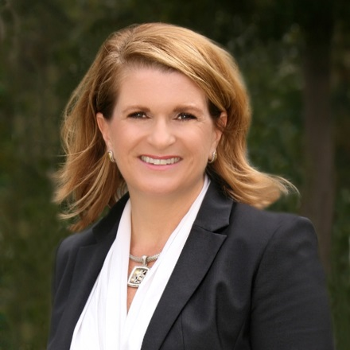**

**Certificate 160**

**Holland Maness, DMD**

Dr. Holland Maness, a South Carolina native, received her undergraduate degree in Business Administration from the College of Charleston in 1988 with minors in Economics and International Studies. Following a 12 year career in hospital administration and informatics, she returned to school receiving her DMD in 2005 from the Medical College of Georgia. She completed an Orthodontic Residency at the Medical College of Georgia in 2007. She currently serves as Graduate Clinic Director of the Orthodontic Department at the University of Tennessee Health Sciences Center College of Dentistry. She is a Diplomate of the American Board of Orthodontics.

Dr. Maness had the privilege of completing an undergraduate elective in forensic dentistry at the BOLD Lab at the University of British Columbia and completed the AFIP course in spring of her senior year of dental school. She is a graduate of the Fellowship in Forensic Odontology from the University of Texas Health Science Center in San Antonio, 2010. She has served the State of Georgia as forensic dental consultant since 2008.

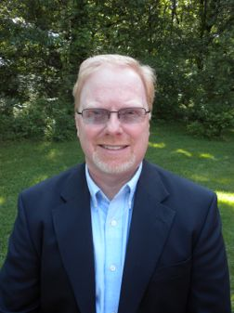

**Certificate 161**

**Eric S. Wilson, DDS**

Dr. Eric Wilson received his DDS in 1991 from the University of Missouri at Kansas City and maintains a full-time dental practice in Cole Camp and Versailles, Missouri. He is a member of the ADA, Missouri Dental Association, has served as Chair of the MDA committee on Dental Education. He is a Fellow in the American Academy of Forensic Sciences and has served on the Board of Governors of the American Society of Forensic Odontology.

He is Co-chair of the Missouri Emergency Response Team and has been on the team since its inception in 1996. He has also served as a forensic Odontologist on the Region VII DMORT team since 1998. He has been deployed by DMORT to New York after 9/11, American Airlines crash in Kirksville MO in 2003, Hurricane Katrina in 2005, Hurricane Ike in 2008, and the tornado in Joplin, MO in 2011.

Dr. Wilson is currently working with the Missouri Disaster Response System and is the lead forensic odontologist and continues his private forensic practice with the St. Louis City Medical Examiner’s Office. He has also been appointed to the Mass Fatality Advisory Committee for the state of Missouri and to Congresswoman Vicky Hartsler’s Health Care Advisory Committee.

He was certified by the American Board of Forensic Odontology in 2013.

**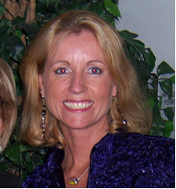**

**Certificate 162**

**Robin Ainsworth, DDS, MS**

Robin Ainsworth, DDS, MS, is a Captain in the United States Public Health Service (USPHS) currently detailed to the U.S. Coast Guard (USCG). She has served with USPHS for over 18 years. Throughout her career she has served in various Public Health Service and military assignments. Her dental forensic career began in 2001, when she was deployed through HHS/DMORT to the Office of the Chief Medical Examiner in New York City. She was also deployed to Louisiana (St. Gabriel and Carville) for Hurricane Katrina, through DHS/DMORT. CAPT Ainsworth currently augments the Armed Forces Medical Examiner System with dental identifications of remains processed through Dover Port Mortuary at Dover Air Force Base, and with potential bitemark cases. She is currently a member of AAFS, ASFO, ADA and AGD. CAPT Ainsworth earned a MS in Oral Biology from the Uniformed Services University of the Health Sciences, in conjunction with completing a two-year Comprehensive Dentistry Residency through the Naval Postgraduate Dental School. She completed a Fellowship in Forensic Odontology from the University of Texas Health Science Center, Center for Education and Research, and earned her DDS from the Ohio State University College of Dentistry.



**Certificate 163**

**Phillis Ho, DDS**

No biographical information submitted.

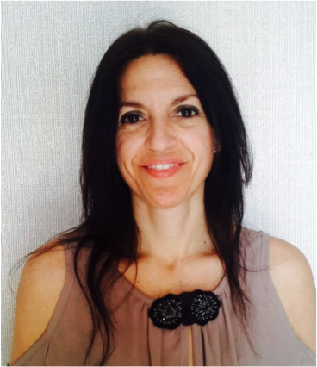

**Certificate 164**

**Joe Adserias Garriga, DDS, PhD**

Dr. Joe Adserias obtained her dental degree in Barcelona, Spain and a degree in biology in Girona, Spain. As a dental student, she received a scholarship from the Department of Anatomy, where she conducted human dissection. Her interest in Forensic Science began with her first lesson in Forensic Odontology. Following graduation she obtained a Master’s degree in Forensic Odontology from the University of Toulouse, France and was honored for her masters project. Additionally, she has a Master’s degree in Forensic Anthropology and Genetics from the University of Granada, Spain. Dr. Adserias’ PhD is in the field of Molecular Microbiology. Dr Adserias is a practicing oral surgeon and implantologist in Barcelona, Spain. She has demonstrated dedication to forensic science through participation in different professional and educational services and directs and teaches at multiple postgraduate programs in Forensic Science. Dr Adserias is an external advisor of Mossos d´Esquadra (Catalonian Police), recognized for her contribution in forensic casework. She received the 2016 Ellis Kerley Foundation International Award in Forensic Anthropology, serves at the International Association of Coroners and Medical Examiners as Member of its Board of Directors, is a co-founder and Deputy Chair of the international group Forensic Odontologist for Human Rights, a Member of the INTERPOL DVI Anthropology SubWorking Group, and Member of the INTERPOL DVI Odontology Working Group.

.

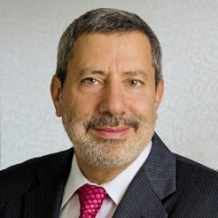

**Certificate 165**

**Kenneth Aschheim, DDS**

Dr. Kenneth W. Aschheim graduated with honors from New York University College of Dentistry. His postdoctoral training includes a residency in General Dentistry at Bronx Municipal Hospital Center/Albert Einstein Medical School and a residency in Dental Anesthesiology at the Manhattan VA Hospital/ New York University/ Bellevue Hospital Center. He joined the staff of the Department of Dentistry at the Mount Sinai Medical Center as a Clinical Instructor and was promoted to Assistant Professor in 1992. In 1999, he was promoted to Section Chief of Esthetic Dentistry and Advanced Technologies and was elevated to Associate Clinical Professor in 2004. In 2011, he joined the faculty of New York University College of Dentistry's Advanced Programs in Esthetic Dentistry for International Dentists as an Adjunct Associate Clinical Professor.

Following the September 11th attack of the World Trade Center, Dr. Aschheim became a dental consultant to the Office of the Chief Medical Examiner in New York City (OCME NYC). He was instrumental in setting up the digital image acquisition section and served as a liaison between OCME and the developer of the dental identification software used by OCME. Since then, he has helped develop new software that should further reduce the time necessary to dentally identify disaster victims. He has lectured on the topic on four continents and was appointed Assistant Chief Forensic Odontologist to OCME NYC in 2009. In 2014, he was appointed assistant chair to the FBI’s Scientific Working Group for Disaster Victim identification. He has also consulted throughout the world to numerous government agencies as well as the National institute of Science and Technology (NIST) where, in 2015, he became a member of the Crime Scene and Death Investigation Subcommittee of the Organization of Scientific Area Committees for Forensic Science. In 2011, he was honored with the ADA SCDI Informatics Award and in 2016, he was recognized by the American Academy of Forensic Sciences for the work that he has done in the field of forensic standards.

03/18

****

**Certificate 166**

**Corinne D’Anjou, DMD**

Dr D'Anjou graduated with a DMD from Laval University, Quebec, Canada in

2002. In 2014 she completed the Certificate in Forensic Dentistry from McGill University and in 2016 the Fellowship in Forensic Odontology at the University of Texas Health Science Center at San Antonio.

As a private consultant to History Flight Inc. Corinne has been involved in the identification and repatriation of United States servicemen from the 1943 Battle of Tarawa as part of the History Flight Odontology Team since 2015. This organization is in public/private partnership with the United States Defense POW/MIA Accounting Agency (DPAA).

She is employed as a weekly forensic odontologist consultant at the Laboratoire de Sciences Judiciaires et de Médecine Légale in Quebec, Ministry of Public Security of Quebec. This forensic laboratory is the main institution for forensic work in Quebec, and services more than 8 million people.

Dr D'Anjou is a Diplomate of the American Board of Forensic Odontology (ABFO), a member since 2013 of the American Society of Forensic Odontology (ASFO) and a full member of the Odontology Section of the American Academy or Forensic Sciences (AAFS). She is also a member of the Faculty of Forensic and Legal Medicine of the Royal College of Physicians of London and a member of INTERPOL odontology working group.

Dr D'Anjou is involved in humanitarian aid groups and operates a 12 operatory general dentistry office near Montreal where as a co-owner she has helped mentor other dental professionals.

03/18

**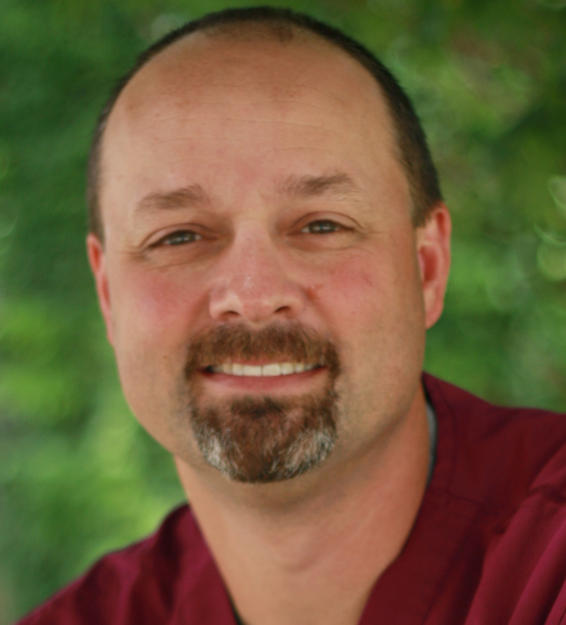**

**Certificate 167**

**Derek Draft DDS**

Dr. Derek Draft received his D.D.S. degree from the University of Michigan Dental School in 1998 and currently practices as a general dentist in Grandville, MI. Dr. Draft joined the State of Michigan Forensic Dentistry ID Team in 2000 and he joined DMORT Region V in 2001. He was deployed to Joplin, MO with DMORT after the devastating tornado in May 2011. Dr. Draft has furthered his forensic education by attending multiple forensic courses including Forensic Odontology in a Medical Examiner’s Office, and the 21st Southwest Symposium on Forensic Dentistry. Dr. Draft recently finished the CERF fellowship at the University of Texas Health Science Center. He is on the Board of Governors for the ASFO and a member of the AAFS Odontology Section. Dr. Draft was appointed as a Clinical Associate Professor in the Pathology Department at the Western Michigan University Homer Stryker M.D. School of Medicine as a Forensic Odontology consultant. Dr. Draft successfully challenged the boards and in February 2018 he achieved diplomate status with the American Board of Forensic Odontology (ABFO). Dr. Draft developed the Draft Age Estimation QuicksheetsTM which was presented at the 2015 AAFS meeting in Las Vegas.

Dr. Draft is married to his wife Heidi and has two children, Ashleigh and Hayden. He enjoys time with his family snow skiing in the winter and boating in the summer. He is an avid volleyball player, playing both beach and indoors volleyball. He also builds and runs 1/8th scale trains with his son, Hayden and father, Tom.

03/18

**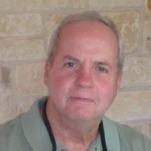**

**Certificate 168**

**James P. (JP) Fancher, DDS, MA, PhD**

Dr. Fancher is a native of San Antonio, TX, and currently lives near Martindale, TX; north east of San Antonio. His experiences with forensic odontology began as a dental officer in the United States Air Force. He completed the Fellowship in Forensic Odontology at the UT Dental School, San Antonio, in 2010. He also completed a master’s degree in biological anthropology, concentrating in forensics, at Texas State University in 2015. His interests currently focus on humanitarian identifications of undocumented migrants in South Texas, as well as routine dental identifications, dental age assessments, abuse cases with dental evidence, and standard of care cases. Dr. Fancher is dual boarded in Forensic Odontology and Periodontics, a Century Club member of the Texas A&M University Association of Former Students, and a Lifetime Member of the National Eagle Scout Association.

03/18

****

**Certificate 169**

**Lena D. Karkalas**

Dr. Lena Karkalas started her career at the New York University College of Dentistry (Class of 1996) and went on to do her residency at Columbia Presbyterian Hospital (Class of 1997). She is the Chief Forensic Odontology Consultant for the State of Rhode Island Medical Examiner’s Office and affiliated with the Child protection program/Aubin Center at RI Hospital. She has been part of many identifications, has helped with many Bitemark cases and worked on litigation cases. She completed her certification in Forensic Dentistry from McGill University in Montreal (2011-2012), Canada. She received her Diplomate status from the American Board of Forensic Odontology in 2018 and has been certified by the FBI/NCIC to help with the Missing and Unidentified since 2012. She is also a fellow of the International Academy of Coroners and Medical Examiners, a member of the American Academy of Forensic Sciences, and member of the American Society of Forensic Odontology and New York Forensic Dental Society. She has maintained a private practice in Providence, RI Dentistry for the past 22 years.

03/18

**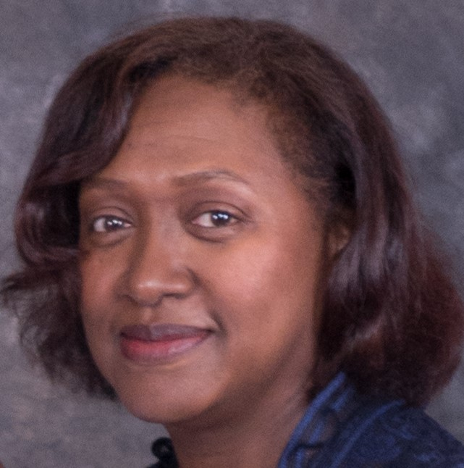**

**Certificate 170**

**Elizabeth Ruth Smith, DDS**

Elizabeth (Ruth) Smith, DDS, is a 1988 graduate from the University of Texas Dental Branch, Health Science Center - Houston. Upon graduation she practiced general dentistry in the underserved areas of Worcester and Boston Massachusetts, eventually participating with the National Health Service Corps from 1992- 1994. During her time in Boston she was a Clinical Assistant Professor (Preceptor) in the Department of Dental Care Management at the Boston University Goldman School of Dentistry from 1989-1995. She completed a Fellowship in Forensic Dentistry at the Center for Education and Research in Forensics (CERF) located at University of Texas Health Science Center in San Antonio (UTHSCSA) in 2005. Currently she is Clinical Assistant Professor for the Department of Forensic Pathology Fellowship at the Virginia Commonwealth University in Richmond Virginia. She has been the Chief Forensic Odontologist consultant for the Commonwealth of Virginia ‘s Office of the Chief Medical Examiner for the past thirteen (13) years.

She has invented and patented a Forensic Camera Device that reduces and or eliminates angular distortion in Bite Mark Photography. This apparatus can also be used in any photographs that require scalability.

She is an Associate Member in the American Academy of Forensic Sciences, and a Member of the American Society of Forensic Odontology.

Dr. Smith practiced general dentistry for many years and has practiced forensic odontology exclusively since 2004.

03/18